Action File Cabinet Enhancements

Discovery Packets

Zip files created for Defense can now either be on a District Wide Setting set to display the File Name, or now just the Bate Stamp numbers of the pages.

Please contact CDAC to have this functionality turned on for your District.

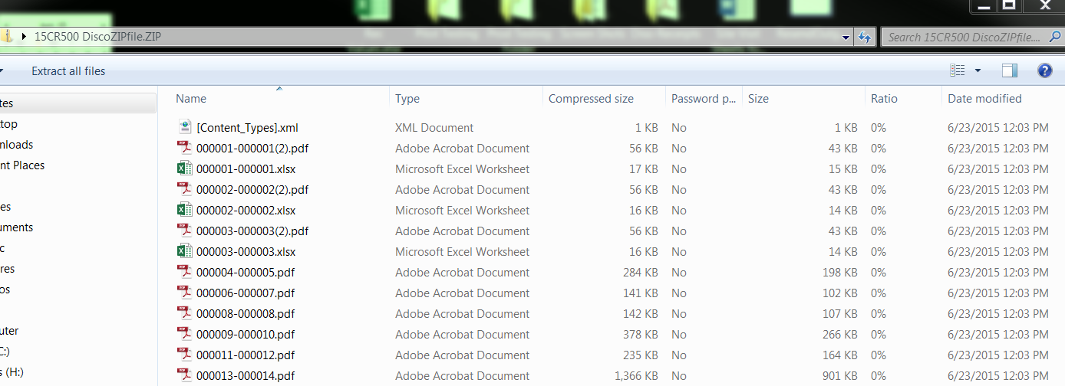

Messages to Users about Actions they are taking in the File Cabinet

More Descriptive message for users when trying to add open or locked files to the filing cabinet.

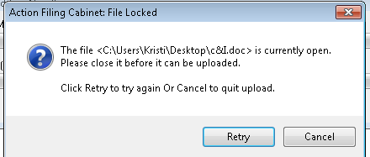

Deleting and Prevent Deleting enhancements for filing cabinet

Districts can set up certain users with Delete privledges from within the file cabinet- utlizing the Right Click menu after selection of folders/files has been made.

Some of the enhancments in this release regarding deleting are:

Prevent Deletion of Original Items at have been bate stamped

Prevent deleting the Root (case number folder)

Recording/Auditing of all Delete functions

Allow Deleting the entire e-discovery packet

Allow deleting the ZIP File

Allow deleting Bate Stamped file if not in a Zip File

Allow deleting originals if not bate stamped

Allow deleting of Actual files if not in an e-disocvery packet

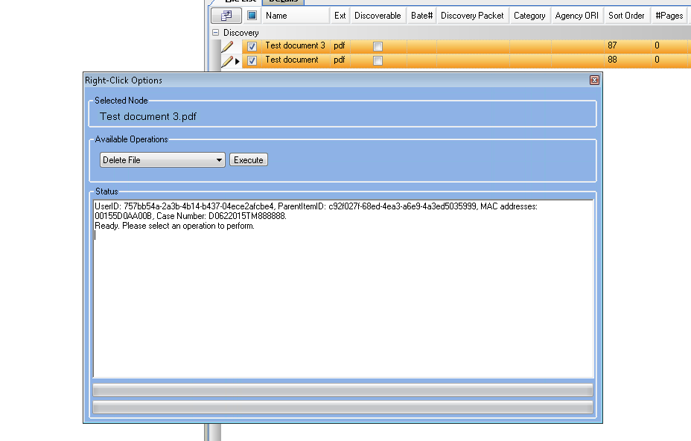

Moving files will now take on the inherit folder property with the move

When moving files between your folder stucture (click and drag) the files will take on the Folder property of which it is being moved to.

Examples:

1. Click and drag any files to tha Red Discoverable Folder will auto check all the files as Discoverable.

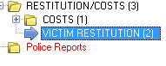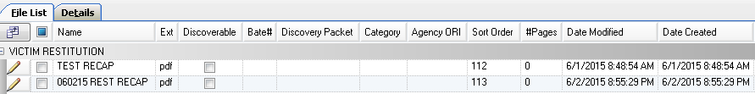

After the click and drag into Police Reports- Red Folder:

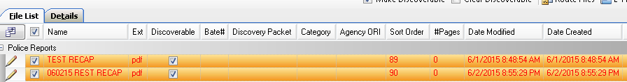

1. Click and drag any files into a Blue Prevent Discoverable Folder will auto check the files with the Prevent Discoverable setting of the folder.

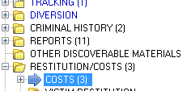

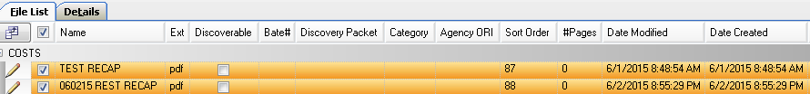

After click and drag into Diversion -Blue folder:

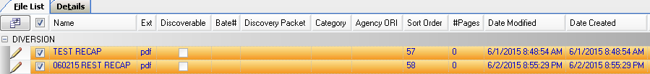

1. Click and drag an existing Discoverable (Red) file into a Black folder (no inherit properties) will keep the file marked as Discoverable until it is checked and also Clear Discoverable is clicked.

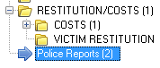

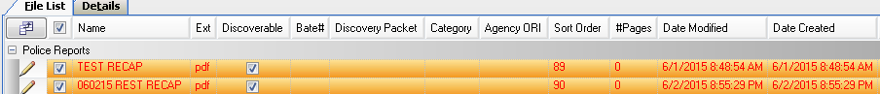

After click and drag into the Costs (Black folder)

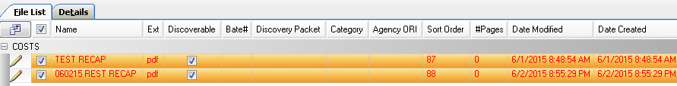

Now leave checked and click on Clear Discoverable

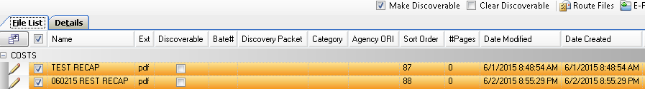

File Cabinet Impersonation

Alleviates the issues for your district to not be able to browse the physical file location and gain access to the files stored from the filing cabinet on your server.

User still needs access to their NAS share but the actual directly can only grant permission to a single admin user on the same domain as the user. Then using impersonation of the admin user, permission is granted on a case-by-case basis to the user.

This is a District Setting- please contact [kristi@cdac.state.co.us](mailto:kristi@cdac.state.co.us) for more information.

Linking and Copying Cases Enhancement

Linking and Copying Cases To and From when selecting the Keep Charging Text will now update the correct co-defendants name that you are coping the charges to.

Intake- Offense Screen – Link Case example



When your charges are displayed the Keep Charging Text box has been moved to the top of the form for easier selection. When this is enabled and you copy charges retaining the text variables the new

Defendant’s name will be changed out automatically for you.

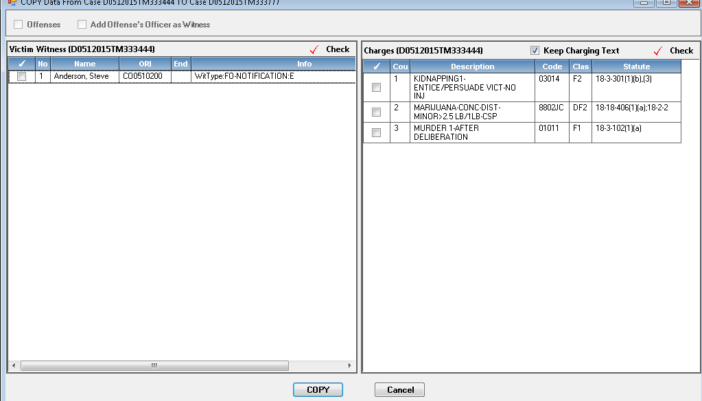

Example brings in name of defendant that you copied the charges to:

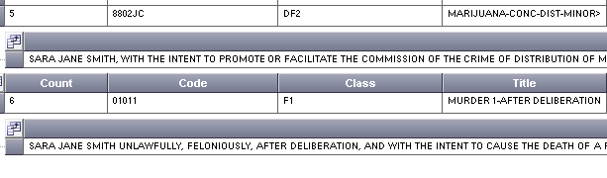

Charges Tab

Editing of charges from Intake and Case Maintenance on the Charge Tab, will now retain the users variable selection when amending or tabbing through your date ranges.

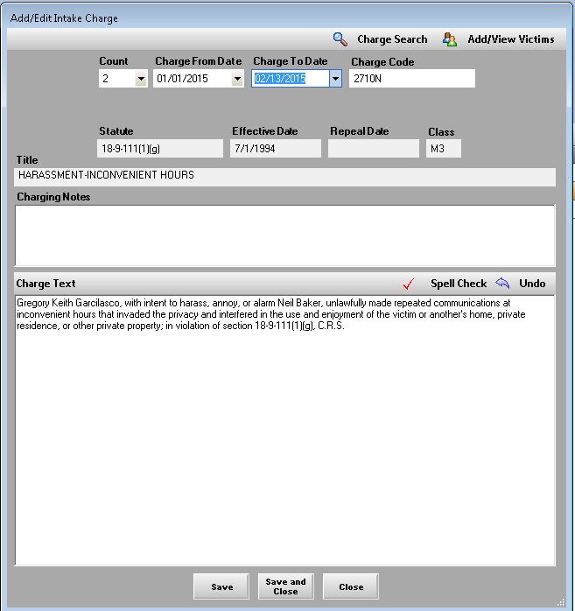

Task Work Flow Enhancements

Work Flow

Insert Work Flow Task form has been redesigned to be **District** Specific. This means that only the templates your district has created will be displayed now when your users log in and select Task Templates.

All of the templates are available to be applied to your District- please forward requests to keep certain templates to [Kristi@cdac.state.co.us](mailto:Kristi@cdac.state.co.us) if your district has not done so yet.

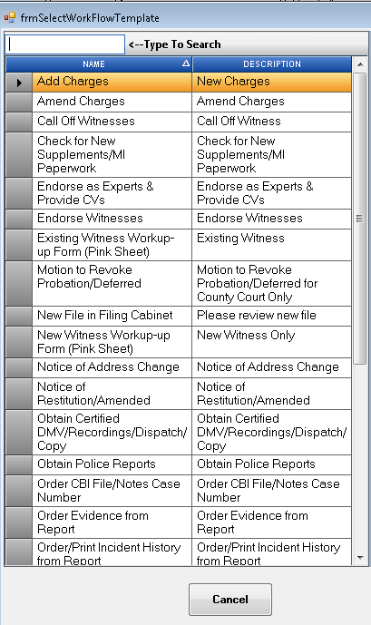

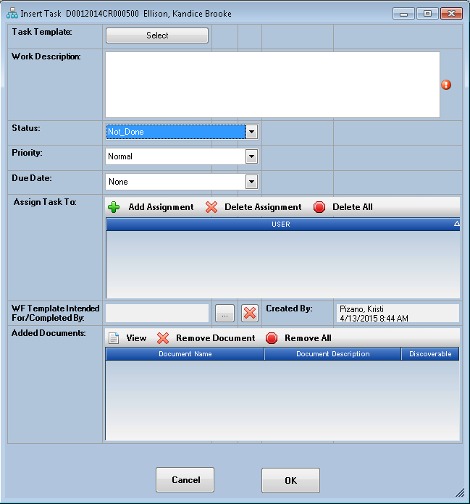

Removing the Assignment list number in your tasks and set order to alphabetically by last name.

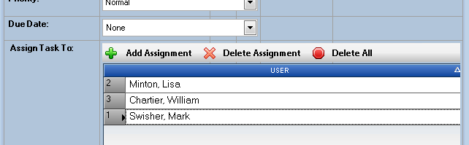

Previous view

Changed/Current view

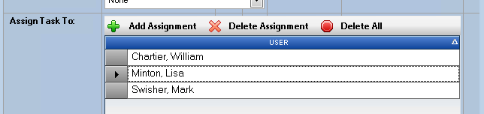

Removing the Numbering associated to your task templates and set order to alphabetically by template name.

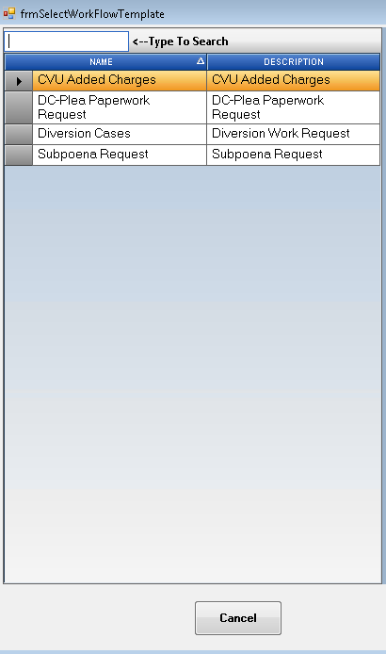

Bug Corrections and Miscellaneous

Events Tab

Future Events that have an Event Action in the record indicating that the event was Vacated etc. Will no longer be highlighted in green. Only future events without an event action will be highlighted for easier visual que for users.

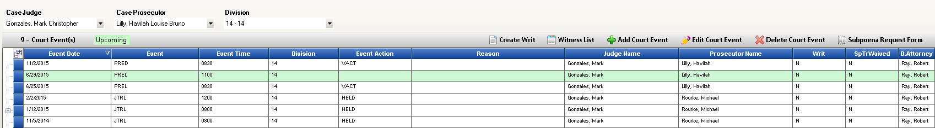

Security – User Table (Power User Function)

The User Table under Security is now default to display only ACTIVE users within your District. To view Inactive users click on the Display Inactive button in the upper right hand corner.

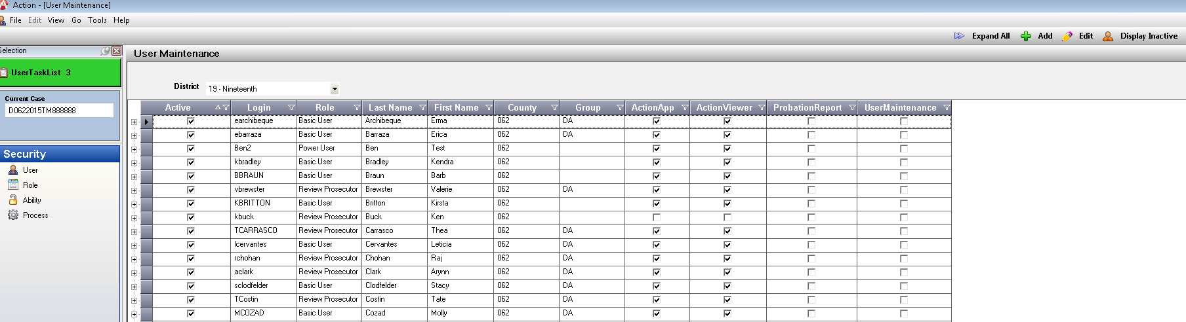

Attorney General Cases retaining controlling county of 000 for e-filing purposes.

Users at the Attorney General’s office will now have the controlling county defaulted to 000 whether a case is set up with their court location or any other court location. Changing the case number will also retain this change so that e-filings be accepted correctly by Judicial.

Action Scaling and DPI issues when using a larger font size.

Users can now set their scaling (view of Icons and programs) to 125 % or 150 % with correct scaling to windows in action. Please report any windows that don’t seem to be scaled correctly.