ACTION ENHANCEMENT GUIDE

June 2015 Release Training Guide



June 23, 2015

CDAC

CDACweb.com

E-Filing Enhancements

E-Filing Form Enhancements

1. Relating Documents in your e-filing form to an existing document/event on the ROA.

This is the first part of development regarding relating documents. More to follow later.

On your E-Filing Window under filing documents you will now see a Relate Button and also added to the Right Click selection menu of the highlighted added document.

1. Select Add/Edit Relationship(s) to R.O.A Document

This will bring up the ROA and allow you select one or many events in which to relate to your current document to by selecting the check boxes.

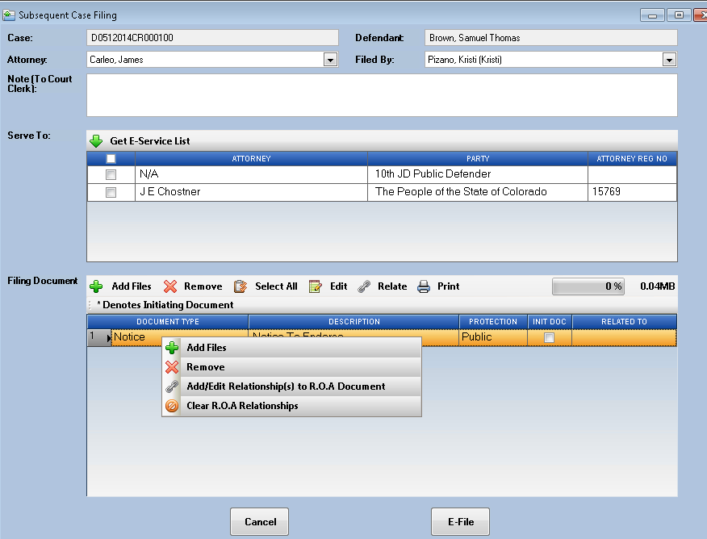

1. Highlight the events from the Add/Edit Relationship(s) to R.O.A.Document listing and click OK

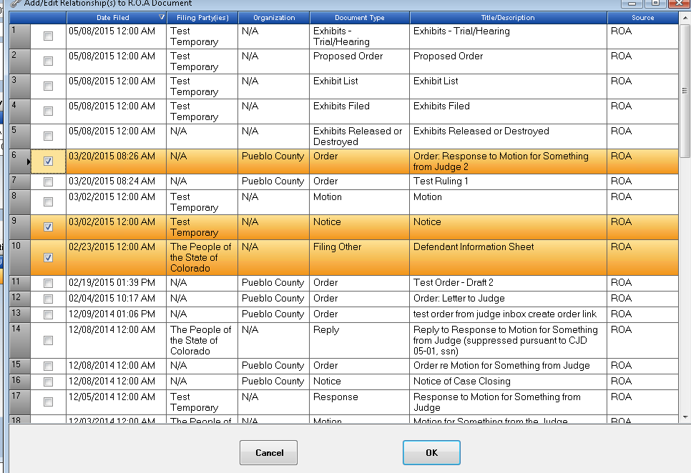

1. In the Filing Document Area – you will now see the Related To column filled in with the selected events from the ROA. These are purposed relationships that the court clerks will accept when reviewing your e-filing package.

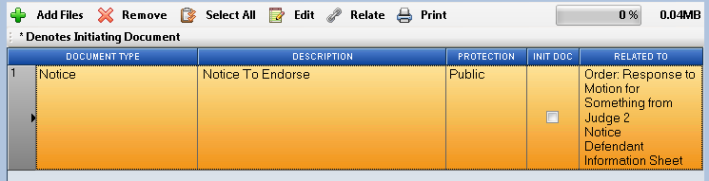

1. Under the Relate Button or Right Click Selection you can also choose now to **edit** these related events bring back up the Add/Edit Relationship(s) form so you can add additional or remove.

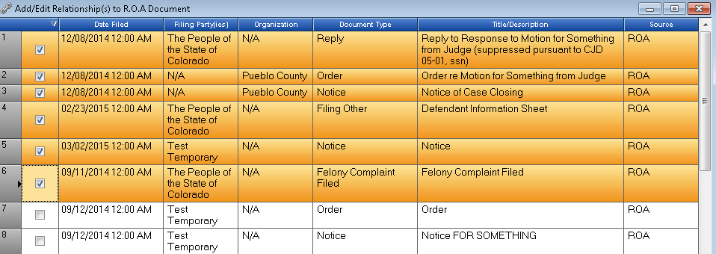

1. To **remove** all relationships click on the Clear R.O.A. Relationships selection under the Relate Button.

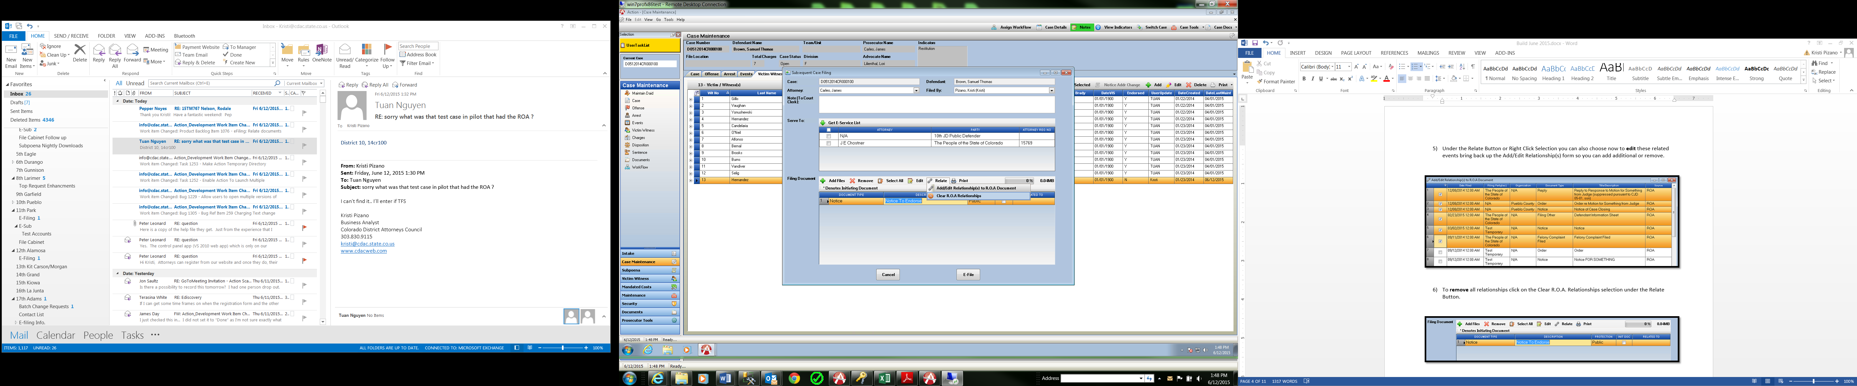

1. E-File your case as normal proceedures.

When the court clerks accept the package the connected between related documents will then be displayed.