aCTION enhancement GUIDE

February 2015 Release Training Guide



February 24, 2015

CDAC

CDACweb.com

E-Filing Enhancements

**Display the ROA - Register of Action**

Court R.O.A. Tab - Display of the R.O.A. from ICCES and the Documents Attached.

You will see the listing of all of the Actions in ICCES through your case in Action-

**Print Screen**- Print a screen view of the R.O.A record.

**Get Document** – Highlight the Event or Multiple Events and click the Get Document button the PDF Document will open and can be printed and or saved. Note- these documents open individually even with the multi-select.

**Columns** – All are sortable by clicking on the Column Name – Date Filed, Authorizer, Organization, Filing Party, Event, Document Title and Security.

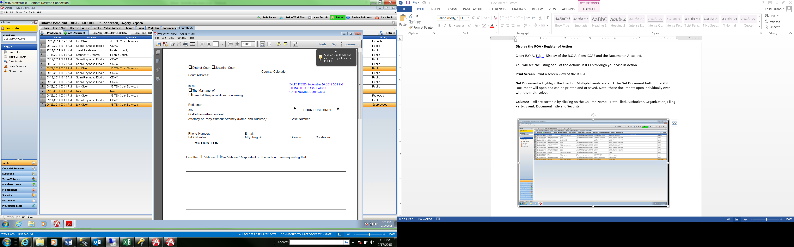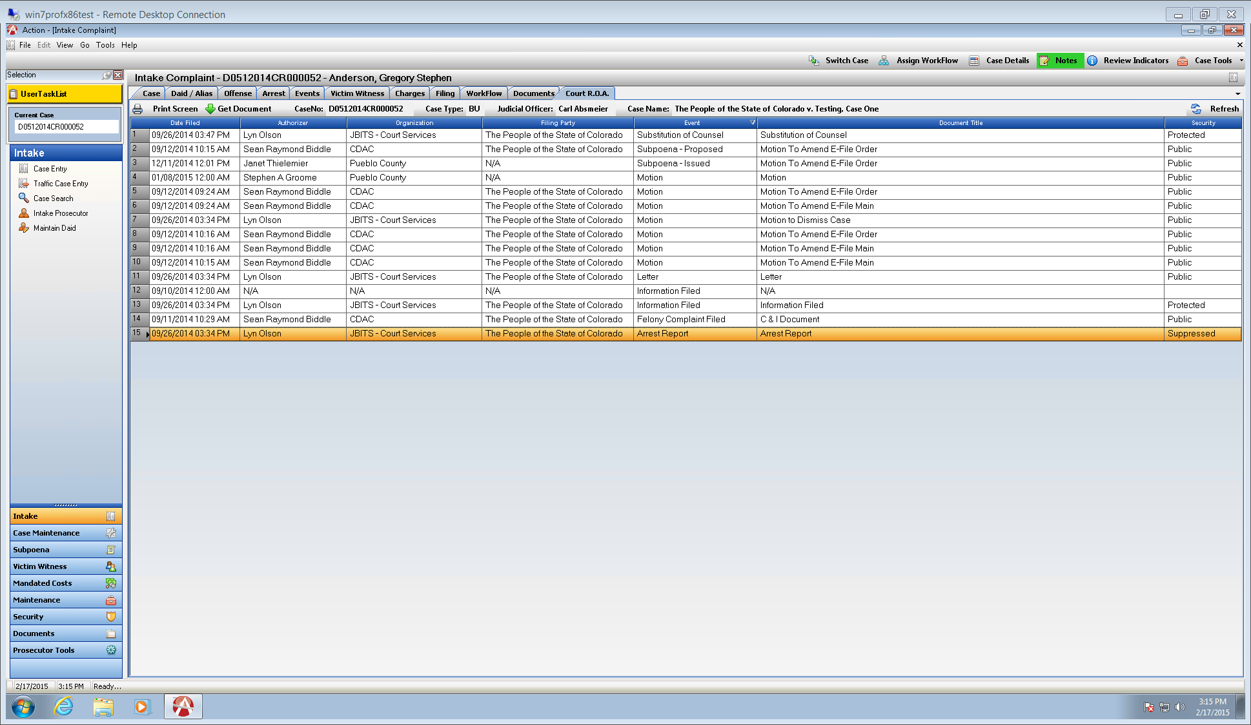

Allow Users to E-file All File Types that are accepted by ICCES

**Action will now allow users to add and drag/drop files with all file Extension types that are accepted by ICCES. These include the following file types:**

DOC, DOCX, PDF, GIF, HTML, JPEG, MSCD, ODP, ODT, PJPEG, PNG, PPT, PPTX, TEXT, TXT, TIFF, WP, WPD, XLS, XLSX, XPNG, JPG

T-Case Filing Document Default if C&I is generated

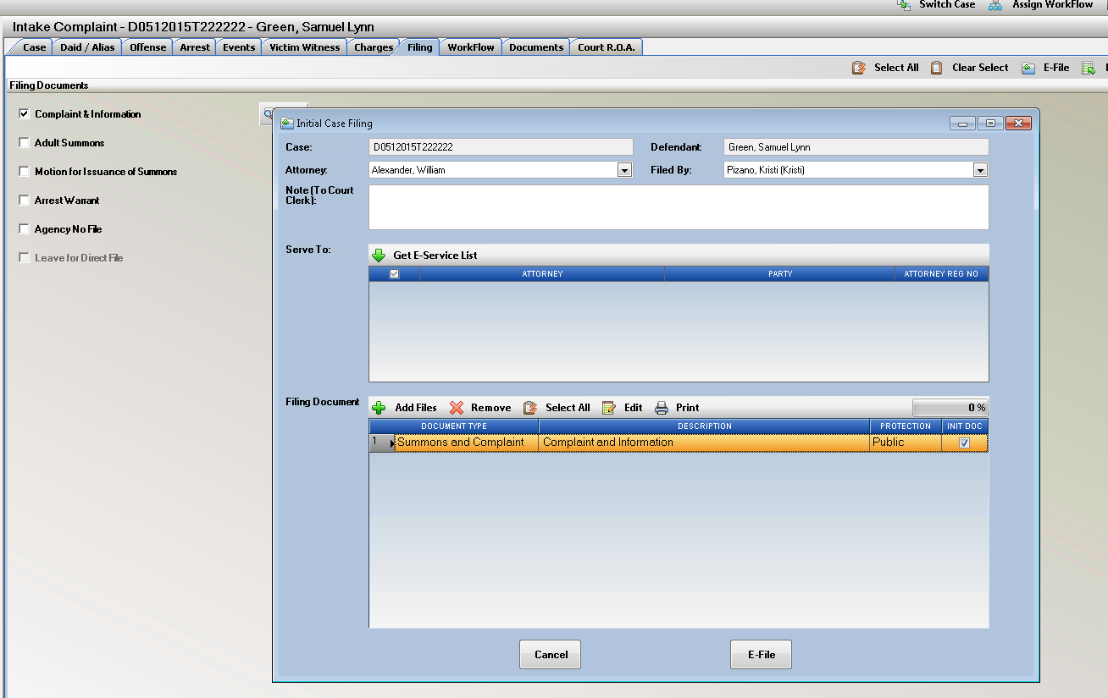If the case is a T case, but you are creating a C&I Document – defaulting document type is the Summons and Complaint. Init. Doc checkbox is also auto checked as this is an initiating document.

E-File Button on Documents tab in Case Maintenance

Renamed to just E-File instead of the drop down selection as the case has already been filed.

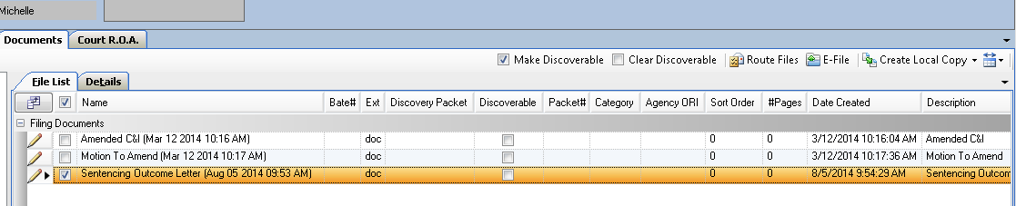

User Task List Enhancements

Description name of the Event has been added to the Next Event Date Column on the Task List.

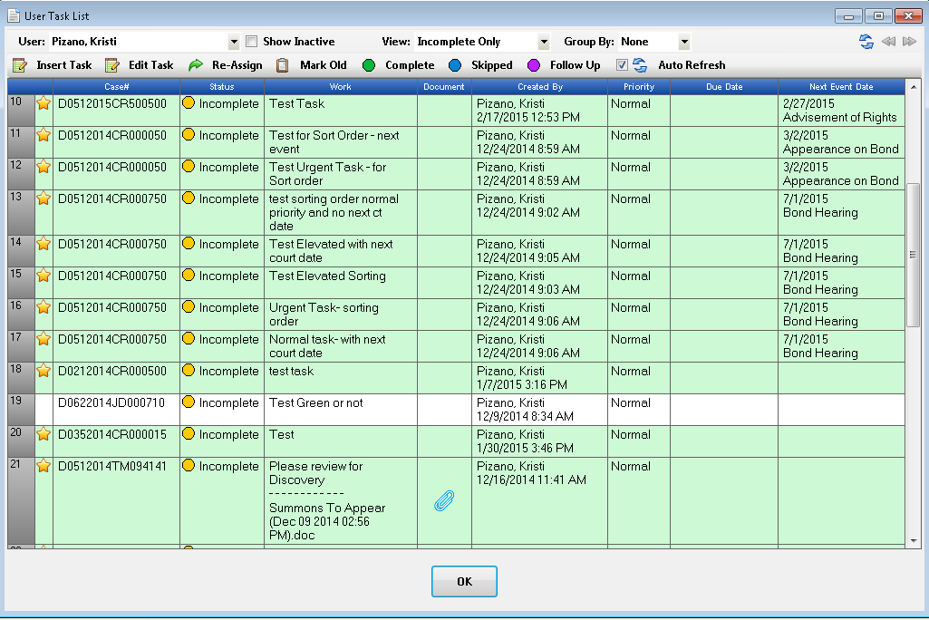

Brady Officer Notification

Brady Officer Notification Message to User

When a user enters an Officer marked on the Officer Table as being a Brady Officer, this pop up message will display to the user to remind them they have just entered a Brandy Officer. Click Ok or Hit the Red X to close the message.

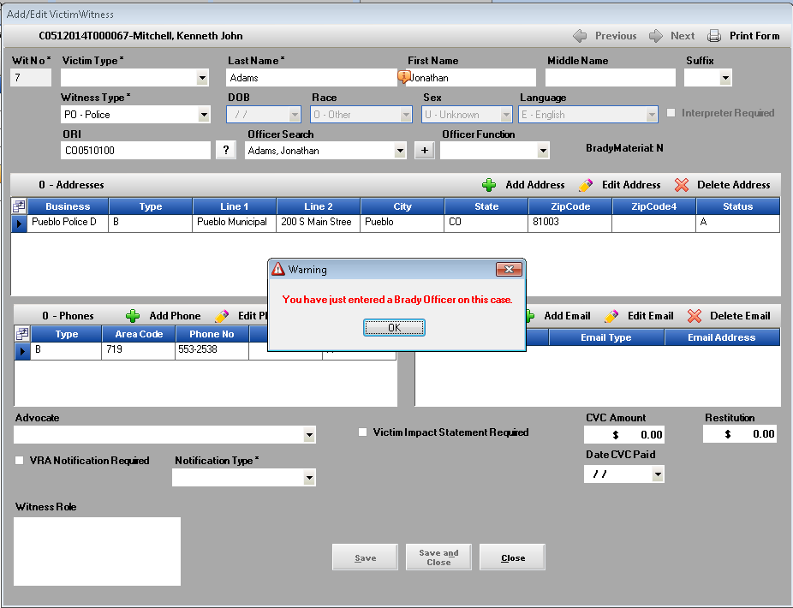On the VW tab there is also the column that indicates for quick reference for Brady Officers as well that are on your case.

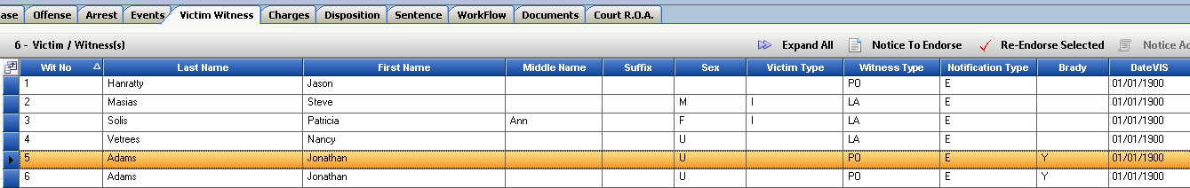

Charges Tab Enhancements

On the Charges Tab we now have the functionality to edit the Offense Date Range that was originally entered on the Offense Tab.

After an offense has been set up originally on the Offense Tab as the dates are part of a validation check with Offense number, and or Summons number; users can now change these date ranges from the Charging Tab to expand a range for Habitual Counts for Example.

Validation rules are as follows for the Charges Tab:

**If no charges exist** on the case in Case Entry Intake = these dates can be changed to any chargeable date range and will be updated on the offense tab.

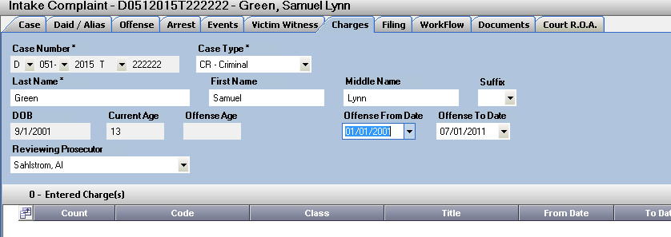

**If Charges exist** then the date range cannot be changed to a smaller range than the greatest date on the existing charge(s). Users would need to Edit the Charges and then change the Date Range. Message is displayed to the user explaining why the range is not valid.

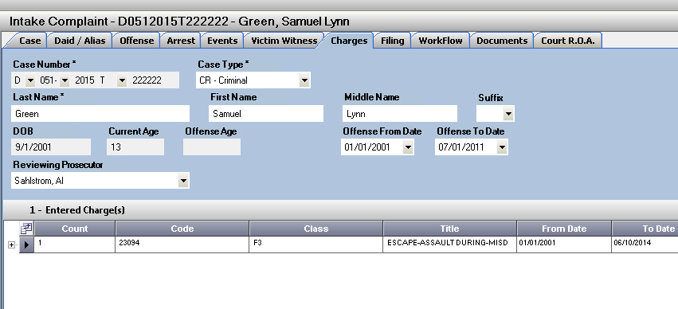

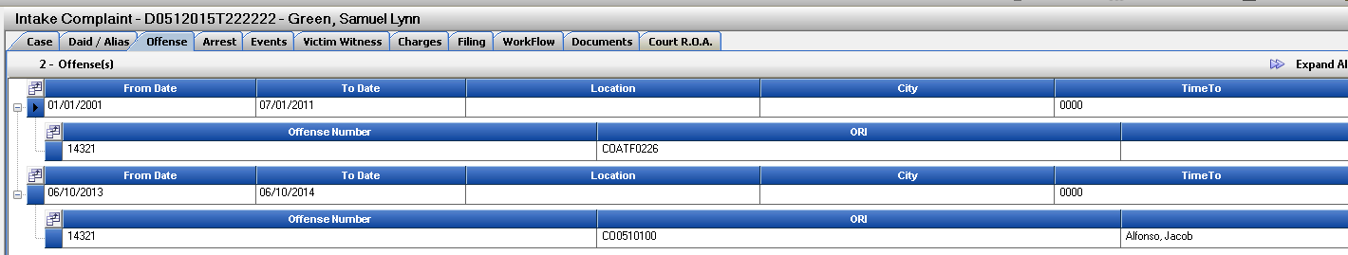**If Multiple Offenses** have been entered on the Offense Tab- with different date ranges- this cannot be edited here on the Charging Tab. A message is displayed to the user to edit from the Offense Tab Directly as the Range Displayed on the Charges Tab is the Min and Max for all Offenses entered on a case.

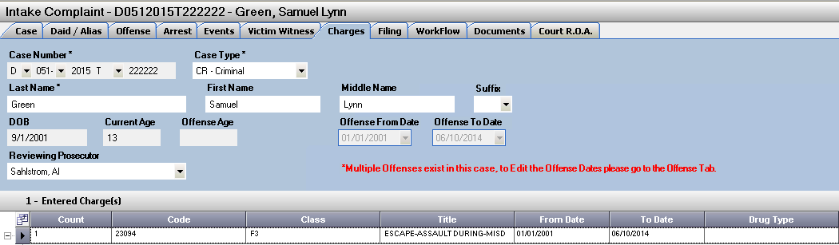

**Age Validation** as current in the offense Tab is still displayed if a range is selected that no longer supports the AD/JV Adult vs. Juvenile Selection for the Case Record.

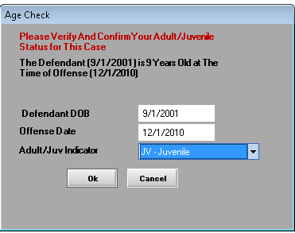

**Charge Text Language Display** on the charges tab you will now be able to click on the + button appearing in front of all charges to view the current charging language.

Hover your mouse over the expanded text to display full text. Users can also as always view the entire charge text by highlighting the charge and clicking on Edit.

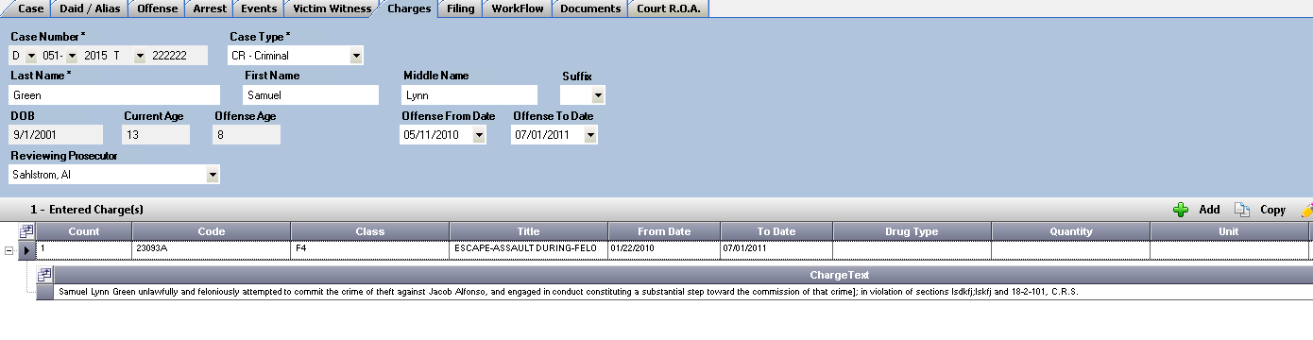

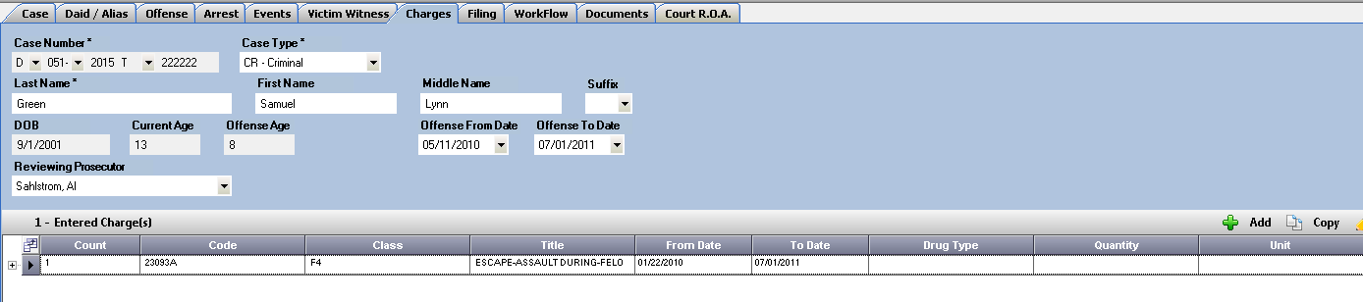

Prosecutor Docket Enhancement

**The Subpoena Request Form** has been added as a Right Click Option from Prosecutor Dockets.

Open an Existing Docket- Right click and select Subpoena Request Form from one or multiple highlighted cases.

The Forms will open in Word that then can be printed.

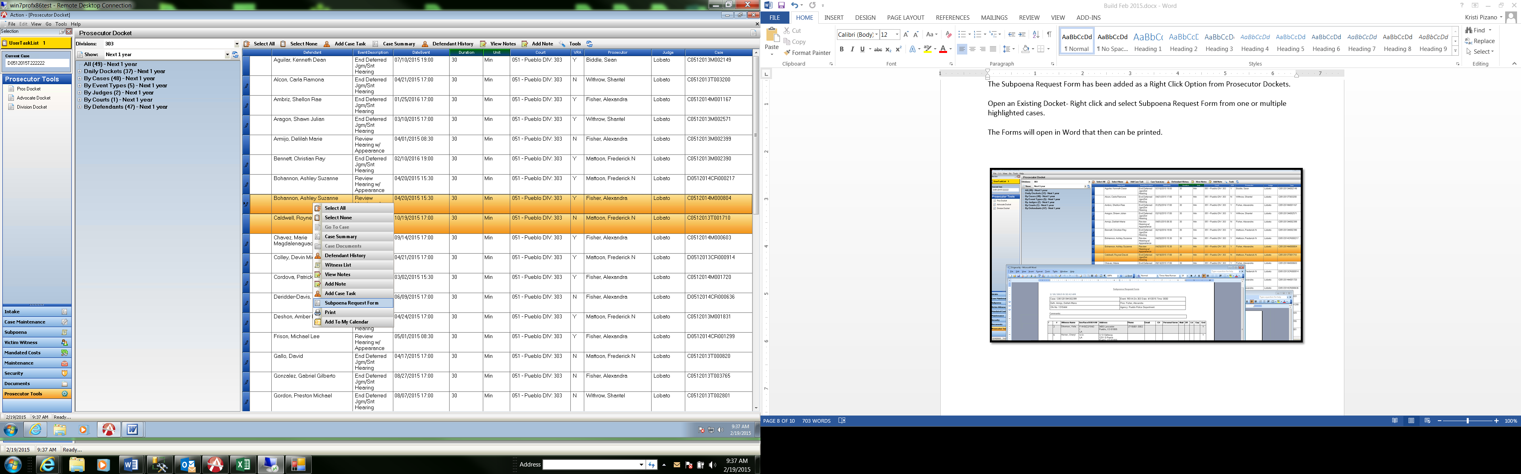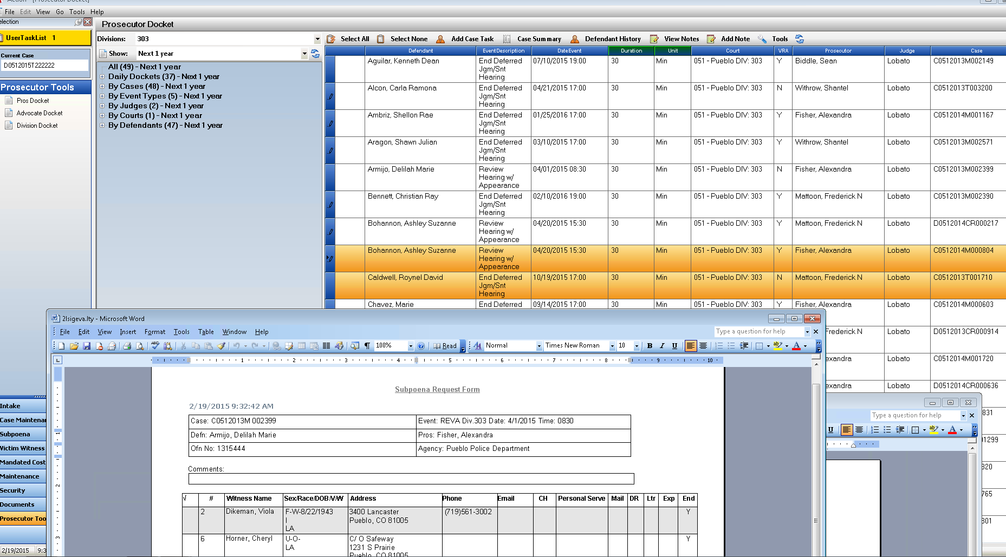

Display in Case Maintenance

The following fields are now displayed in Case Maintenance at the top of the form, so no matter which Tab you are in on your case record you will now be able to see needed information from the Case Tab.

**Case Prosecutor and Division have been added to the display, note the re-arranging of fields to better accommodate the fields displayed.**

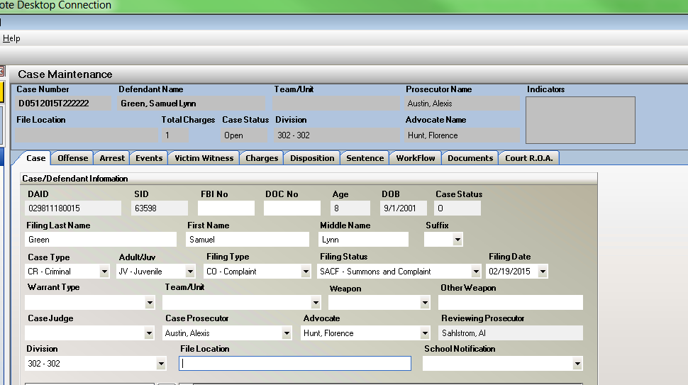

Filing Cabinet Enhancements

Allow Dragging of a CD into Action Filing Cabinet

Action now allows dragging a CD into the tree view of Action Filing Cabinet.

Users can now Cancel import while they are being scanned or coping the files. If you do cancel it will stop but leave any transferred files.

Re-Optimized the Update/Display/Selection of the items after Scanning.

Re-Optimized the Delete function (if enabled per user) for quicker deletion of files.

Discovery Receipt message display

A message has been added to the File Cabinet when a user tries to attempt to generate a Discovery receipt on a Discovery Packet that does not have any uploaded files indicating to the user that it will be a blank receipt.

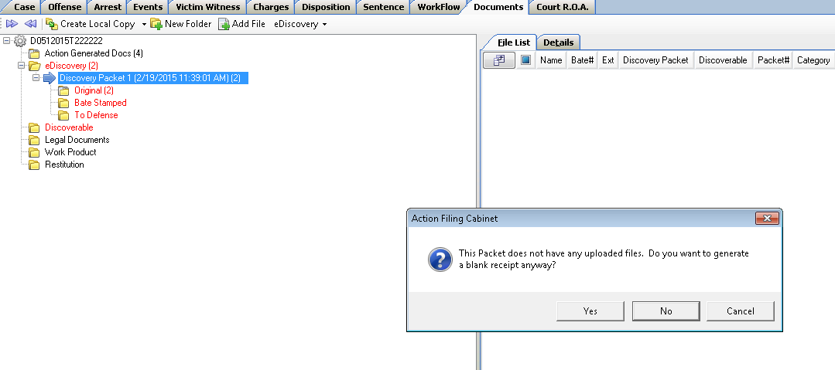

Disable the Category dropdown in the Filing Cabinet

We have disabled the category dropdown in the file cabinet, until we have more functionality related to these categories and tied into the new version of Action Scan.

Improve Filing Cabinet Import Codes

Provided users ability to cancel with dragging in multiple files or directories like from a thumb drive or phone, CD or DVD. If the file size is too large you now have the ability to cancel the import for example if there was an accidental drag on the C-drive.

Bug Fixes

**Offense Tab- Intake**

View of the Offense Number/Summons | ORI | Officer Name are now displayed as in Case Maintenance when Offense is Expanded.

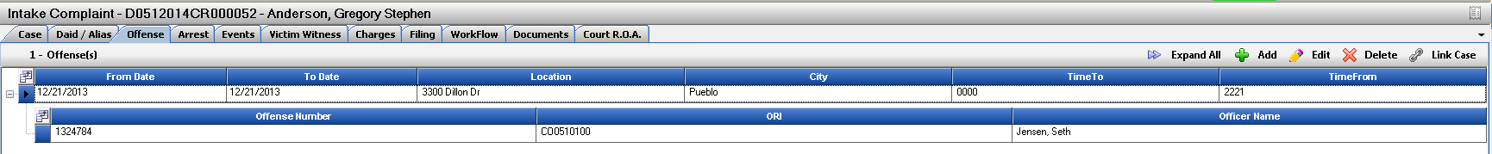

**Disposition Tab- Case Maintenance**

We have hidden the “Reject” button from the CJIS Dispositions Section- as this button had no functionality behind it. CJIS Dispositions are displayed and then user decided if they want to accept them or if they do not want them applied then manual entry on each charge is necessary.

