ACTION ENHANCEMENT GUIDE

August 2015 Release Training Guide



August 23, 2015

CDAC

CDACweb.com

Traffic Case Entry

New functionality added to Action for Traffic Case Entry either through Traffic case forms or Case Entry forms.

Always start your Traffic Cases from Traffic Case Entry in Action remember the correct format for ALL traffic cases is starting with a C and a case class of T example: C512014T002889.

Initiating Traffic Event screen

1. Search for your case to see if Judicial has already entered the record for you to attach to with one of the search options.
2. If the case exists you now have the option to start the case is the Traffic Case Entry forms or from the Standard Case Entry forms (where you have the additional fields and option to generate a complaint on the filing tab.)

As a reminder when Traffic (T) cases are set up in action there is no data transfer to the court. Your court clerks always enter these cases manually.

*Note in E-Filing Districts the court clerks need to create the T cases in their system and then would be able to open your filed documents from JPOD afterwards.

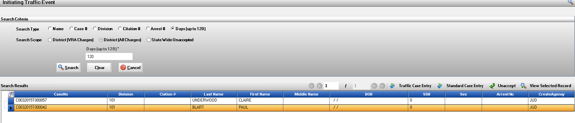

1. Conduct standard DAID search to match your case to an existing DAID within Action. If duplicates exist and all cases associated are within your district an in house Power User can merge these. If the duplicate DAID records have cases from multiple districts please send the DAID numbers to be merged to [Kristi@cdac.state.co.us](mailto:Kristi@cdac.state.co.us) these will be merged to associate all of a defendants cases under one record throughout the state.

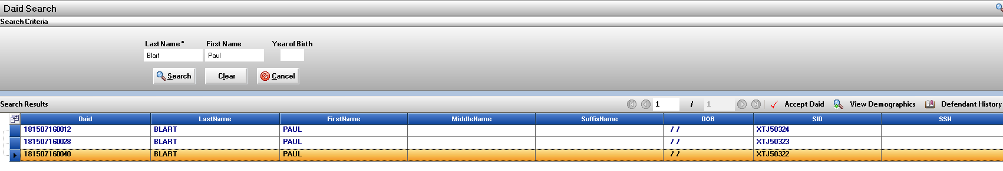

1. If Standard Case Entry form was selected your case will open in these forms for your completion of data entry.

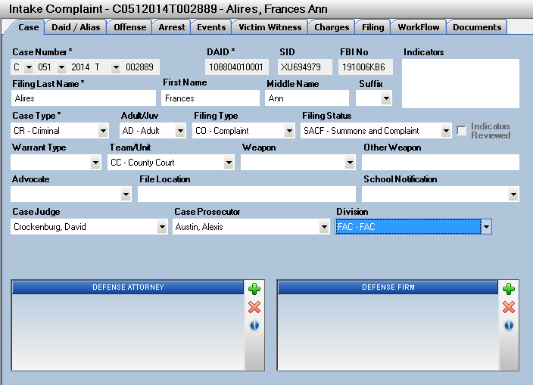

1. 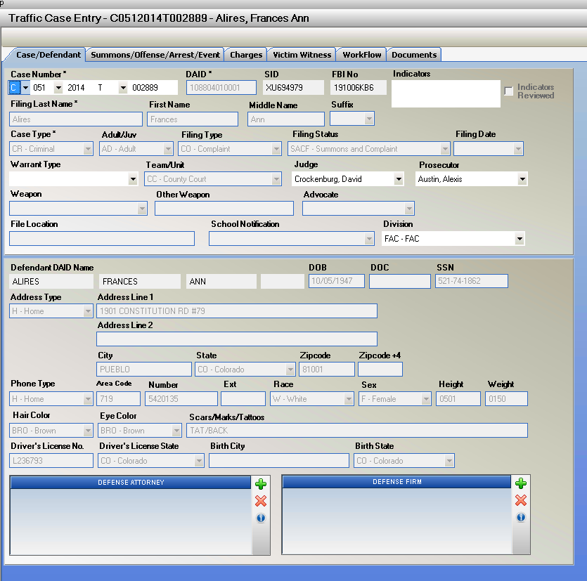If Traffic Case Entry from was select your case will open in these forms for your completion of data entry.
2. At any time while your case is pending in Intake you can select to have your case changed back and forth between these sets of forms depending on your needs.

Under Case Tool selection located in the upper right hand corner.

Dependant on the current forms your case is in this option will say either Standard Case Entry or Traffic Case Entry to let you change. Charge, VW entries ect. are retained on either set of forms your case is in.

*Note if your Traffic (T) case was entered with a D court type these buttons will NOT change the forms the case must be entered with the C court type to function between these form changes.

Select Traffic Case Entry and your data will be converted to the Traffic forms.

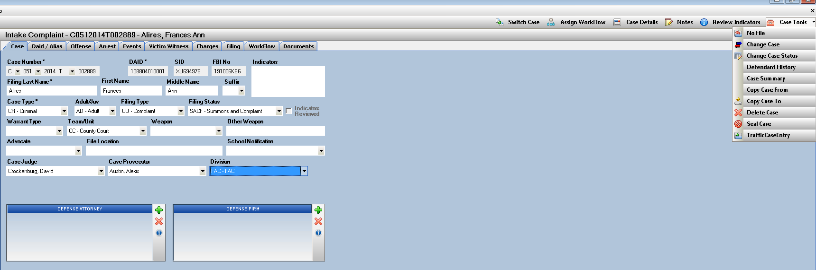

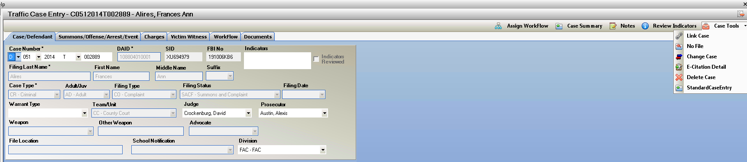Select Standard Case Entry and your data will be converted to the Standard Case forms.

E-Filing Enhancements

1. Enhancement to process of e-filing; auto removal of special characters in the Defendant Name field when this data is transferred to Judicial so that your e-filing package will not fail.

If needed users can enter special characters that previously would cause an e-filing submission to fail validation. These characters can now be left in Action and are removed from the data when submitted so that your filing will go through successfully.

Reference Standardized Name Entry Business Rules on the CDACweb.com site as a reminder for general entries and abbreviations.

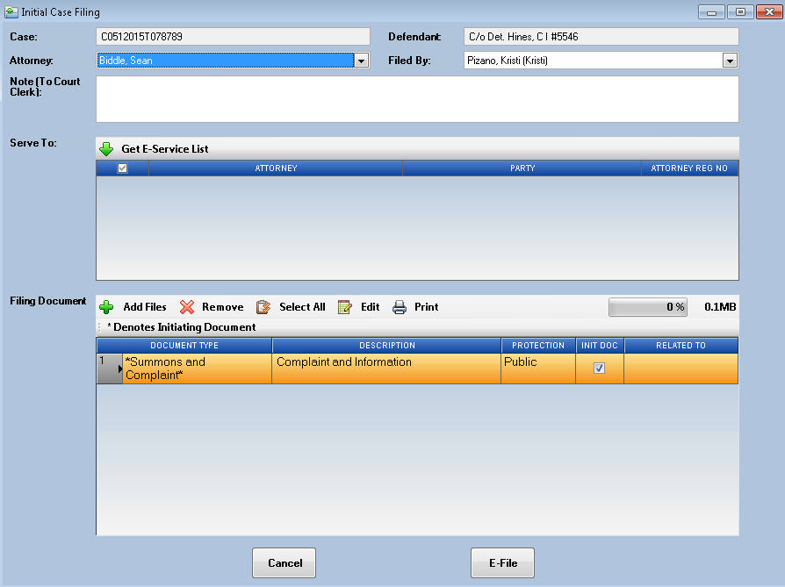

Noting in Action

Highlighting Within a Note.

New ICON when in noting – like in word- select text from Noting Description area and then click on the Icon and select the color of Highlighting you would like.

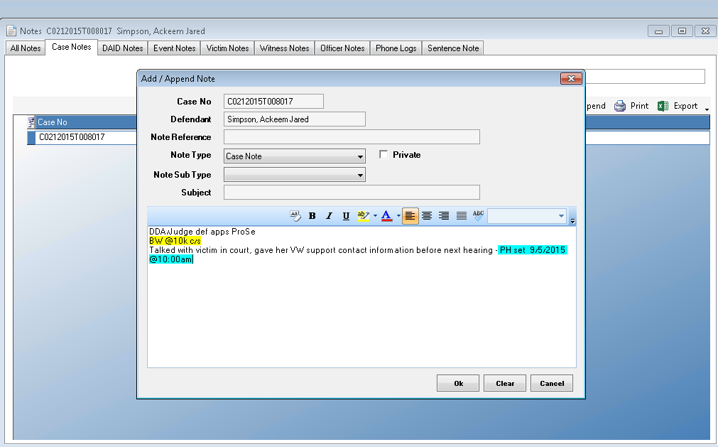

Helps noting practices within your office to have a test within a note stand out.

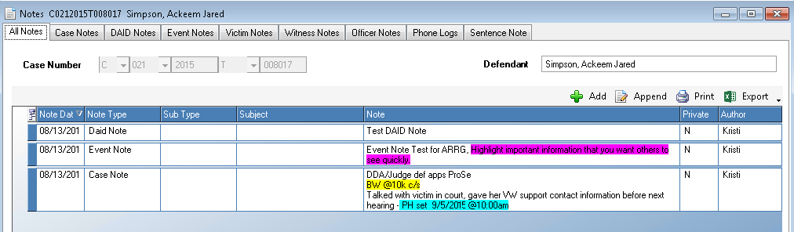

Charge Search in Action

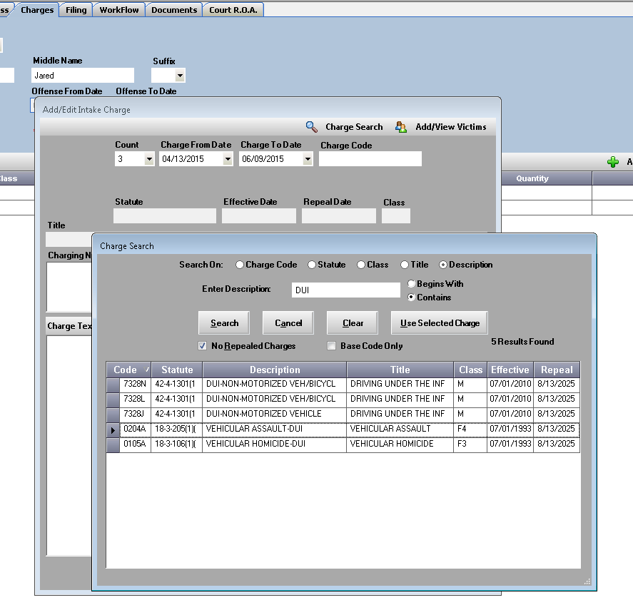From the Charges Tab in Traffic Case Entry, Case Entry or Case Maintenance, when adding charges you now have a new a search option in Charge Search of Description. From the law table now you can select to conduct your search with the Description entered or the Title, giving users more flexibility to conduct quicker search functions.

Action File Cabinet Enhancements

**Discovery Packet Fee Selection**

When creating a Discovery Packet, the listing of files with a total size amount is displayed to the user. Large files will appear in Green Text to help users identify large volume discovery if this changes the pricing model within your office. The Packet Fee Selection has been moved from Create Packet to the Upload process so that after Discovery has been created into a Packet and Bate stamped then a value for pricing can be applied before uploading the cost to the defense attorney.

Create Discovery- shows the filenames and Total File Sizes of documents marked as Discoverable for this packet.

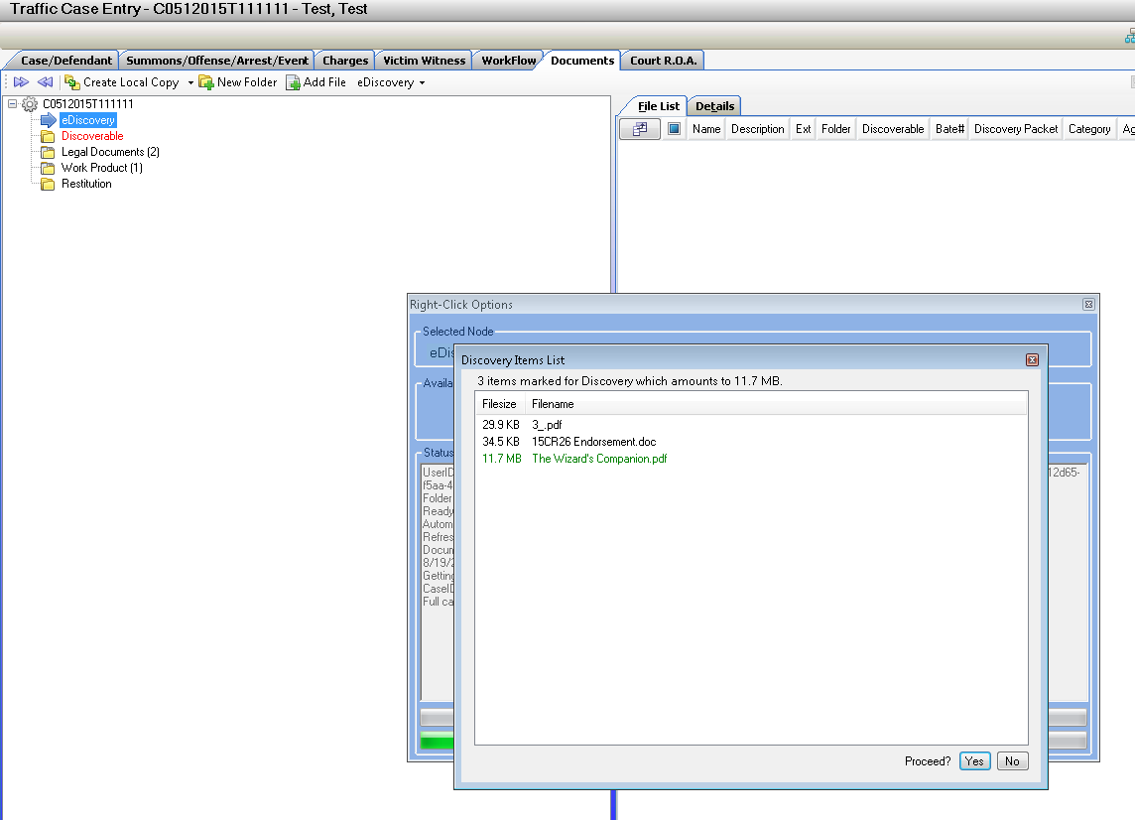

Upload- now shows and lets the user select the appropriate Packet Fee and option to Over-ride the standard amount with the selection of Packet Fee Override. The files are listed file size, the Bate Stamp # range and a Total size of the packet.

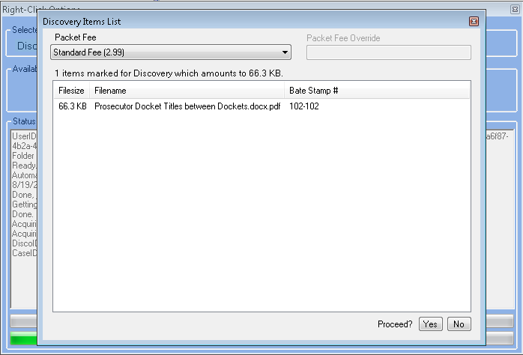

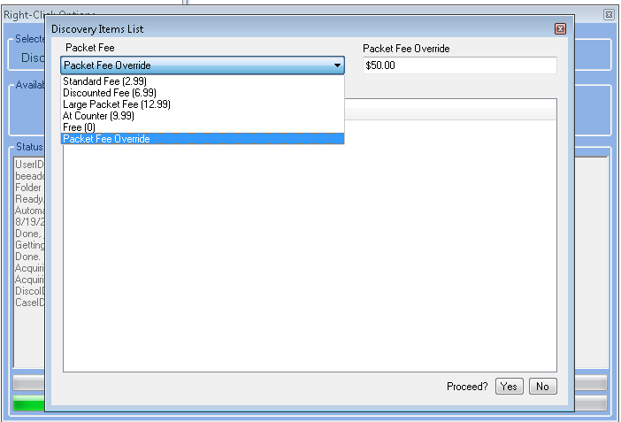

**Bate Stamping your Discovery Packet**

Fixed Bate Stamping on small page size images (PDF) to ensure that the entire Bate Stamp and case number is displayed correctly at the bottom of the pages. Example:

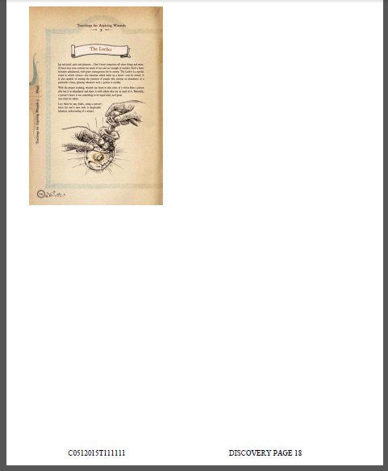

Bug Corrections and Miscellaneous

**Switch Case Button**

This Button had been producing error messages, we have de-bugged the search for smoother faster search results utilizing this existing feature. Please report with screenshots any further error message if encountered while using this feature.

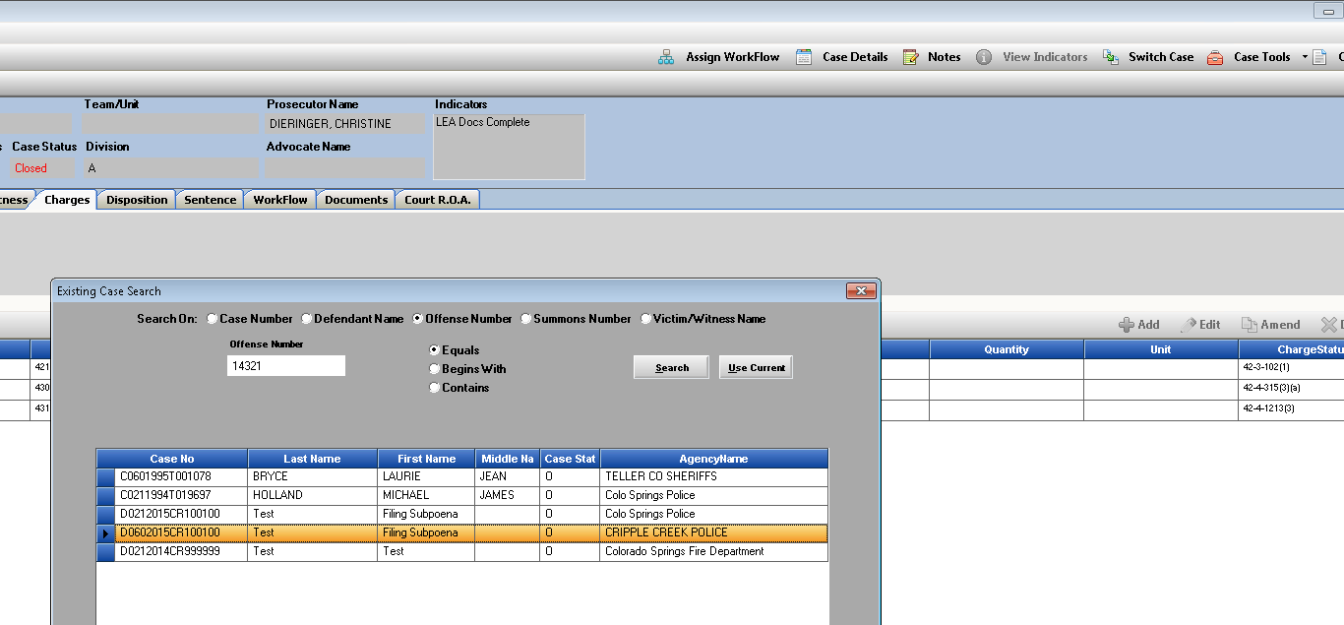

**Delete Case from Intake Pending**

Power User Function- Delete Case while pending in Case Entry or Traffic Case Entry Forms.

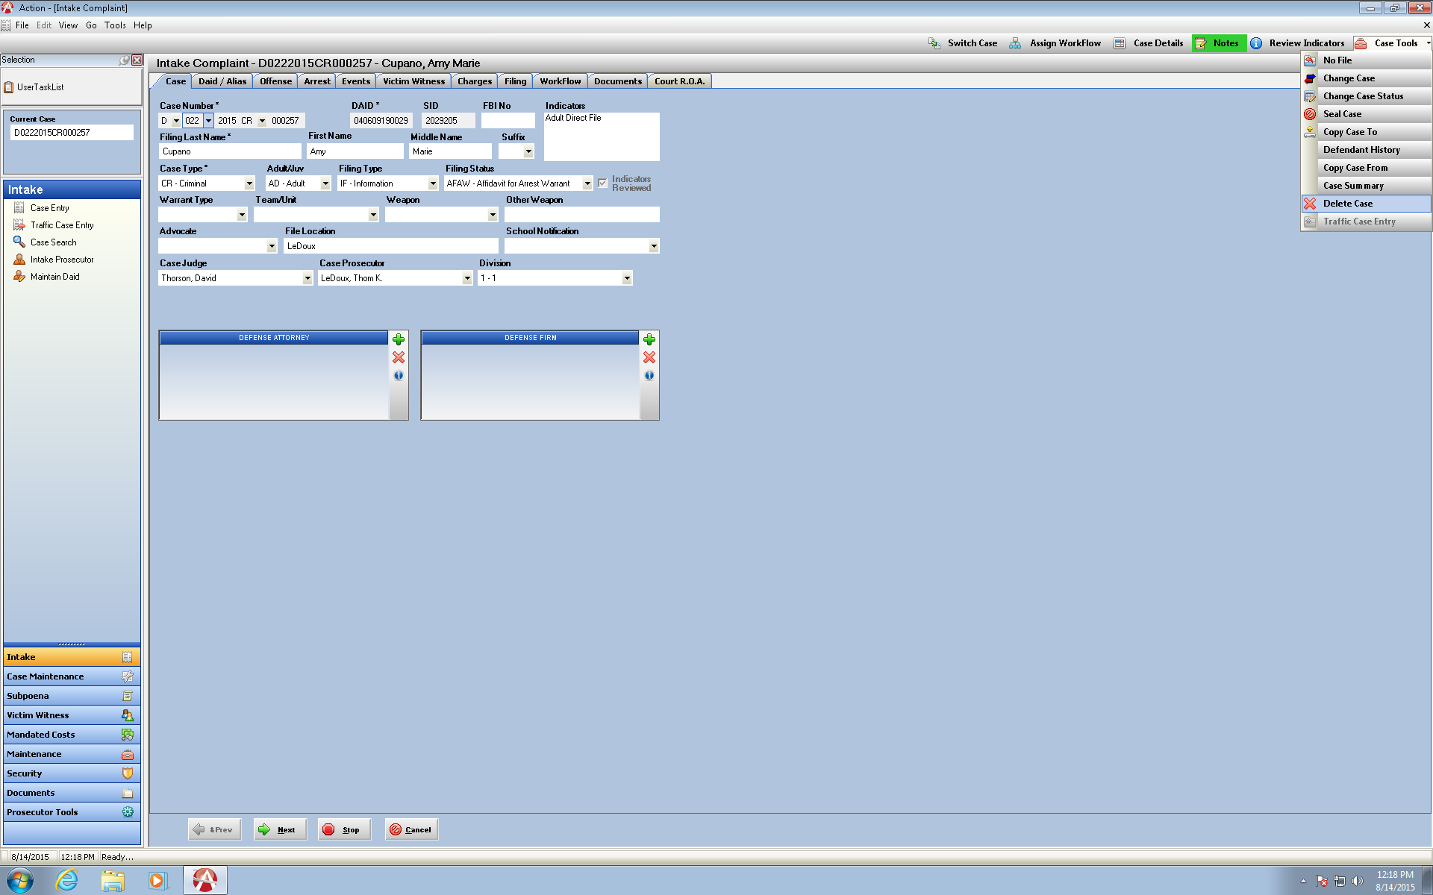Previously would not let a power user delete the case if there were Work Flow tasks, Defense Attorney assigned or Notes attached to the pending case. Updated to allow the power user full functionality to choose to delete a pending case if needed.

**Officer Listings in Table Officer**

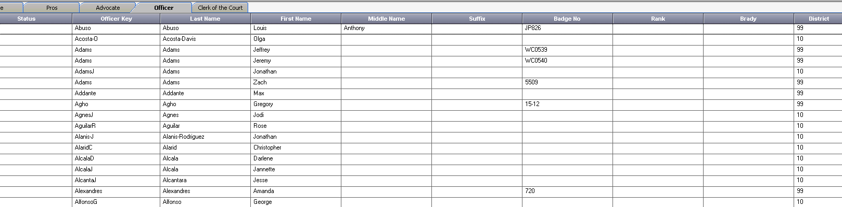Power User Function- If your District uses e-subpoenas you may have noticed some officers not appearing in this table accessible by power users in your district. This has been corrected so when an LEA enters an officer through the website they will appear correctly in this maintenance table to allow a power user to edit the record for example if you need to note Brady Officer.

**Label Corrections on Prosecutor Tools**

When you now click on Prosecutor Tools and select one of the 3 docket choices the titles of the selected docket will appear correctly- previously retained the name of Prosecutor Docket on all 3.

Prosecutor Docket

Advocate Docket

Division Docket

