ACTION ENHANCEMENT GUIDE

April 2015 Release Training Guide



April 2015

CDAC

CDACweb.com

E-Filing Enhancements

E-Filing Form Enhancements

1. Legend to denote the Initiating documents with an asterisk in the dropdown list. (*)
2. INIT DOC column has now been changed to a read only column. See E-filing training doc for listing of Document Types by Case Class.
3. Document Defaults to some Action Generated Documents updated.
4. Notice to Endorse – Defaulted to Notice
5. Amended C&I CR and M cases – Defaulted to Complaint
6. Amended Petition JD cases- Defaulted to Petition
7. Serve To: Get E-Service List will now populate automatically for the users instead of loading when the button is pushed.

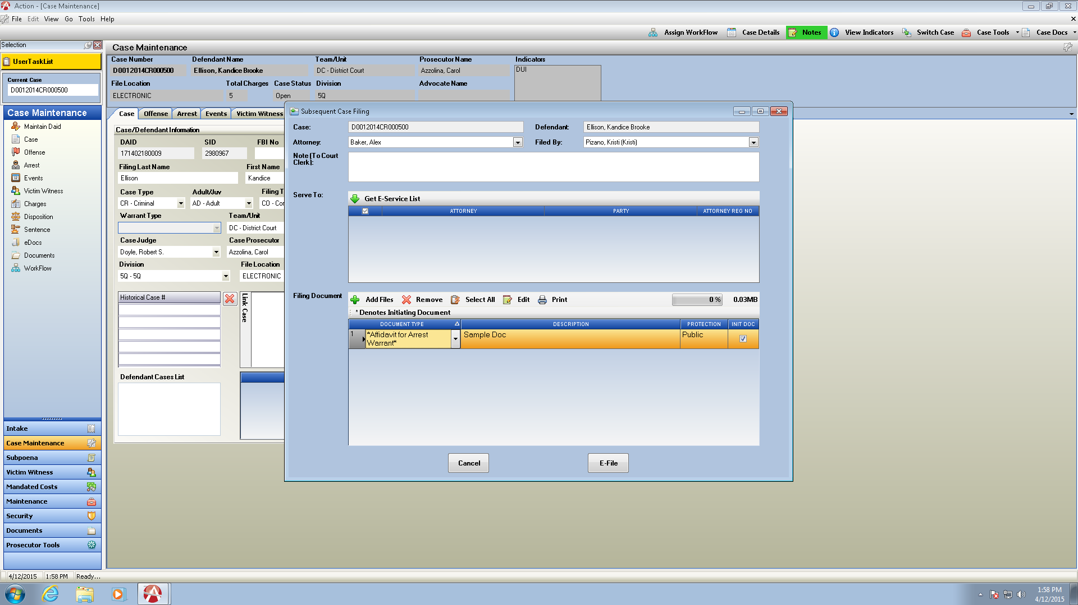

Task Work Flow Enhancements

Work Flow

Insert Work Flow Task form has been redesigned for easier user functionality and to ensure that your workflow tasks are going to the User Task List.

**WF Template Intended for** field has now been made a read only field unless requested by your district. (See notes below on Pre-defined Work Flow Templates)

**Group functionality-** groups set up for your users will now appear in the Add Assignment drop down list. (See additional notes below for group functionality)

**Status:** defaults to Not-Done read only now- this changes to Incomplete automatically when task is sent.

**Re-**named some of the fields on the form to more clear descriptions.

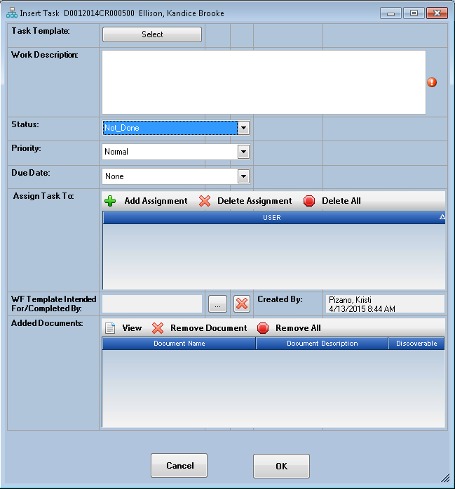

Work Flow Pre-determined Work Flow Templates- is now on a District Setting. When this setting is turned on by CDAC then the Intended For field on the Insert Task will be enabled on the Work Flow Tab in your case allowing task inserts in the Work Flow on the case. Default for Districts is turned off. If your district utilizes this feature it will be turned on.

Group functionality- Set up Groups within your Office to send a Task To under Add Assignment-

By selecting a Group all members linked to that Group Name will receive the task, the first user to set the status to complete will then automatically remove the task from the other Group Members User Task Lists so the task is not completed in duplicate. The completed tasks are retained on the case WF Tab in Action and is retained as record attached to the case.

Contact [Kristi@cdac.state.co.us](mailto:Kristi@cdac.state.co.us) to set up your Group Work Flow Assignments.

List Group Name, and Members in the Group- Currently functionality is a one to one relationship between a user and WF group.

After a group has been created by CDAC, it will display in the Add Assignment Listing. When a Group has been selected the individuals names of those associated to that group are then displayed in the Assign Task To. This allows the task creator the chance to see who will be receiving this task for any follow up purposes and no confusion as to whom the task was sent to.

For Example:

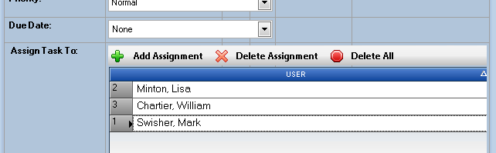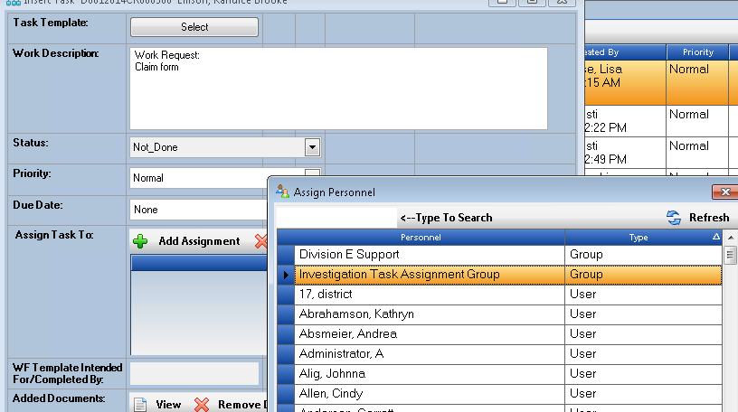

Routing Files from the Action File Cabinet to Tasks

If your district is set up with the action file cabinet you can route files from the case attached to the task.

Open the Documents Tab- select a single file or multiple files holding CTRL and Highlighting files from your file structure then click on the Route Files Button.

This brings up your Insert Task Template with all of the selected files into the Added Documents at the bottom of the Insert Task Window.

This shows the Document Name, Document Description and Discoverable column associated to the attached file. Document Names attached to the task are then automatically displayed in the work description on the task so that you can easily refer to the attached files in your task.

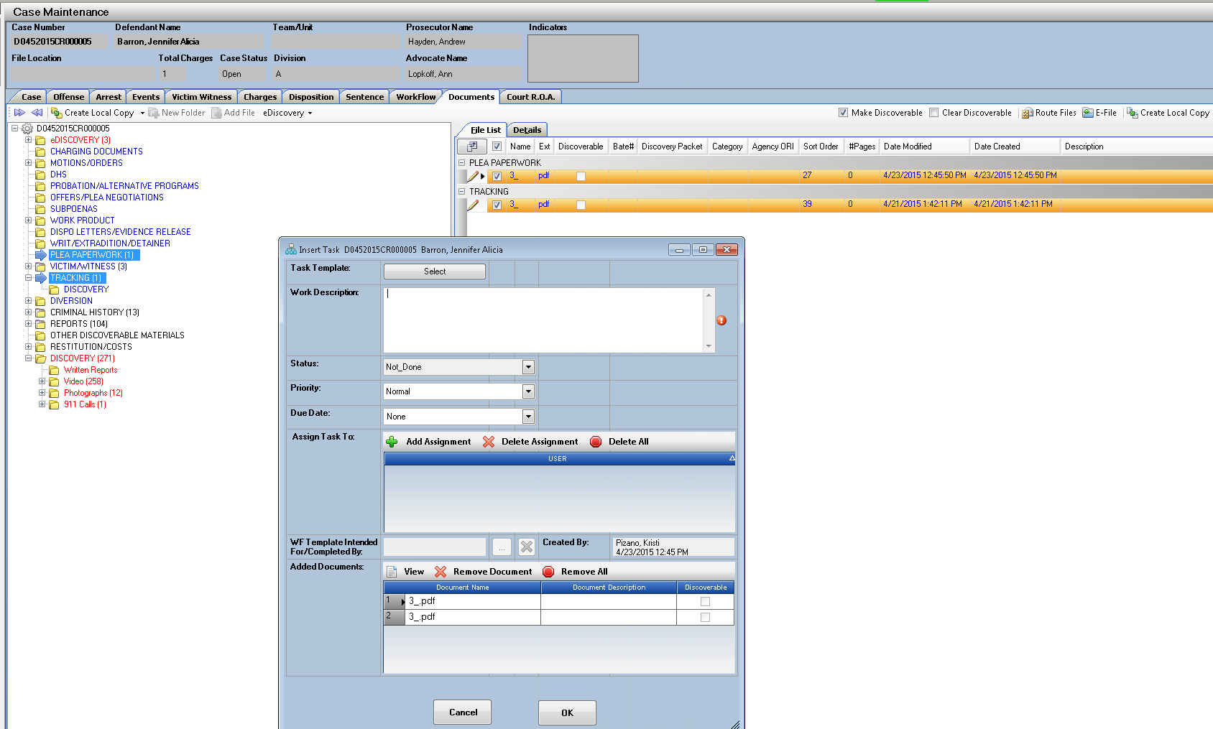



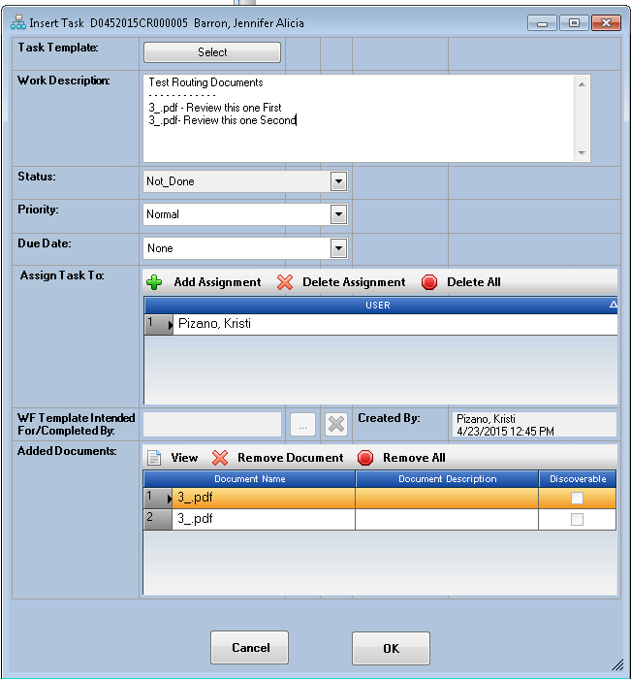

When you receive this task in your User Task List you will see the Paperclip Icon in the Documents Column indicating a document is attached for your review, again with the document names showing in the Work Description for quick reference.

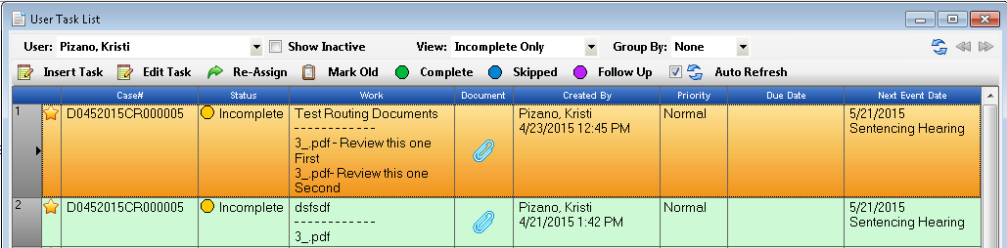

From the User Task List you can double click the task to open, or highlight and click on the Edit Task button. You have several option now how to handle this task.

1. Change the Status of the Task – When sent it defaults to Incomplete automatically.
   1. Change to Follow-up Changes the view removing from the Incomplete Task view.
   2. Change to Completed Removes Task from the User(s) task lists.
   3. Change to Skipped Removes the Assigned to User(s) but task is saved on WF Tab.
   4. Change to Not_Done Removes the Assigned to User(s) but task is saved on WF Tab.
   5. Leave as Incomplete Retains task on the User(s) task lists.
2. Add another user to this task- Keep currently assigned user plus additional.
   1. In the Assign Task To field when you open your task select another user or group to also send this task to- when the task is marked as completed then it will be remove from all users tasks lists it was assigned to.

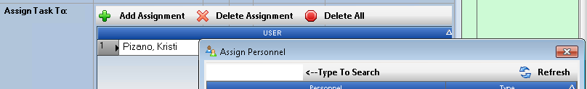

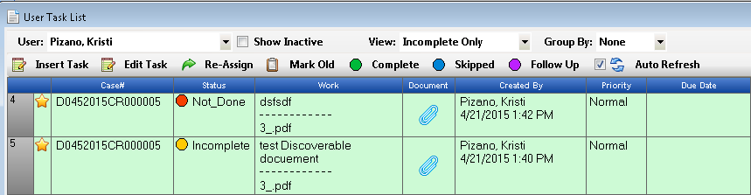

1. Re-Assign this task to a different user – removing all currently assigned users on the task.
   1. 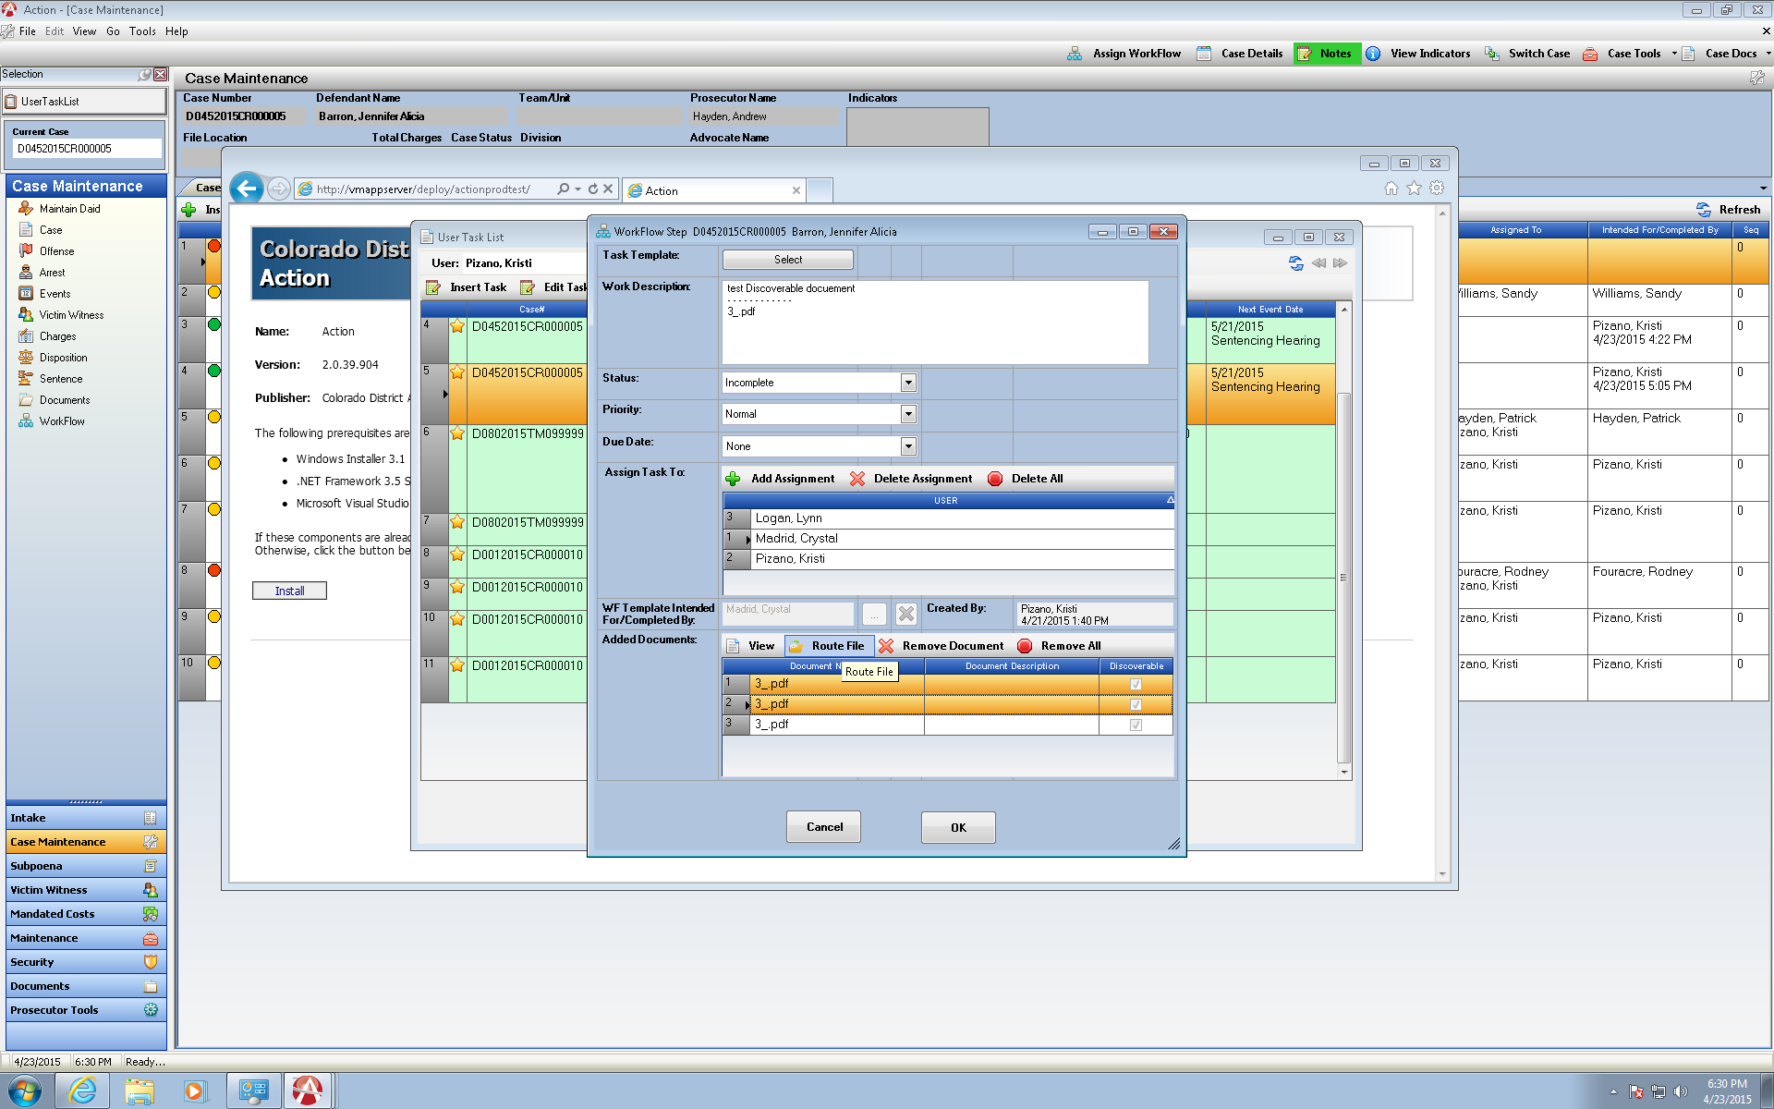Highlight your task- click on the Green Arrow Re-Assign Button the User List will appear and select only one user or one group to re-Assign to.
2. Re-Route selected documents from your Task to a new User.
   1. Highlight the documents on your task and then click on Route File. The document will be added to a new Task for you create a new task from and now route to a user or a group.

Prosecutor Tools- Division Docket

Division Docket has been updated to allow multi-selection of Divisions.

This has been updated to create a format so that multiple Divisions can be selected all at once. The Division is now a drop down Check Box that will allow the users to check which Divisions they want Displayed by the Show Criteria- current default value is to next day.

Your selected Divisions will be displayed at the top.

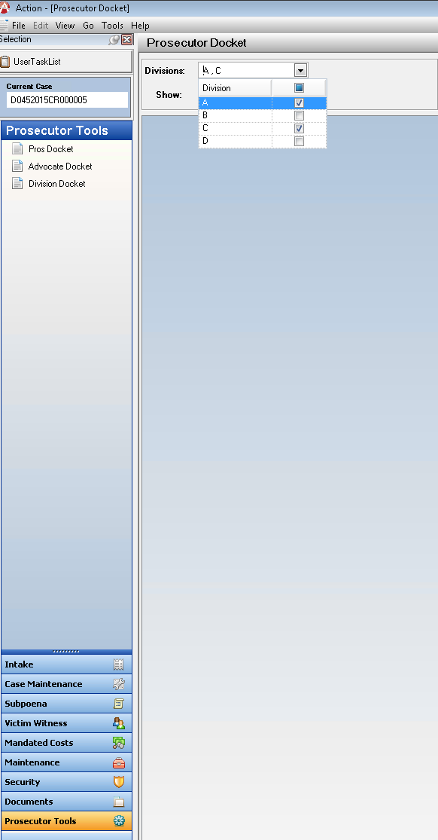Select ALL or De-Select ALL by clicking in the blue box next to the Division name.

Click on your Tab key from the drop down and your results will all display.

Remember all of the columns displayed can be sorted by clicking on the headings- the default is to sort by defendant name.

You can also select the view by cases, Event Types etc. in that time frame.

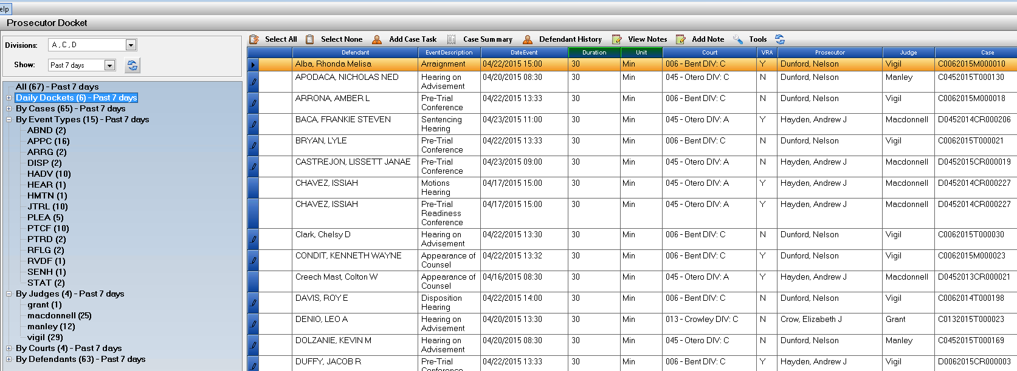

File Validator for use with the Action Filing Cabinet

A stand-alone application has been created to run against your files stored on your District Servers for validation of files saved to the Action Filing Cabinet.

If your District is interested in learning more about this please contact [Kristi@cdac.state.co.us](mailto:Kristi@cdac.state.co.us) and I can send you the specific training document and program to utilize.

Bug Corrections

Charge Code Corrections

The following Charge Codes Alt Q sequence corrections for variable selection within the charging text.

Please email [Kristi@cdac.state.co.us](mailto:Kristi@cdac.state.co.us) with other charges codes that you may notice or are reported to you that are not pulling up the variable selection correctly.

04B72

18546

8802Y

23112

06011

26121

Traffic Case Entry Date Filed

There was an existing bug with the date filed auto populating when the case was transferred from Traffic Entry into Maintenance causing issues with New Events populating into Action on your cases.

This has now been resolved.

Action Filing Cabinet

Fix for creating the E-Discovery folder automatically when a District does not have set up permanently in their folder structure.

Correction for truncating extensions to 50 characters on files saved in the cabinet.