**Action Release November 20th 2014**

**This release of Action several enhancement that you will now see in the following areas:**

* **Case Status Display**

Now located in the Case Caption will show you the current status of the case from any tab. Open, Closed, Re-Opened, Sealed

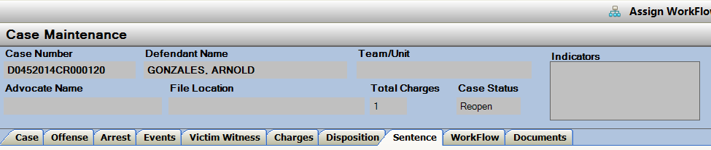

* **Offense Screen**

Officer Name has been added to the expanded view of the Offense Record(s).

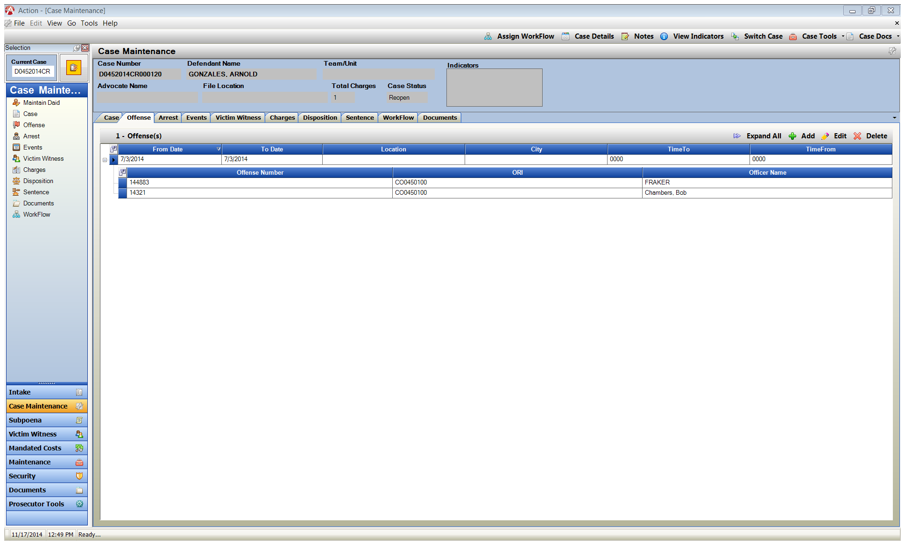Resolution corrections so that windows and selections are viewable.

* **User Task List**

Name of Documents Attached to a task are now displayed from the user task list and within the task.

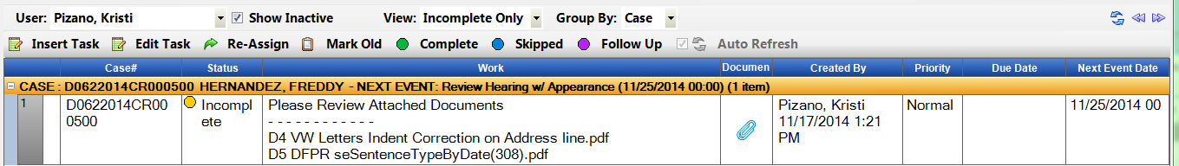

Insert Task has been added to the User Task List so that you can select from any case displayed on your list and add a task quickly without re-opening that case and creating a new task from workflow tab.

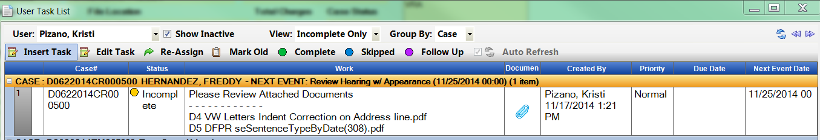

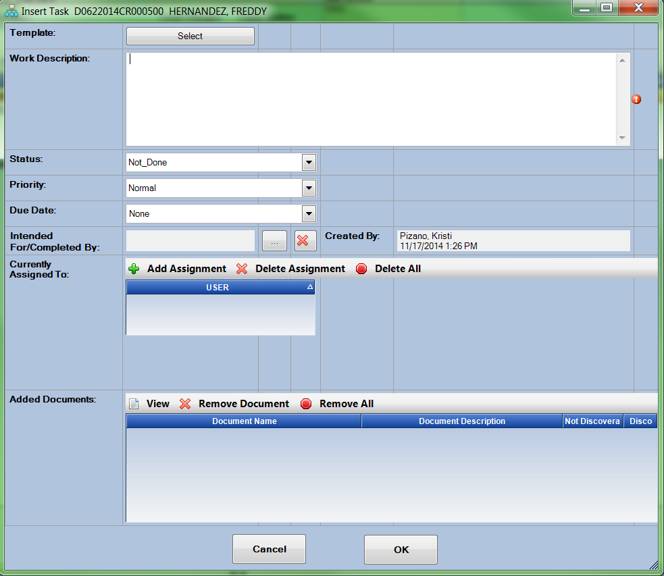

Renamed Insert Window to Insert Task

* **Workflow**

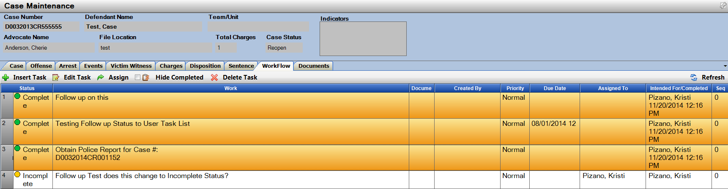Completed by Date and Time have been added to the task and displayed on the Workflow when a user set the status to Completed.

* **Noting**

Noting error corrected- when you had an open Note click between tabs, close and try to re-open Notes from case case- users where receiving an error message. This has been corrected.

Case Notes have been enhanced to default to an expanded view in Noting.

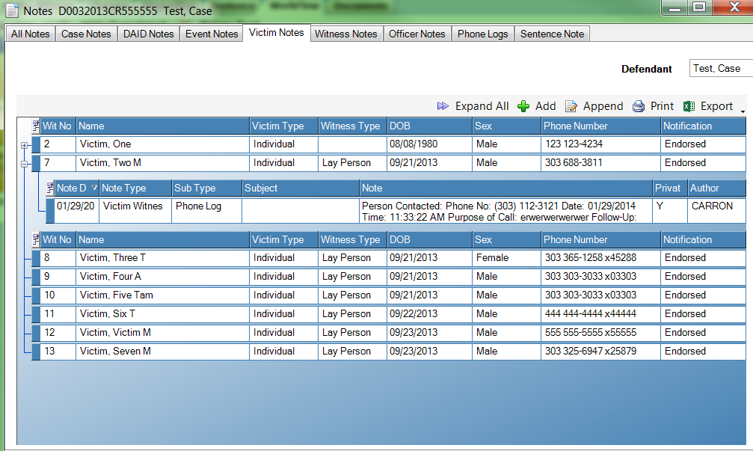Fuctionality Added to Display a (+) next to the records in Notes where a note actually is attached.

* **Prosecutor Tools**

Add Note Function will now be minimized behind the Action Icon congruent with other open windows in Action.

Multi-Select Add Note functionality now exists from your dockets. Highlight several of your cases and click on ADD NOTE, new multi-select windown is brought up so you can add the same Note to several cases at once.

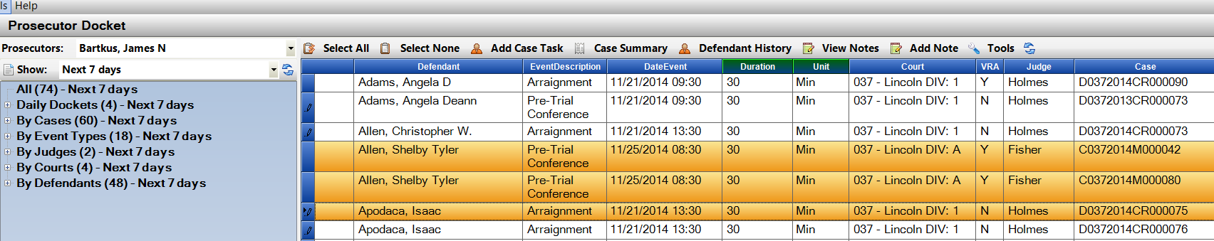

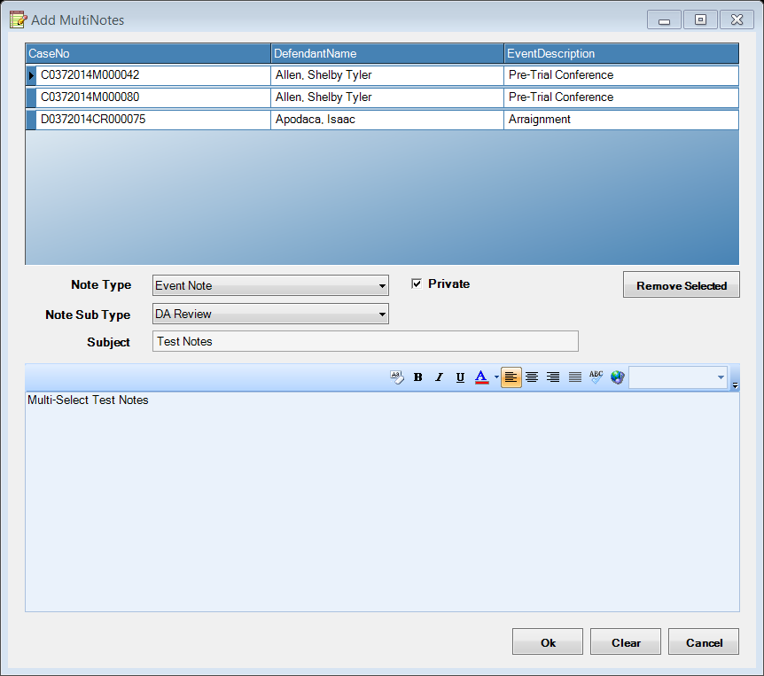

* **Defense Attorney Maintenance**

Power Users functionality added to view Active and Inactive Defense Attorney’s from the Maintenance Screen.

Correct Bug to that Power Users can Edit an existing record for Address etc, but the Reg # is read only.

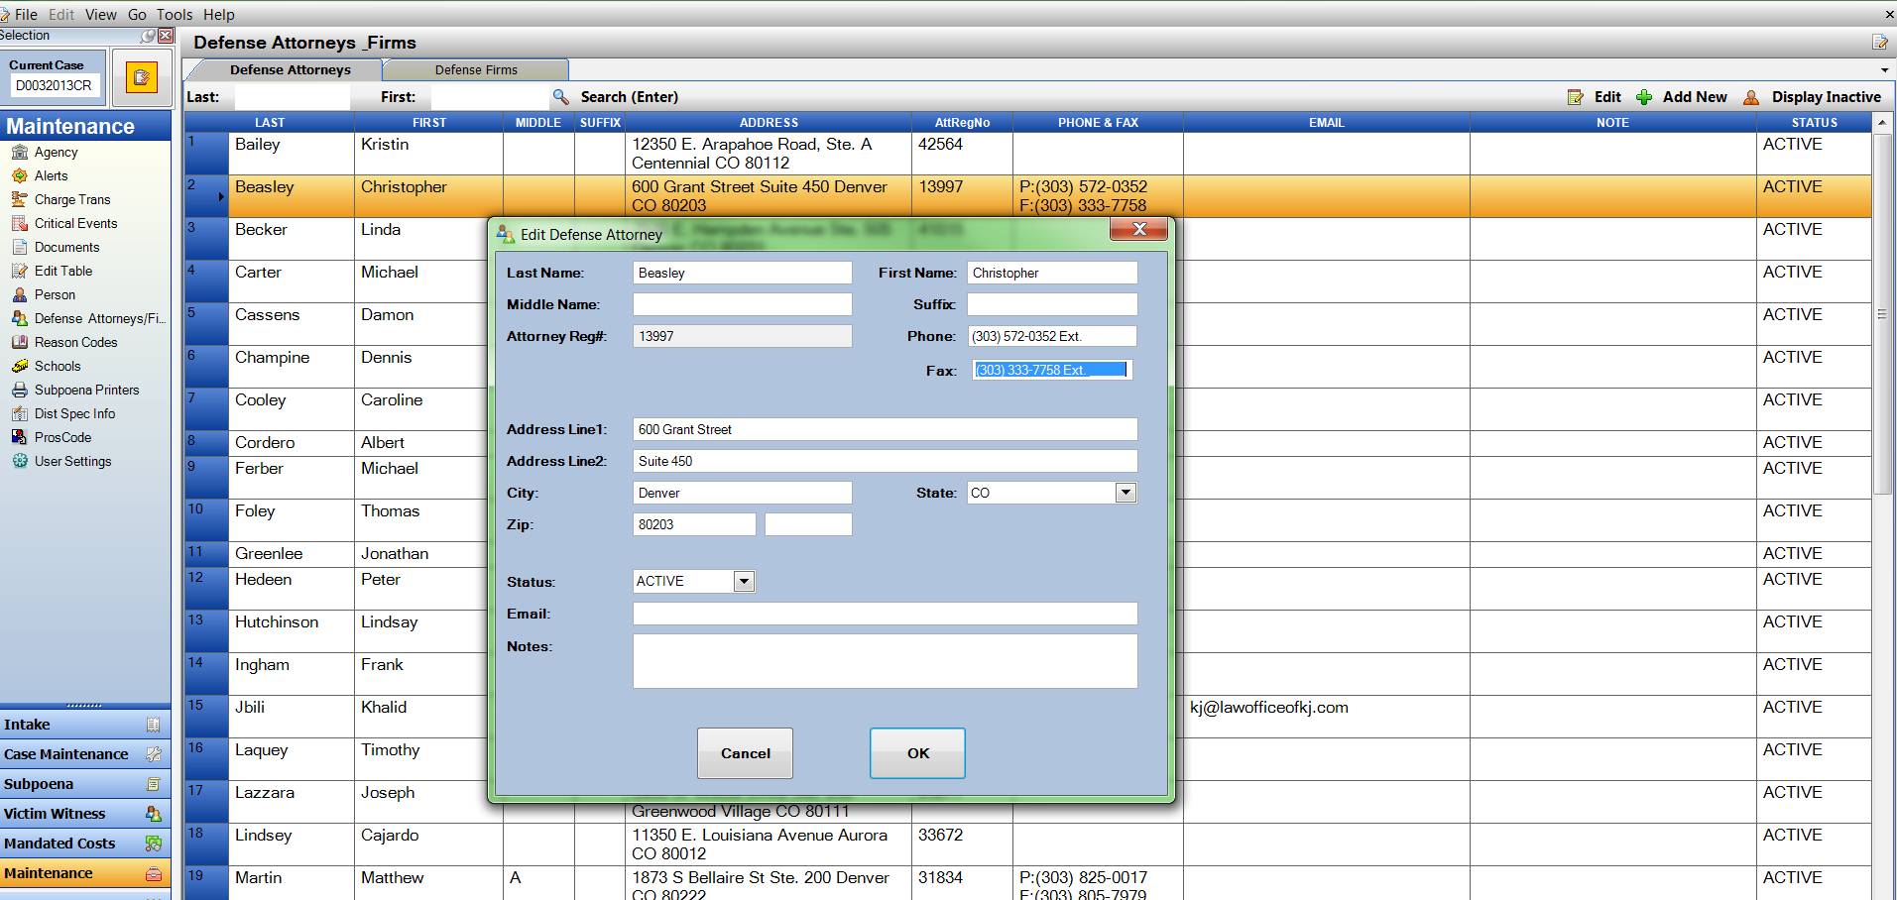

* **Documents (Filing Cabinet)**

Functionality has been added to the Filing Cabinet to E-File Documents to Judicial from.

Select your File from the cabinet and hit – E-File button

This will bring up the Case Filing Form and let the user complete the E-filing Process.

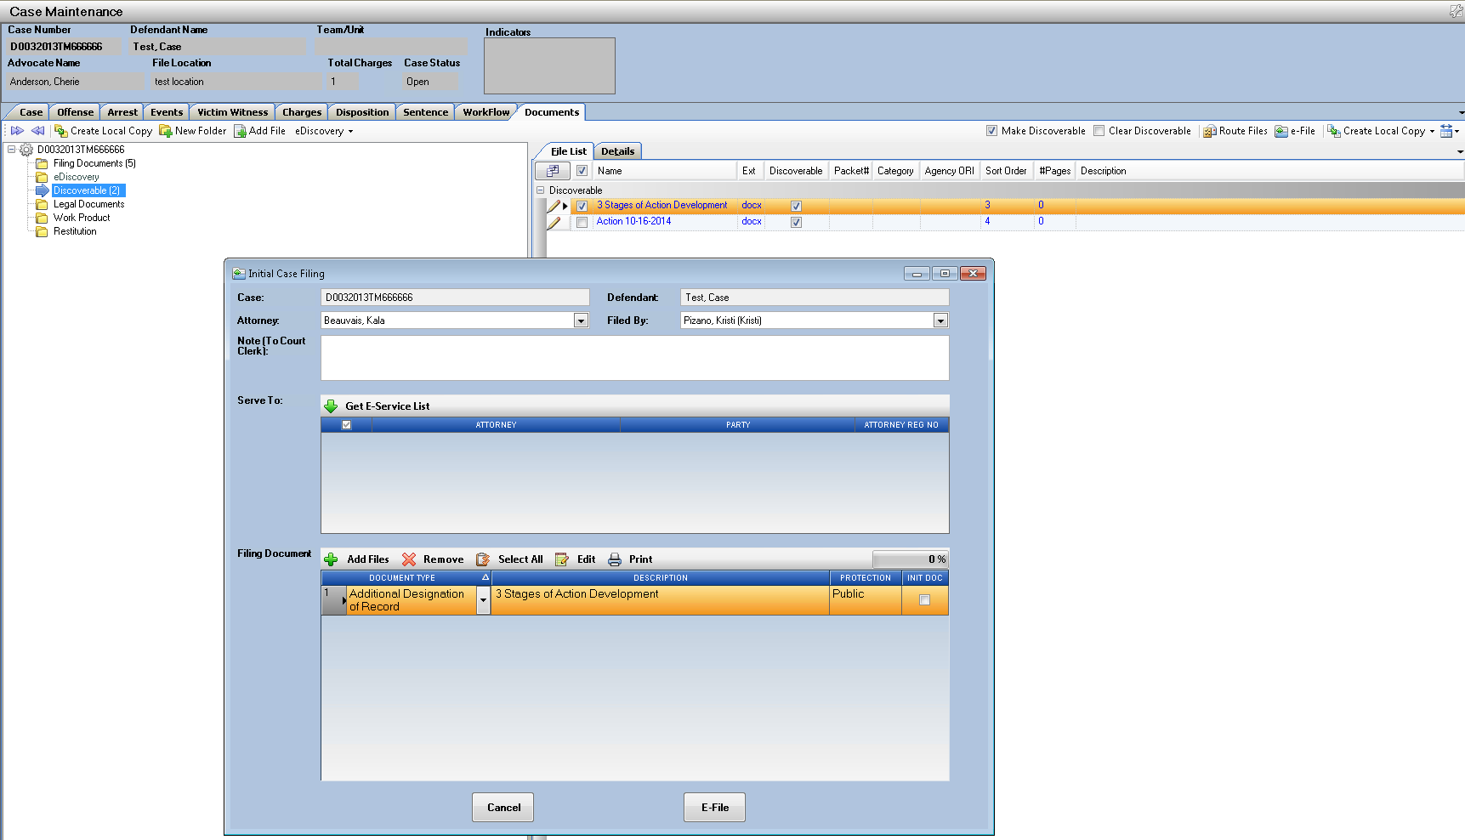

Sort order of files within the Cabinet is now updating/ changing when folders Files are moved to a different order with in the cabinet.

Packet # Added as a Column Option for Users to Indentify files that have been produced in a Discovery Packet and refernce to which Packet.

Enhancement to Create Local Copy options- Users can select multipe or single Local Copy Options.

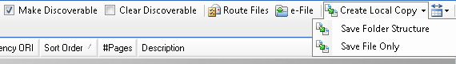

* **Bug Fixes**

1. DOB calculation of Age at Offense and Current Age has been corrected.
2. Fix Sort Order on WorkFlow Intended for dropdown list.