Action Enhancement Guide

May 2022 Training Guide



Training Materials can be found on our website on the Action Page

DA Office User Website: <https://coloradoda.org>

Action Questions Contact: [Support@cdac.state.co.us](mailto:Support@cdac.state.co.us)



Table of Contents

1. Short-cuts to URL links to other applications updated in Action. ..……….. 3
2. Action: User Accounts linking as Investigators and Diversion Counselor.. 4-5

1. Action: New Juvenile Diversion Case Types ………………………………..………… 6-7
2. Action: Juvenile Diversion Sending Files to Diversion System ……………………… 8-10
3. Bug Fixes: …………………….……………………………………………………………………………………………… 11
   1. Fix on use of # Next TM number shortcut
   2. Fix for AG’s office updating Controlling District to others for Special Pros.
   3. Fix for starting a case # from case entry- that already exists within Action.

Short-cut URL links from Action updated

Action has updated the short-cut links to other applications so they can be accessed directly from Action.

After logging into Action- go to Tools- dropdown selection- this will give you the following links to access which are now updated.

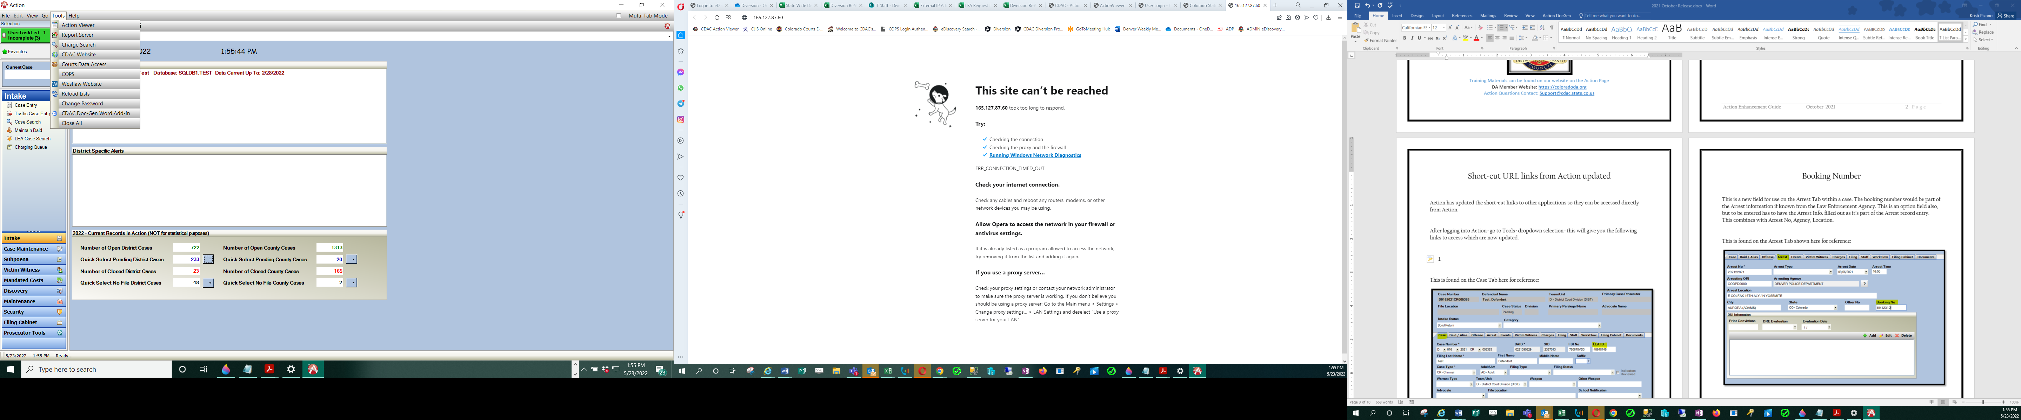

1. Action Viewer
2. Report Server (Action Viewer Reports)
3. CDAC Website- updated to <https://coloradoda.org>
4. Courts Data Access (Judicial Program)
5. COPS (CICJIS Program)

Action: User Accounts now available to link for In-house Investigators and Diversion Counselors

Action Update to the User section. This allows In-House Investigators and Diversion Councelors to be linked to a user entry.

1. Power User Function
2. Security 🡪 Users
3. Edit the User Entry
4. In the “Person List” the In-House Investigators and Diversion Councelors will then be listed. Select correct person from list and TAB🡪 Save and Close. This connects the user to the person entry.
5. When this connection is made, the In-House Investigators for example when they access the Investigator Case List under Prosecutor Tools- will default with there name selected and populate in their cases.

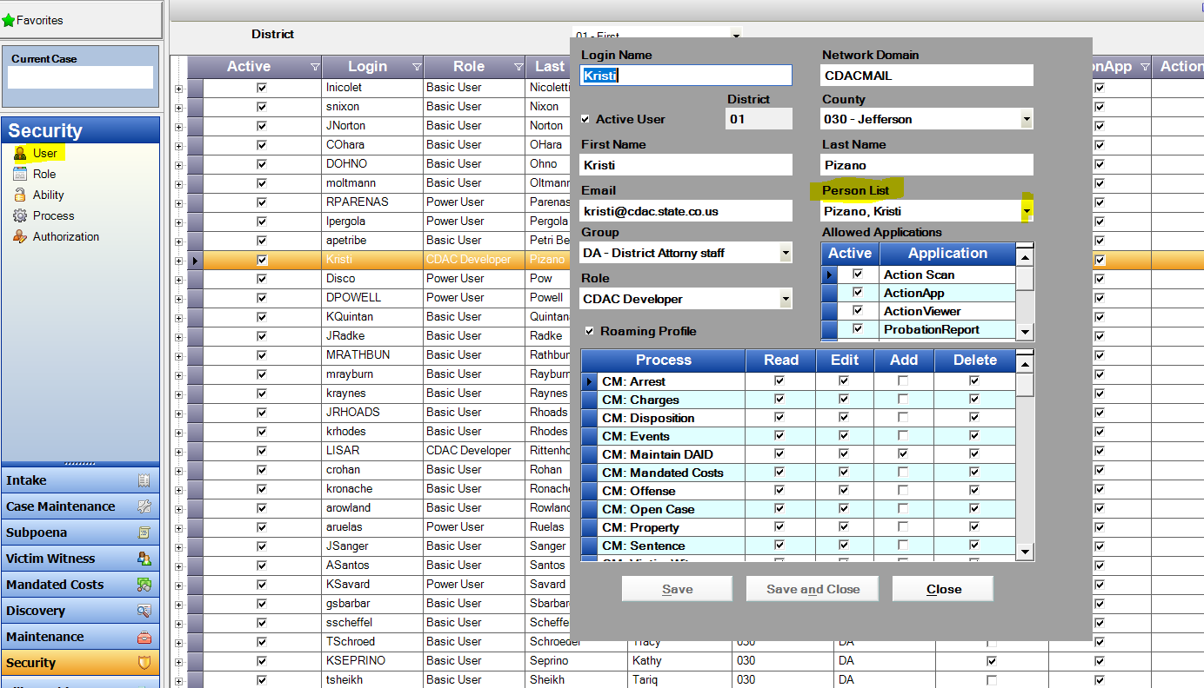

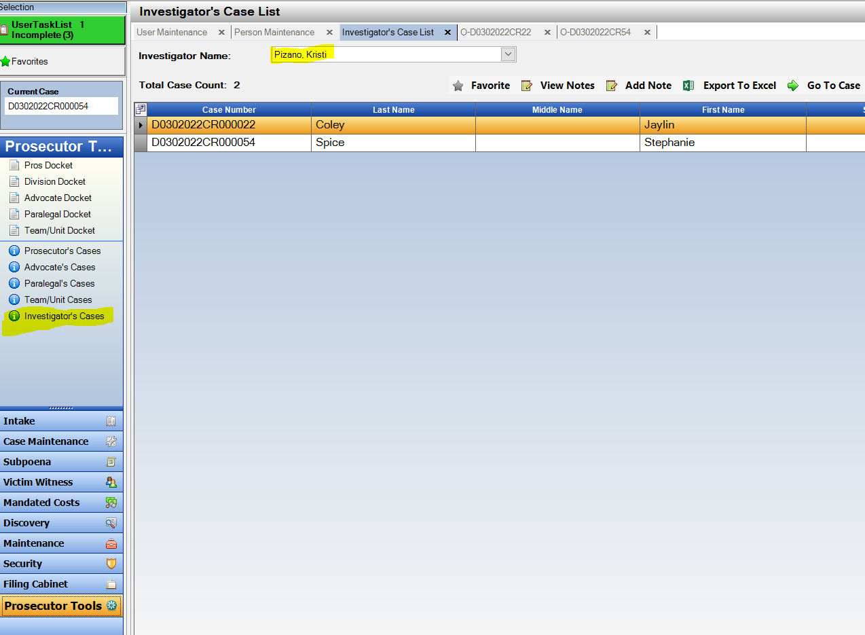

Diversion: Diversion Types Updated

Diversion Types have been updated. These are the selections that will appear when sending a case to the Diversion system.

1. Action Case🡪 Case Tools 🡪 Refer Case to Diverion
2. New Diversion Types in Drop down:
   1. Adult Diversion
   2. Adult Recovery /Drug Diversion
   3. Adult Wellness/MH Diversion
   4. Juvenile Diversion
3. The Diversion types appear within the Diversion System as a default value and can be updated once there if needed.

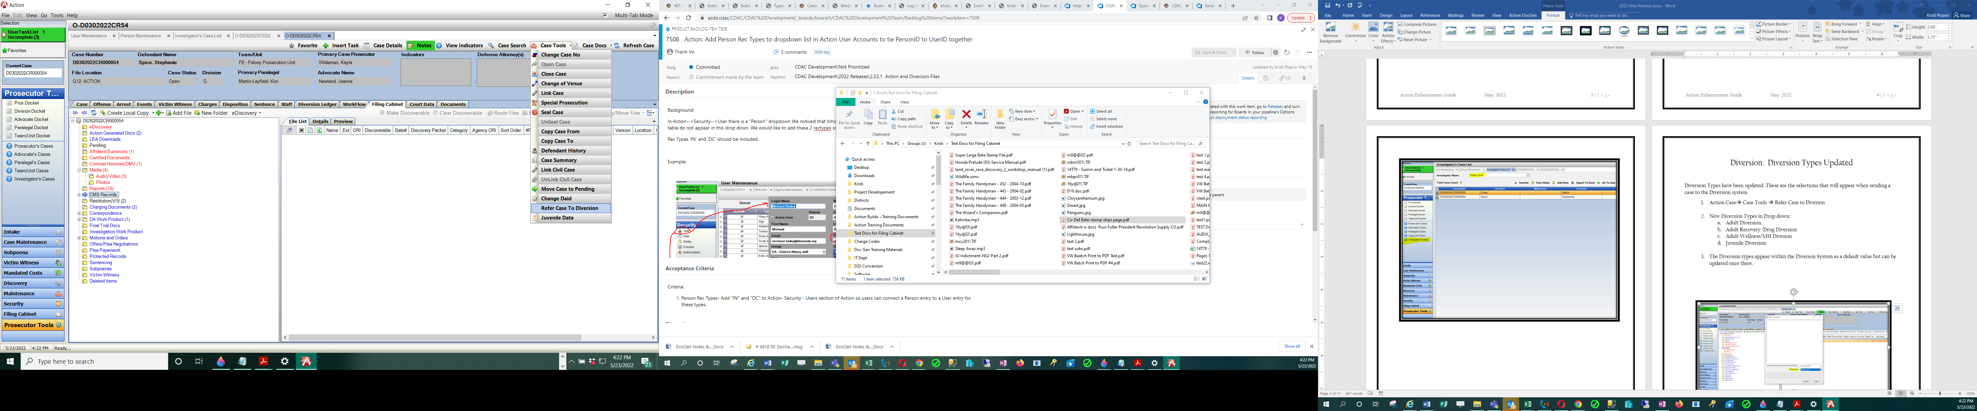

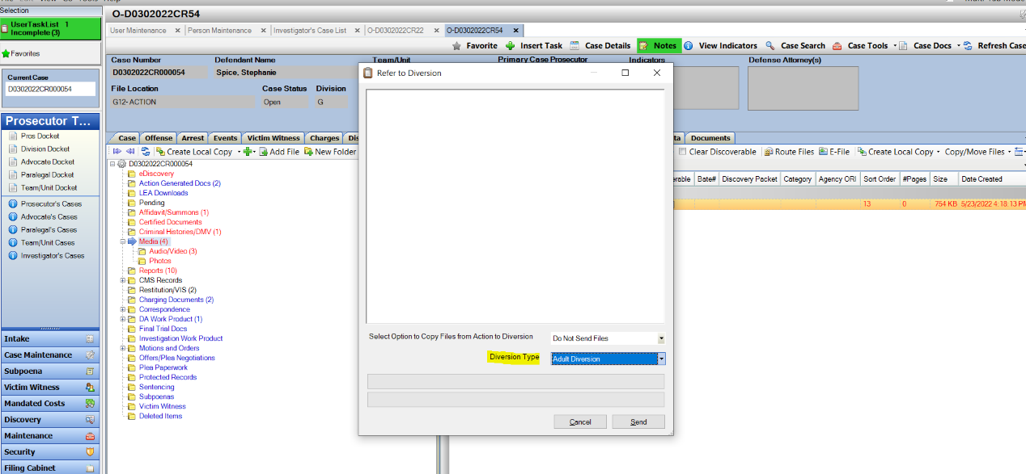

Diversion: Send File Cabinet Files with Case Data

When a case is being sent to Diversion- There is a new option to also send files that are in the file cabinet. There are different options to select from. Note that this process is only for new cases being sent to Diversion.

Location: Action Case🡪 Case Tools 🡪 Refer Case to Diversion

Pop-up Appears for Refer to Diversion new option:

Select Option to Copy Files from Action to Diversion

Option Descriptions:

1. **Do Not Send Files** = No files sent & default option
2. **Send All Files** = All files in case- *note this would include Discovery packets, plus the original discoverable files as well as any work product. The discoverable files would be a duplicate of what is in the discovery packets.
3. **Send Only Discoverable Files** = Files that are marked as being discoverable does not send a discoverable packet- just the files in a case appearing in “Red” denoting a discoverable property.

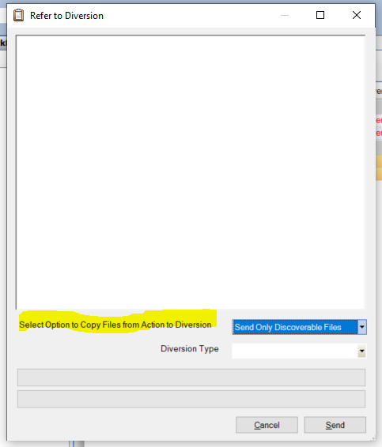

1. 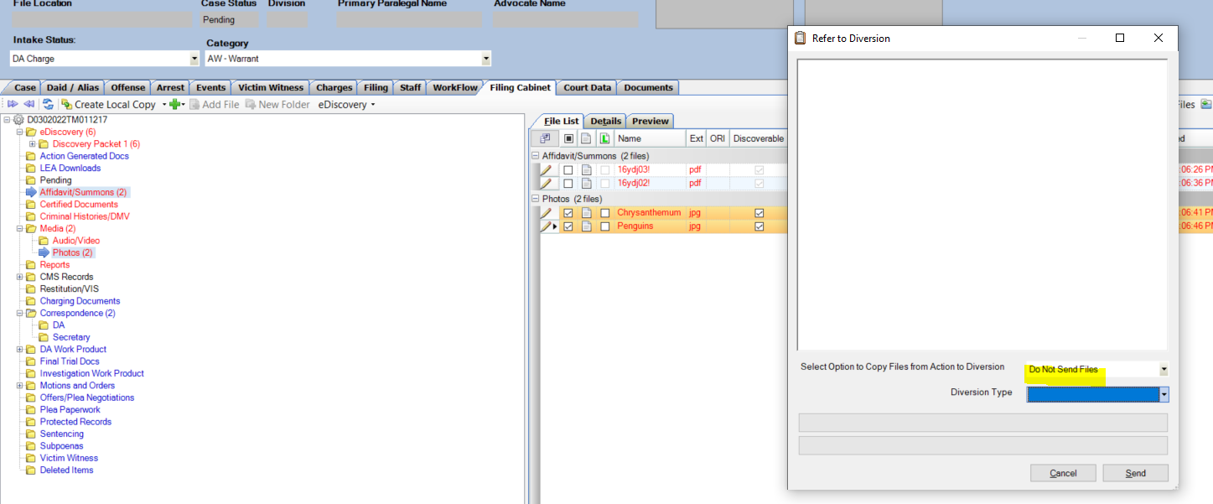**Do Not Send Files** = No files sent & default option
2. **Send All Files** = All files in case- *note this would include Discovery packets, plus the original discoverable files as well as any work product. The discoverable files would be a duplicate of what is in the discovery packets.

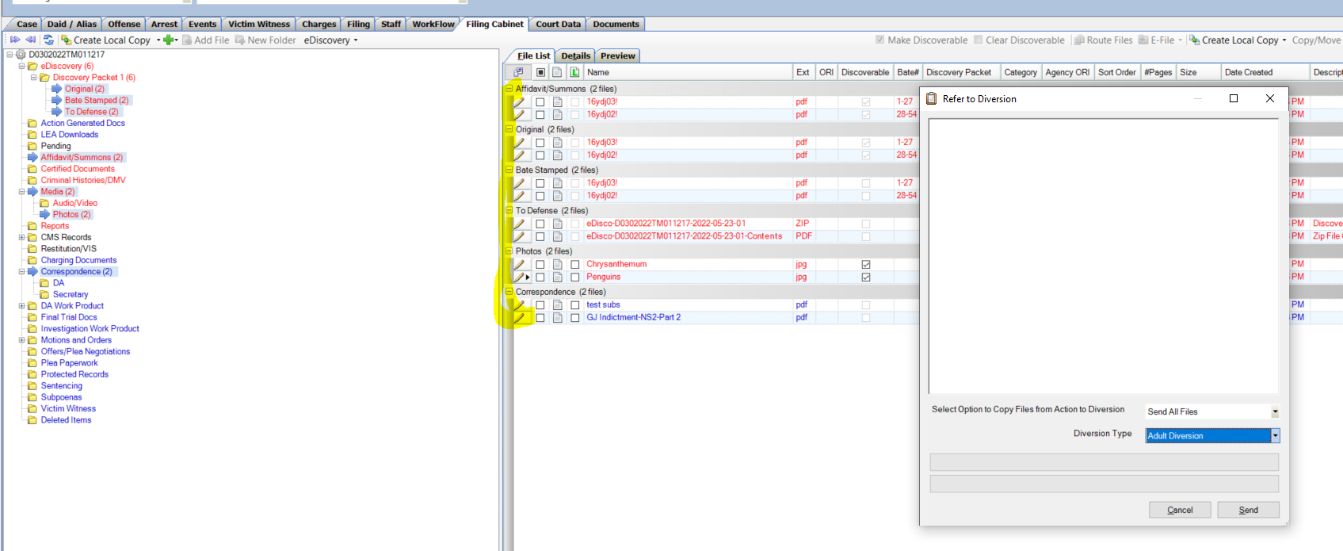

1. 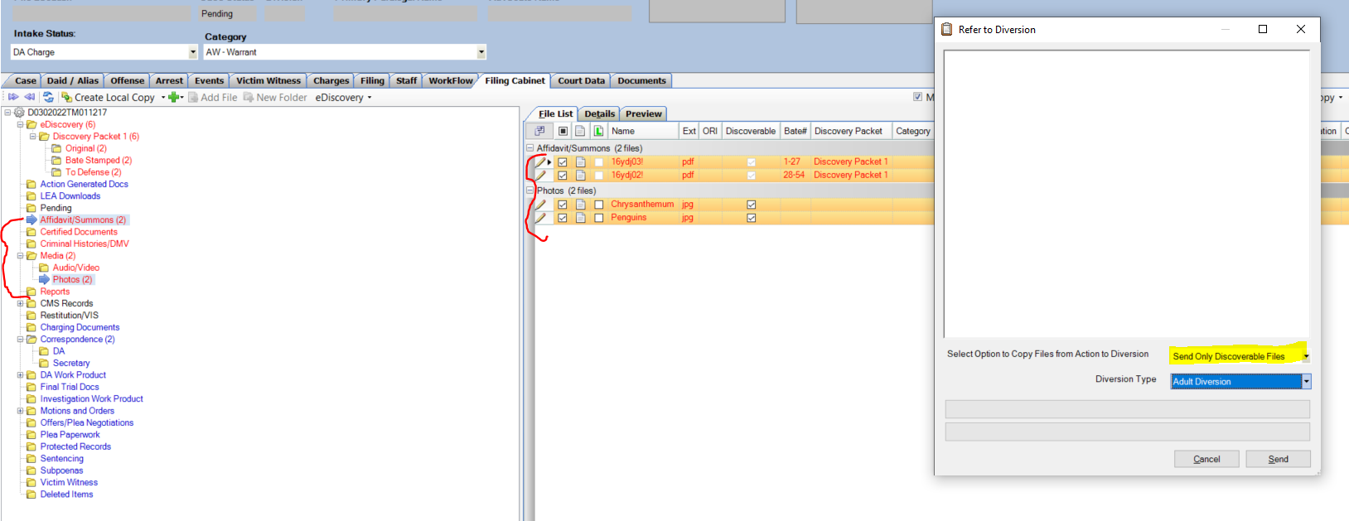**Send Only Discoverable Files** = Files that are marked as being discoverable does not send a discoverable packet- just the files in a case appearing in “Red” denoting a discoverable property.

Bug Fixes

1. Fix on use of # Next TM number shortcut
2. Fix for AG’s office updating Controlling District to others for Special Pros.
3. Fix for starting a case # from case entry- that already exists within Action.