Action Enhancement Guide

July 2022 Training Guide



Training Materials can be found on our website on the Action Page

DA Office User Website: <https://coloradoda.org>

Action Questions Contact: [Support@cdac.state.co.us](mailto:Support@cdac.state.co.us)



Table of Contents

1. Virtual Hearings: Maintenance Screen {*Power User Function)…………………….. 3-8
2. Virtual Hearings: Dockets …………………………………………………………………………………….. 9-11
3. Virtual Hearings: Virtual Hearing Language Option for Writs ………………….. 12-13
4. Virtual Doc Gen Variables ………………………………………………………………………………………. 14
5. New Doc Gen Variables …………………………………………………………………………………………… 15
6. Action Update to Dot Net 4.8 …………………………………………………………………………………………… 16

Virtual Hearing Maintenance

**Purpose:** Created to allow Districts to maintain a list of Virtual Link information connected to a Judge and/or Division. This information will be displayed in different areas in Action allowing quick access to the created links. * Power User Function.

**Add/Edit/Delete Virtual Court Links**

Power Users will be able to Add/Edit/Delete entries under the Maintenance Tab within Action.

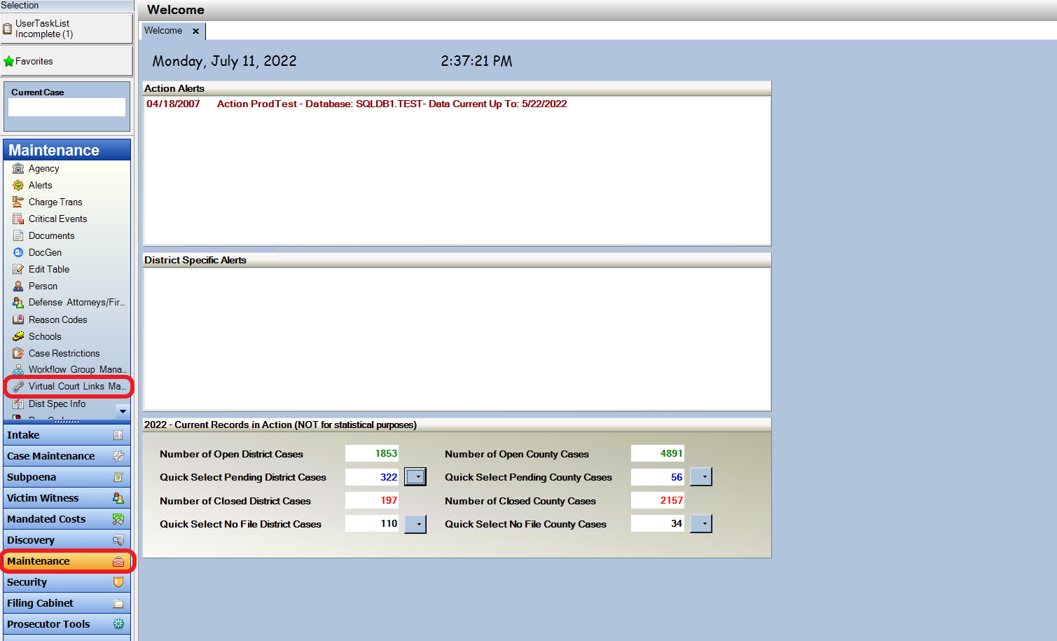

Add/Edit/Delete functions are located in the top right corner of the screen.

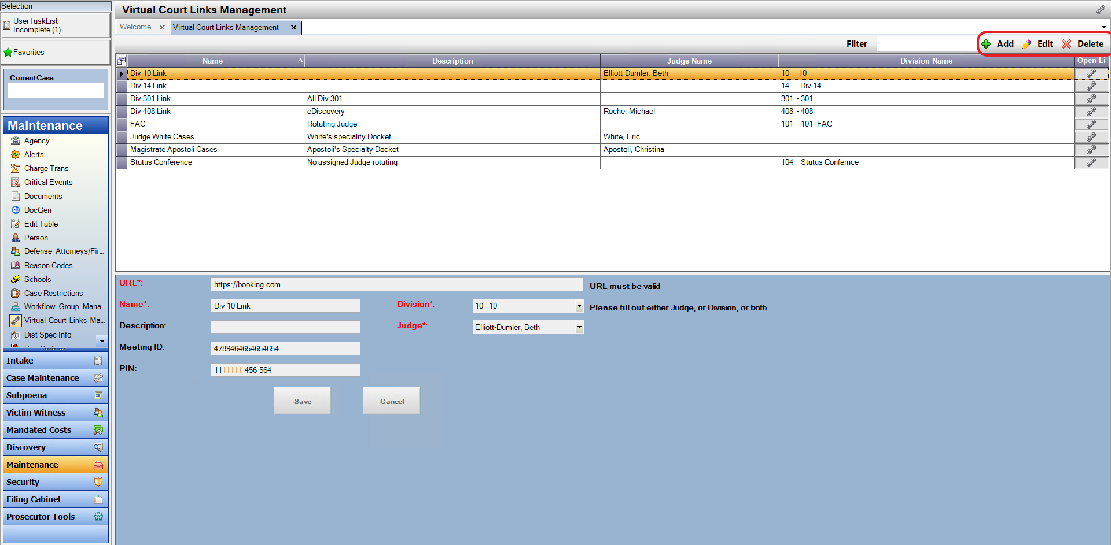

To Add a new Virtual Link click on the Add tab. The bottom section of the screen will populate a grid to fill in. The full URL needs to be added. When you click on the tab button, it auto-populates the same link for Name and Description. This can be left as is or this field can be overwritten to display a new entry. The Division and/or Judge is a required field. Both dropdowns can be selected but only one of these selections is required.

Once the information is entered, select the Save button and it will be placed in the grid list above.

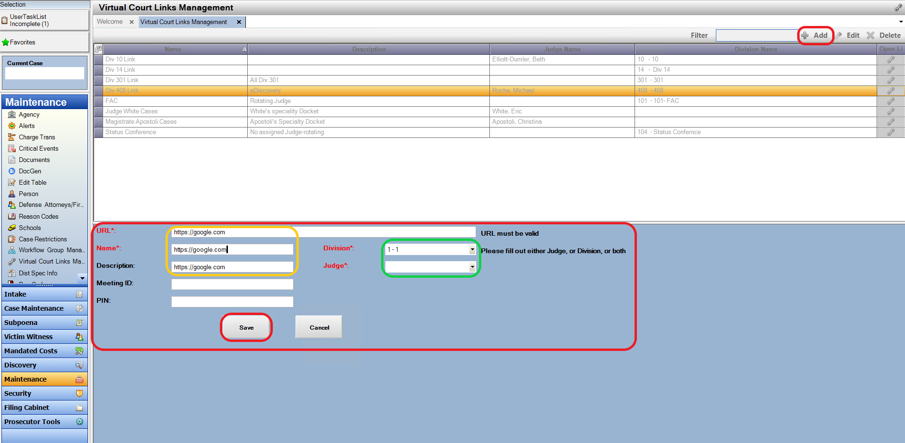

To Edit a Virtual Link, highlight the correct link and click on Edit. The information will populate below. Update the entry and click on Save.

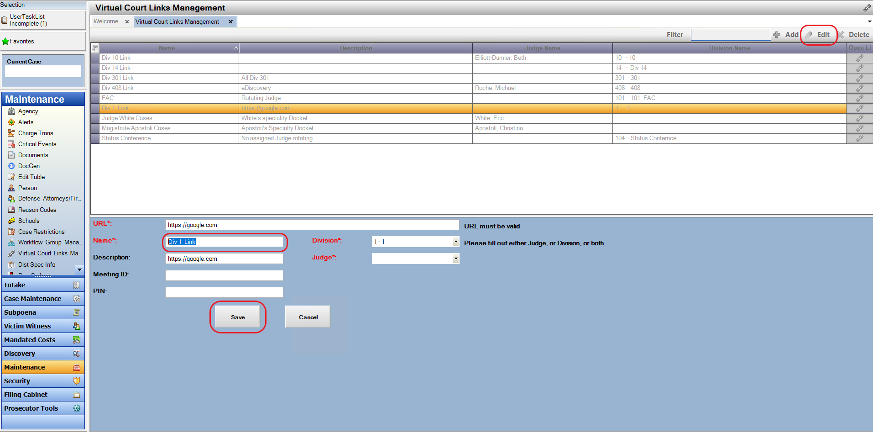

Only 1 entry is allowed for a Judge or a Division. An error Pop-Up will result when adding a Judge or Division that is already an entry.

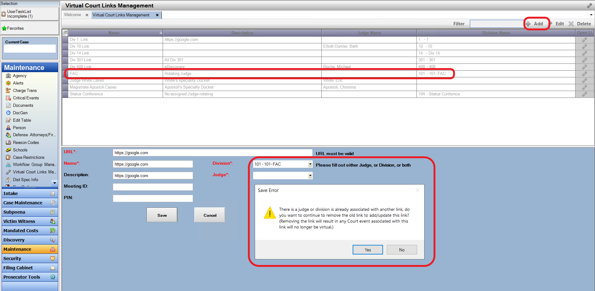

An error message will also appear if editing a record that already has a Judge or Division connected to a different Virtual Link.

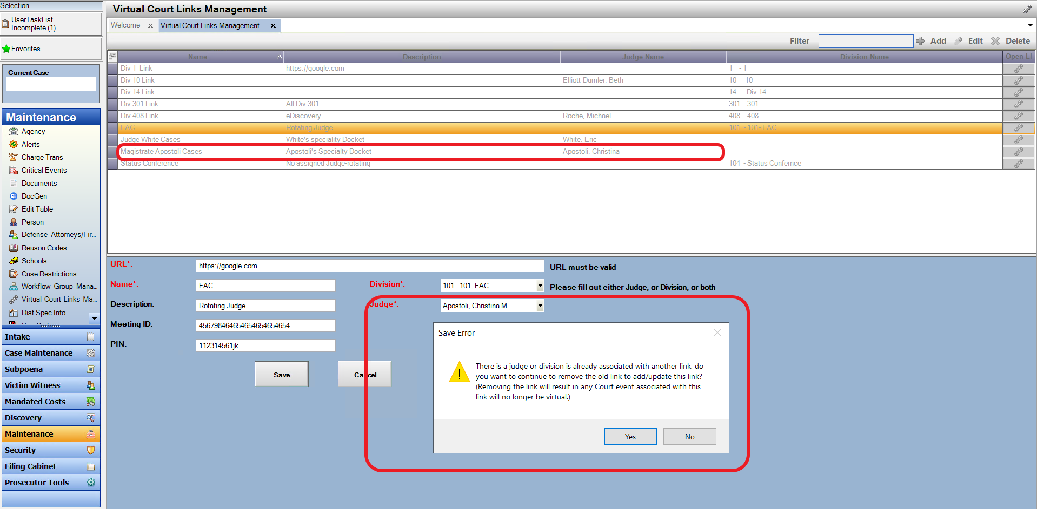

To Delete a Virtual Link, highlight correct link and click on the Delete tab. A Pop-Up will show confirming this Link will be deleted.

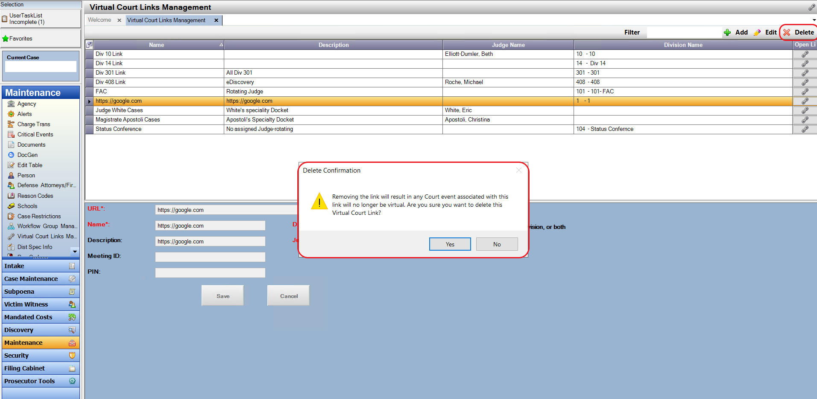

The Hyperlink for all the Virtual Hearing entries will be shown on the Maintenance tab to the right of the entered Link. Once an entry has been made, a User can click on this link to confirm this is the correct Hyper-Link.

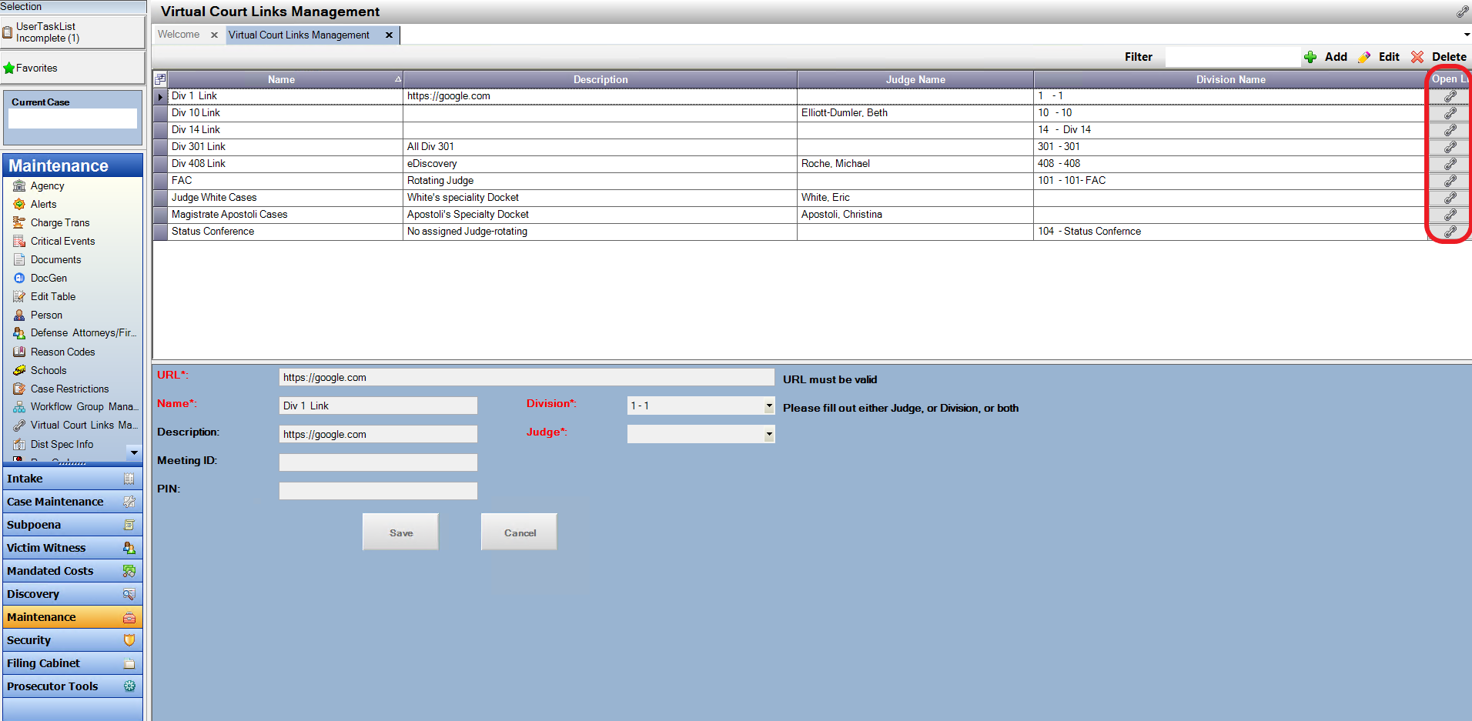

Use the Filter function to search for an entered Link. All columns are searchable.

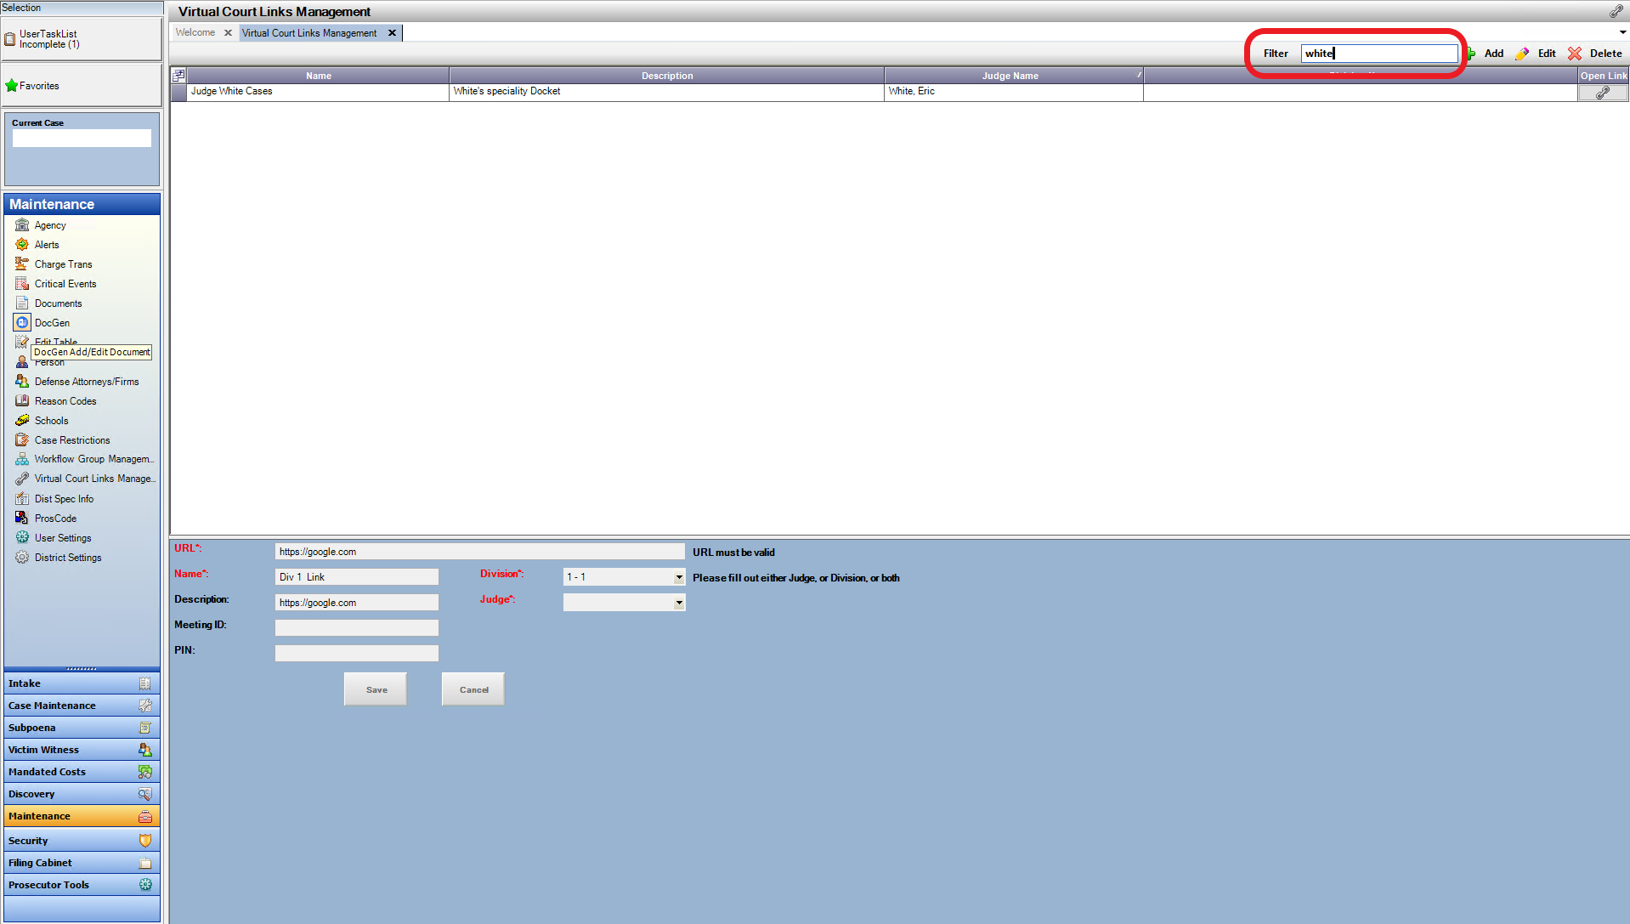

Partial Filter entries will also return results.

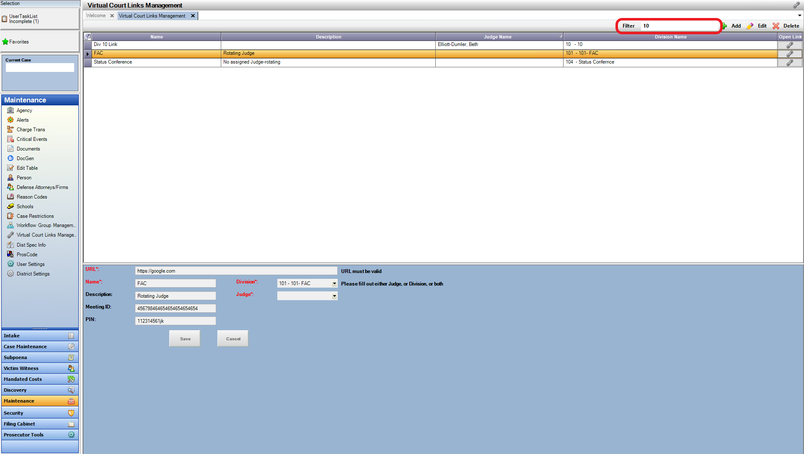

Virtual Hearing Access from Dockets

**Purpose:** Created to allow District users to access virtual link information from the entries made by a Power User in the maintence screen. **These DO NOT populate in from Judicial nor indicate that the specific event is a Virtual HHearing.** This just provides acess to a set link for a Judge or Division in the instance the hearing is virtual.

The Virtual Link that was entered into the Maintenance tab will display in all of the Dockets. Users need to add this new column if they wish to have access: Select from the Field Chooser🡪 V-Court to add this as a column. This Hyper-Link is a direct Link to the meeting and can be accessed by clicking on the Link function.

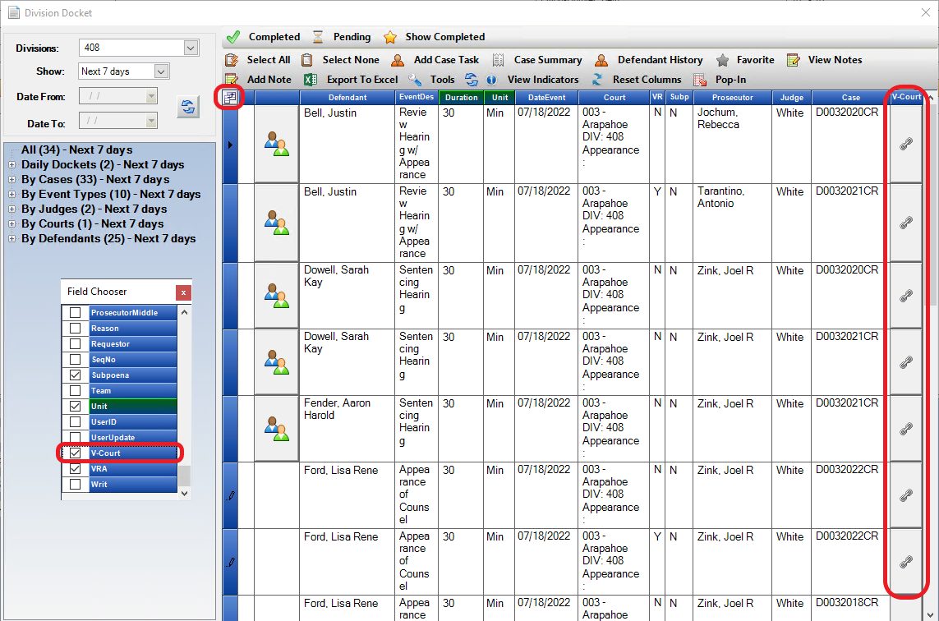

Click on the Link within your Docket, a Pop-Up Box will appear with this meetings information. Click on the Link within the Box and it will open the Meeting Site. User’s will be able to copy/paste and toggle between the URL Site and this box to easily enter Meeting ID and PIN number if provided.

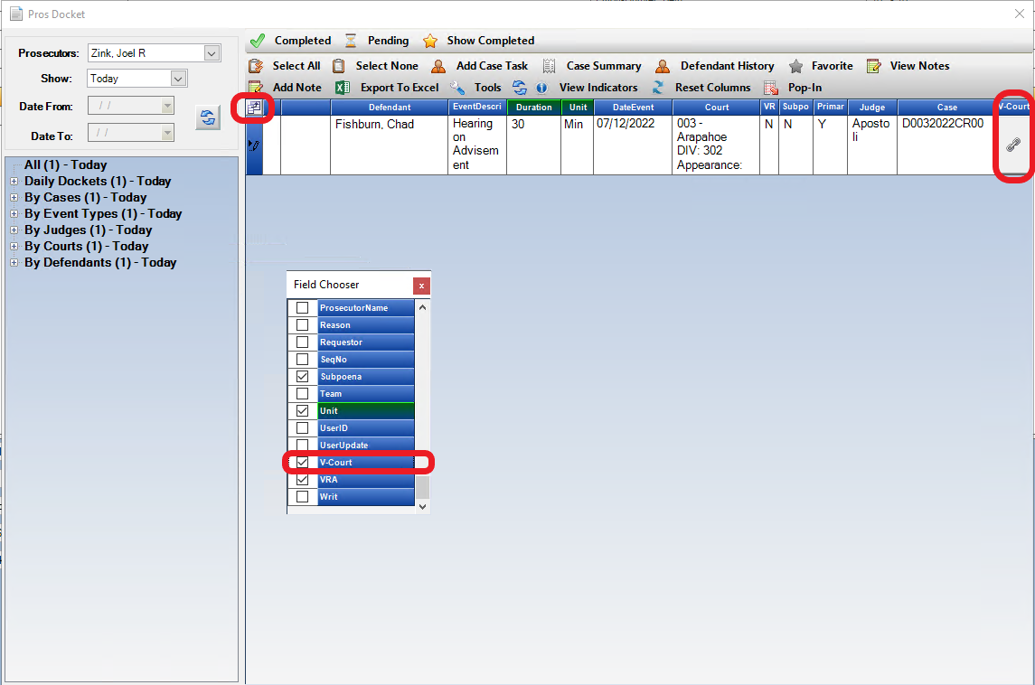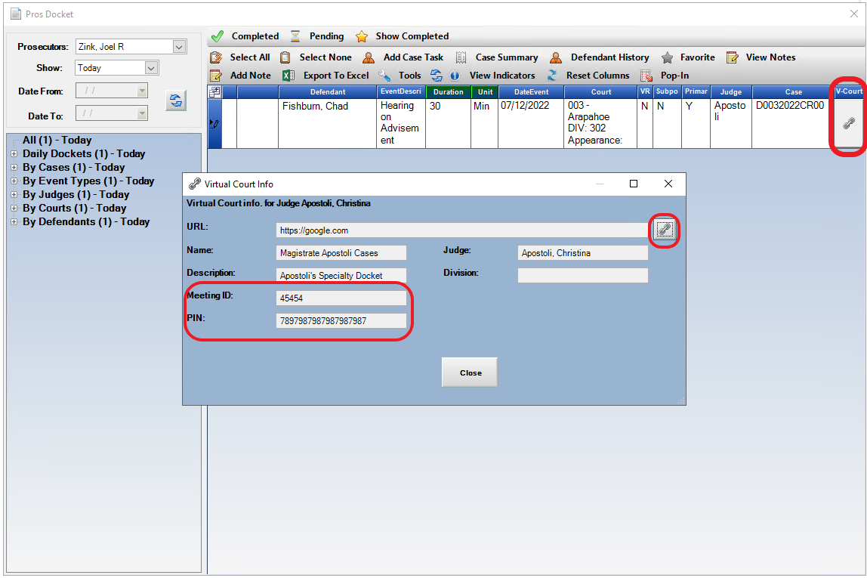

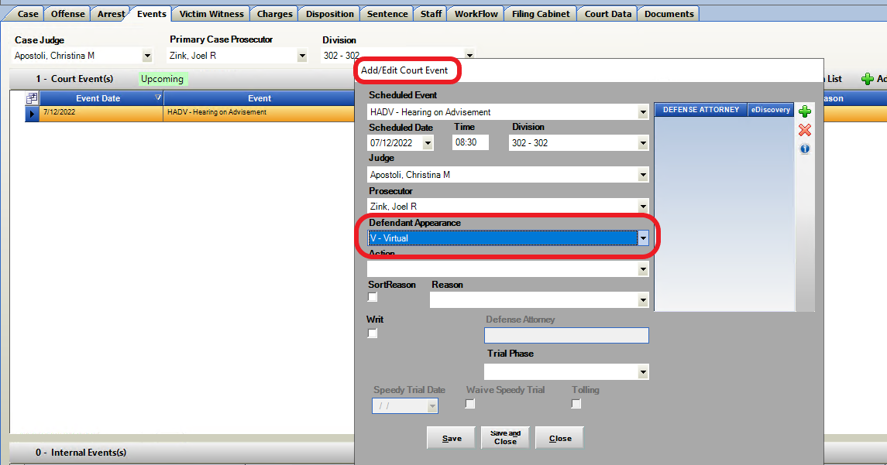Reminder or prior released functionality that can be used: User’s are able to update an Event if it’s known that it’s a Virtual Hearing. It’s added adutomatically to the Court Column, or can be added as a separate column as shown below with the Field Chooser- Defendant Appearance.

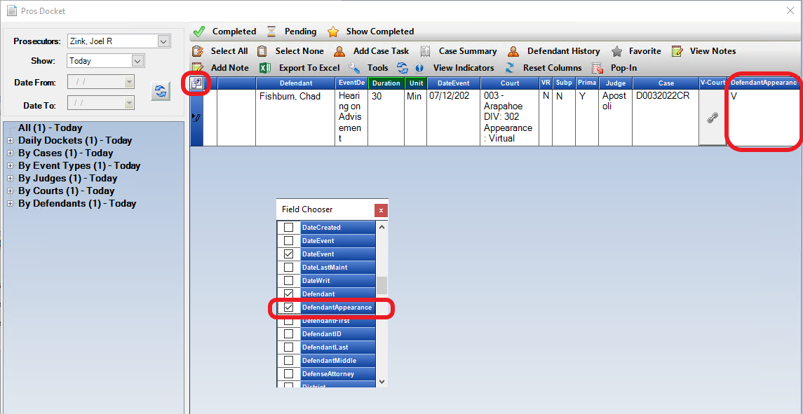

Virtual Hearing Language Option for Writs

**Purpose:** Created to allow District users to add optional virtual link information from the entries made by a Power User in the maintence screen to Action Generated Writs on the Events Tab. **These DO NOT populate in from Judicial nor indicate that the specific event is a Virtual HHearing.** This just provides acess to a set link for a Judge or Division in the instance the hearing is virtual.

**Access:** Action Case 🡪 Event Tab 🡪 Create Writ (both Defendant and Witness Writs)

Option for a user to add Virtual Hearing Information to an Action Writ Document. The user can then edit/modify the document further to apply any other special language. The document will auto populate on the e-filing form- which can be edited and saved be3fore filing.

When choosing a Writ, click on the box Add Virtual Court Information.

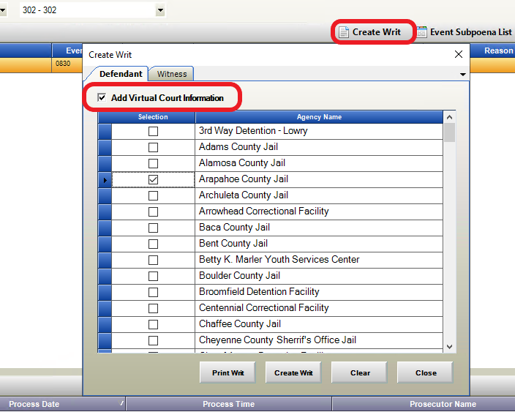

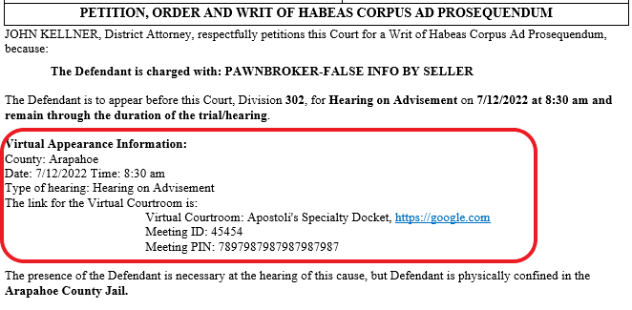

When this box is left un-checked, this information will not show on the Writ.

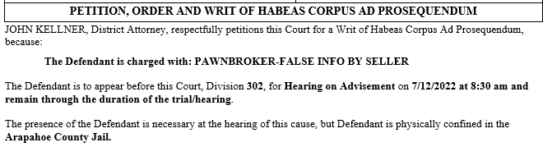

Doc Gen Virtual Hearing Variables

**Purpose:** Created to allow District users to add optional virtual link information from the entries made by a Power User in the maintence screen in the Doc Gen Variables, so that in-house created documents can utilize these entries. **These DO NOT populate in from Judicial nor indicate that the specific event is a Virtual HHearing.** This just provides acess to a set link for a Judge or Division in the instance the hearing is virtual.

**Acceess:** Doc Gen Word Add-in 🡪 Event Tab – VirtualCourtInfo.

*See separate ZIP attachment for new Doc Gen Variables examples- it’s added as Single Event, One Column Event List and Two Column Event List options.

Example:

**********************Single Event*********************************************

Event Division:<<[Case.Event.Division]>>

Event VirtualCourtInfo: <<[Case.Event.VirtualCourtInfo]>>

Doc Gen New Variables

**Purpose: Additional Doc Gen Variables have been created for Districts use. These new variables have examples listed in the attached ZIP file.**

**Acceess:** Doc Gen Word Add-in 🡪 Variable tabs- see Examples of each.

1. Paralegal Information 🡪 Staff Tab
2. Prosecutor Information –updated including phone, address/email 🡪 Staff Tab
3. Judge Information – updated including phone, address/email 🡪 Staff Tab
4. Investigator 🡪 Staff Tab
5. Diversion Counselor 🡪 Staff Tab
6. Internal Events 🡪 Event Tab
7. LEA ID field 🡪 Case Tab
8. Defendant- his/her 🡪 Defendant Tab
9. Victim Witness- Updated to include below items 🡪 VW Tab
   1. Active Phone
   2. Active Email
   3. VW Note
   4. Interested Parties
   5. His/Her -Capital
   6. Language
   7. Officer Brady/Badge No
   8. Witness Role
   9. Officer Function
   10. VW Phone List
   11. Phone Status
   12. Phone Type
   13. VW Email
   14. VW Email Status

Action Update to Dot Net 4.8

This release includes an Action upgrade to Microsoft framework 4.8, Your users should be able to continue to work in Action during the release.  Action will update itself to the latest version when it is restarted by the users.

With the new version,  Action (Filing Cabinet)  will require user computers to have access to an additional URL/web address of <https://api.cdac.state.co.us> .   Please have your IT make the change needed to add this additional URL to your allowed list if your district enforces URL access restriction.

The framework update only requires users to log out and back into Action once released. We were able to check through our logs that the majority of user computers are already running this framework for a seamless transaction,  there were however a handful of computers that may require an uninstall and fresh re-installation of Action to upgrade to the net 4.8.

If any of your users are having issues accessing Action Friday a.m. try that re-installation first.