Action Enhancement Guide

October 2021 Training Guide



Training Materials can be found on our website on the Action Page

<http://www.CDACweb.com>

Action Questions Contact: [Support@cdac.state.co.us](mailto:Support@cdac.state.co.us)



Table of Contents

1. LEA Defendant Number……………………………………………………………………………………….. 3
   1. New field to use to reference a Law Enforcment Defendant number.
2. Booking Number ….……………….……........………………………………………………….…………….. 4
   1. New field to use to reference an arrest Booking number.
3. Charge Code –Drug Charges ………………………….. ………………………………………………… 5
   1. Drug Charges – Drug and Quanity can now be edited.
4. Notes ………… …………………………………………………….……………………………………………………….. 6
   1. Text Size option to increase/decrease users view within the Notes.
5. Intake Charging Queue……………………………………………………………………………………………… 7
   1. Display Next Event Date/Time for Pending cases.
6. Court Events ………..........................………………………………………………………………………. 8
   1. Allow for Weekend Court events to be entered by users.
7. Victim Witness Screen ………………………………………………………………………………………… 9
   1. Officer Info. added as a new Field Selector for users on this screen.
   2. Officer Name/Badge field expanded for easier viewing.
8. Subpoena Witness Screen …………………………………………………………………………… 10
   1. Officer Info. added as new columns displayed on grid.

LEA Defendant Number

This is a new optional field for use that references a defendants id number that a law enforcement office may use. If this is not something that your district is provided with or tracked then does not need to be entered.

This is found on the Case Tab here for reference:

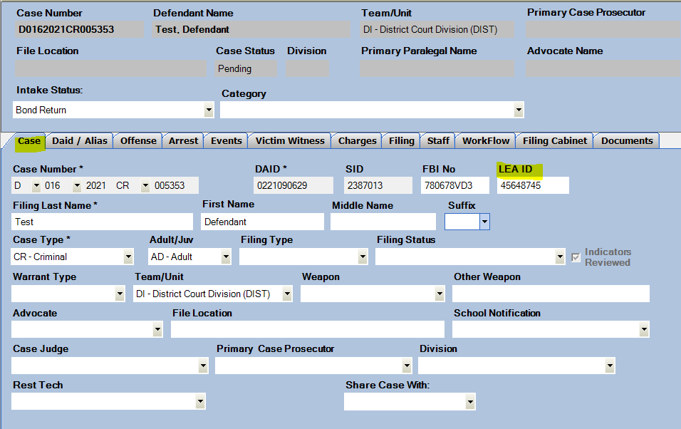

Booking Number

This is a new field for use on the Arrest Tab within a case. The booking number would be part of the Arrest information if known from the Law Enforcement Agency. This is an option field also, but to be entered has to have the Arrest Info. filled out as it’s part of the Arrest record entry. This combines with Arrest No, Agency, Location.

This is found on the Arrest Tab shown here for reference:

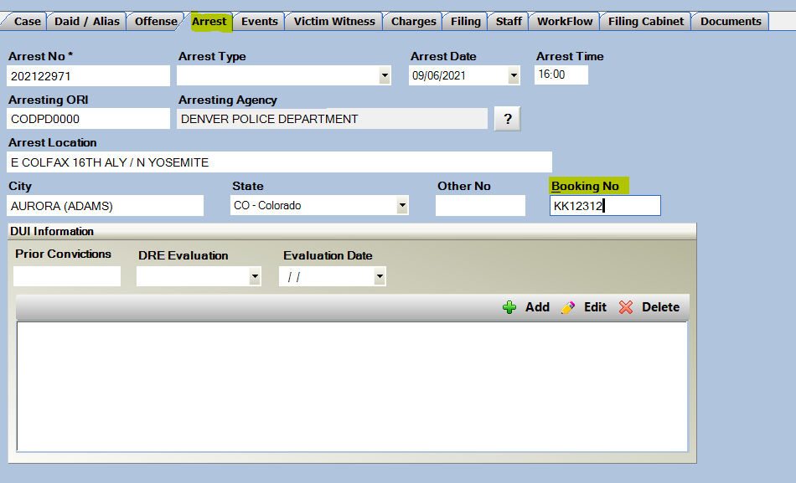

Charge Code- Edit Drug Charges

Charge Codes that include the Drug information have been updated to allow users to edit the Drug choice and quanity after first selection. Currently the form allows users to only select this on the initial add of the charge.

*Note: if editing a Drug Type after initially selecting it will not re-update the Charge Text. This will need to be manually updated by the user as in current practice.

Example:



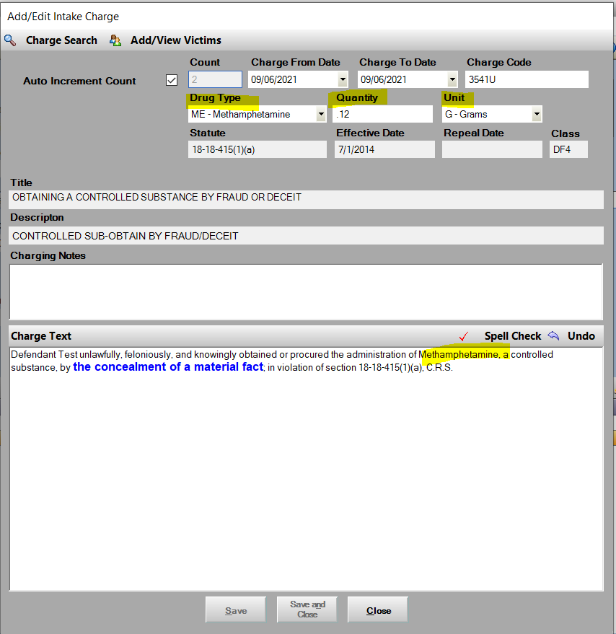

Notes – Text Size Option

Notes feature has been updated to include an option to Increase the Text Size for users for easier reading of the notes. *This applys to just the noting control.

This is found by going to Notes form.

Below is the new field and is defaulted to “Small” which is the current view.

Users can select- Small, Medium or Large.

This will be remembered for the user until they re-set their options or change the view.

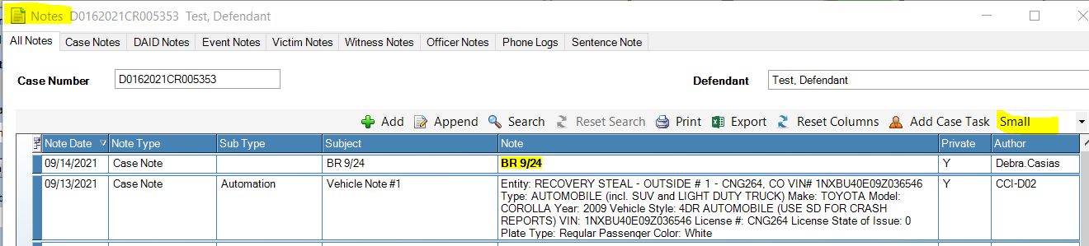Small:

Medium:

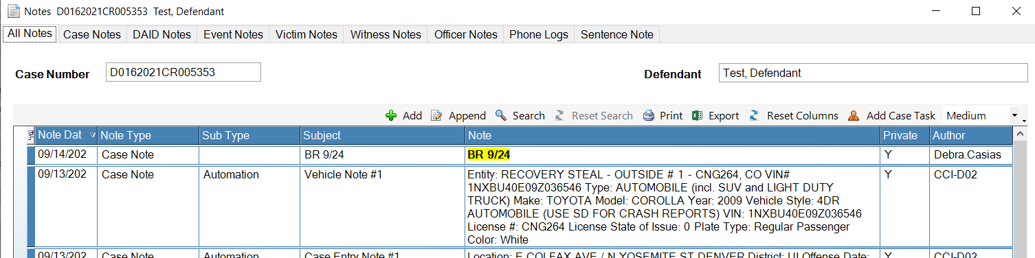Large:

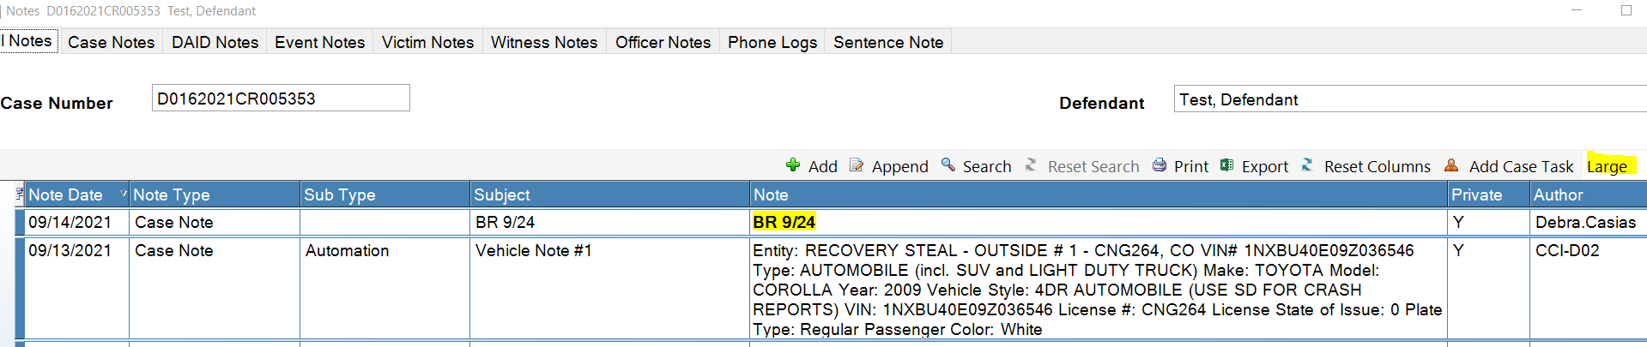

Intake Charging Queue

The Intake Charging Queue now includes next Event Date/Time if one exists for the case. This is to help show prioritaztion for pending intake cases, if the charging queue is used within your district.

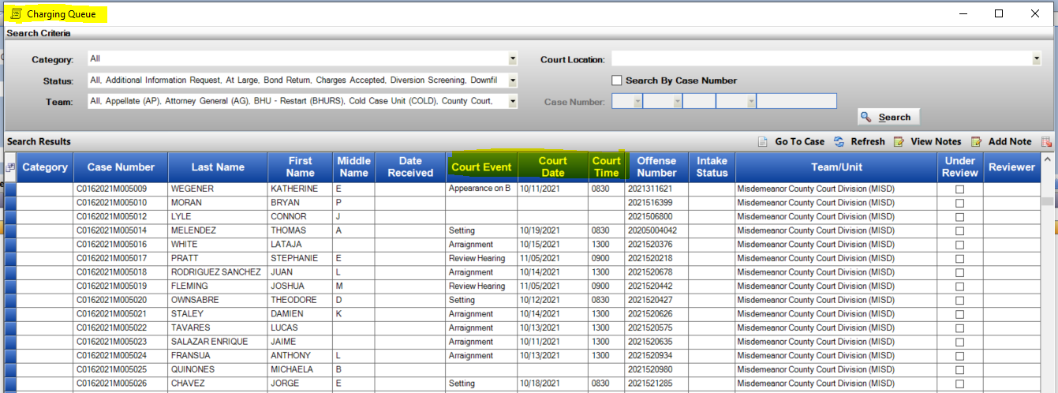Event Date/Time Added to Display:

Court Events

Court Events can now be set on weekend dates as there are courts that have valid This was previously restricted from users to set.

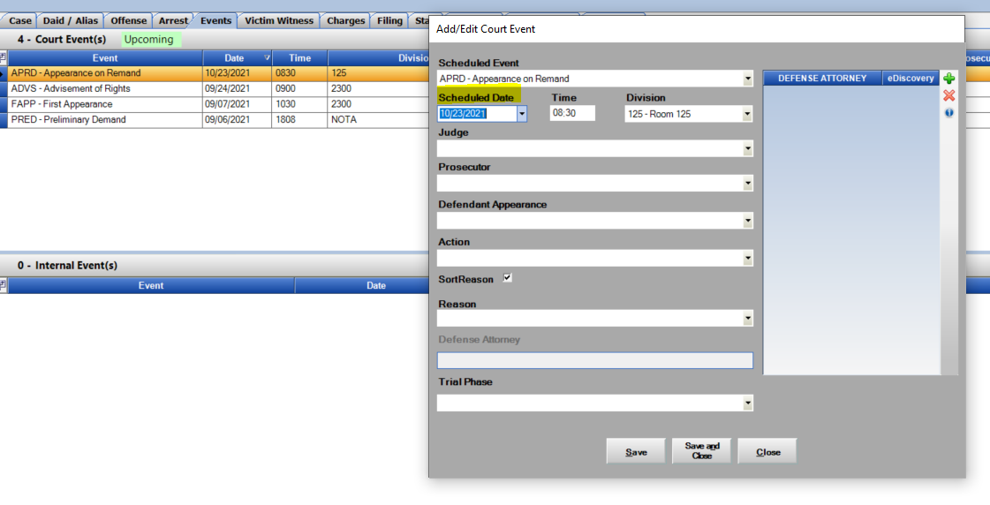

**Victim Witness Screen**

1. User Field Selector now includes an option for “Officer Info.” if selected as a column this will show the Officer’s Agency, Badge Number and Officer Funtion if they had been added to the VW entry on the case.

This is to display this information quickly from the main grid instead of opening each record to view.

This is user specific, once set a user can remove or click on “Reset Columns” to remove from view.

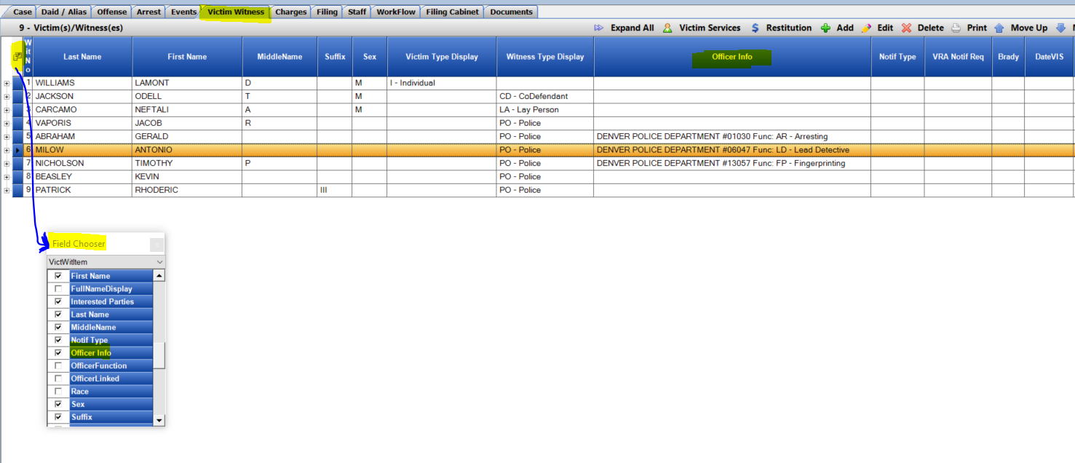

1. Expanded view of the Officer name and Badge Number for easier selection

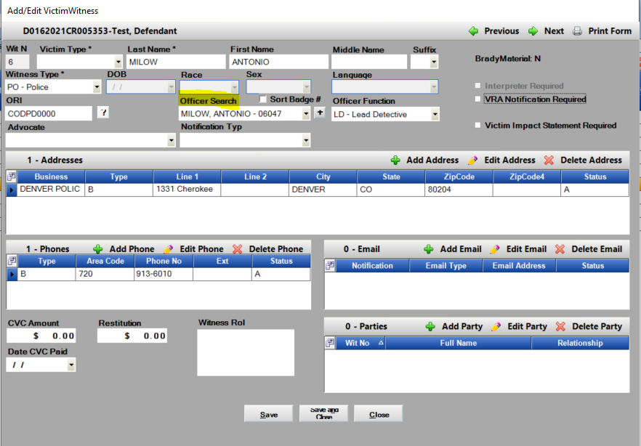

Subpoena Witness Screen

Subpoena Witness Screen has been updated to also include “ Officer Info.” This will show users the Officers Agency, Badge Number and Officer Function if it had been added to the VW Entry on the case. These are default columns as user preferences are not available on this screen.

