1. District Setting- Default to Multi-Tab Mode Checked

There is a new district setting to enable the default of Multiple Open Cases to be checked when you log into Action.

This would be for all the users in your district if turned on. Users could then toggle this off if they wanted Single Mode for that Action session.

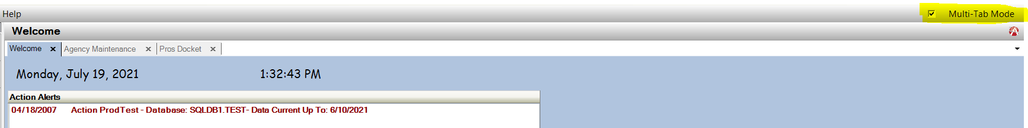Please contact [Support@cdac.state.co.us](mailto:Support@cdac.state.co.us) to have this enabled district wide. Please inform your users prior to support updating this.

1. Case Indicators

The Case Indicator Screen has been enhanced to accommodate more indicators for Districts. Users will see a larger form with a scroll bar, that will enable based on how many entries there are in your district.

Users can mark the checkbox by clicking in the checkbox, or on the name.

Users must click on the Save & Close button for the selections to Save.

Users may use the Filter at the top to search for a specific indicator, or click the “Show Selected Only” check box to show which indicators are currently marked.

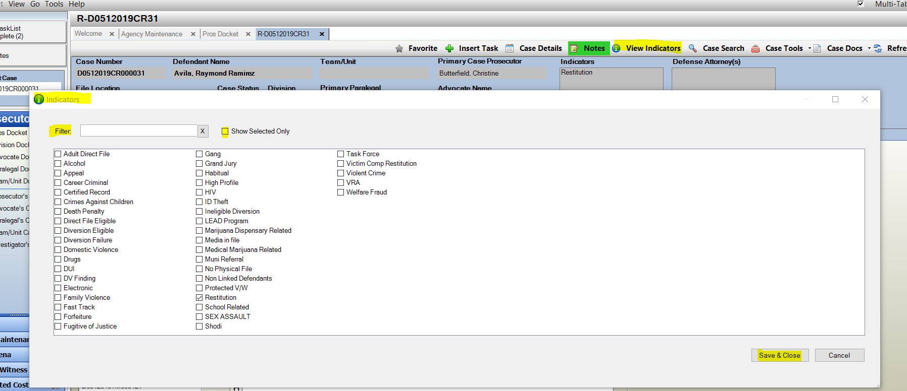

1. E-Filing – Document Size Increase to 10 MB

Per the Judicial increase for e-filing. Action will also let you add in larger files up to 10MB each through the e-filing interface in Action.

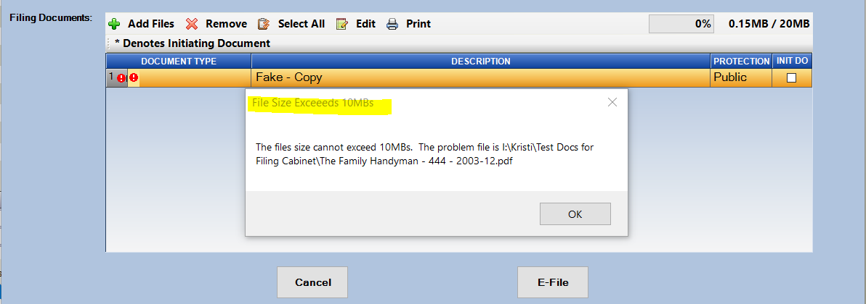If an individual file exceeds the 10MB users will see the pop-up message warning to reduce the size.

1. Bug Fix: Duplicated Rows in Docket views

It had been reported that cases were in some instances appearing in duplicate on some of the docket views. We were able to resolve this reported bug. It was happening in instances where the same event had been added onto an outlook or google calendar by more than 1 user. This will now show only the single row in these instances.