**Note Search**

This feature allows each User to search through all the notes listed within a case.

* This function is available on the All Notes and Case Notes tab only.

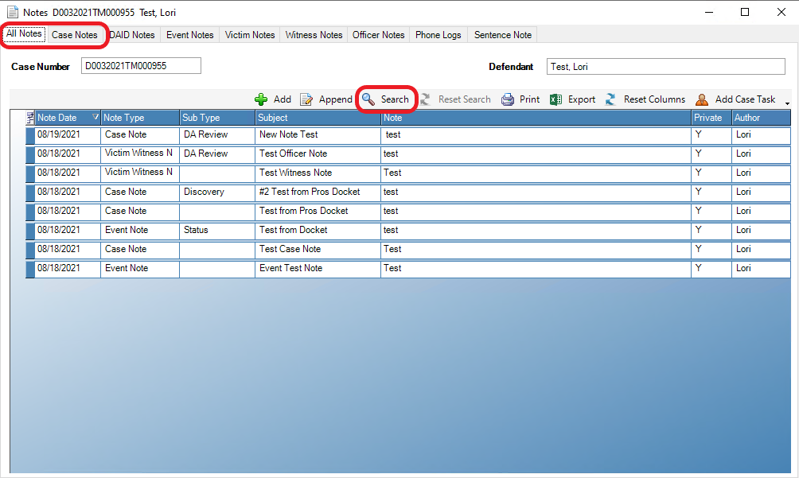

****All of the search options below are individual searches and are not filtered. Results will show on all criteria selected, thus we recommend using 1 variable at a time. Enhancements to this feature will be developed****

Users are able to search by Note Type by choosing the dropdown, highlighting their choice and selecting Search.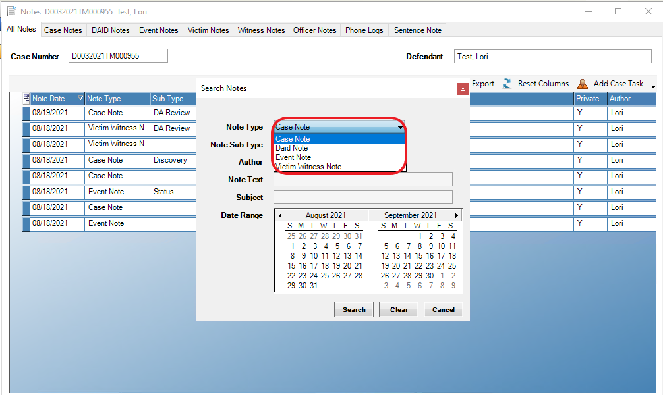

Note Sub Type, also with dropdown options.

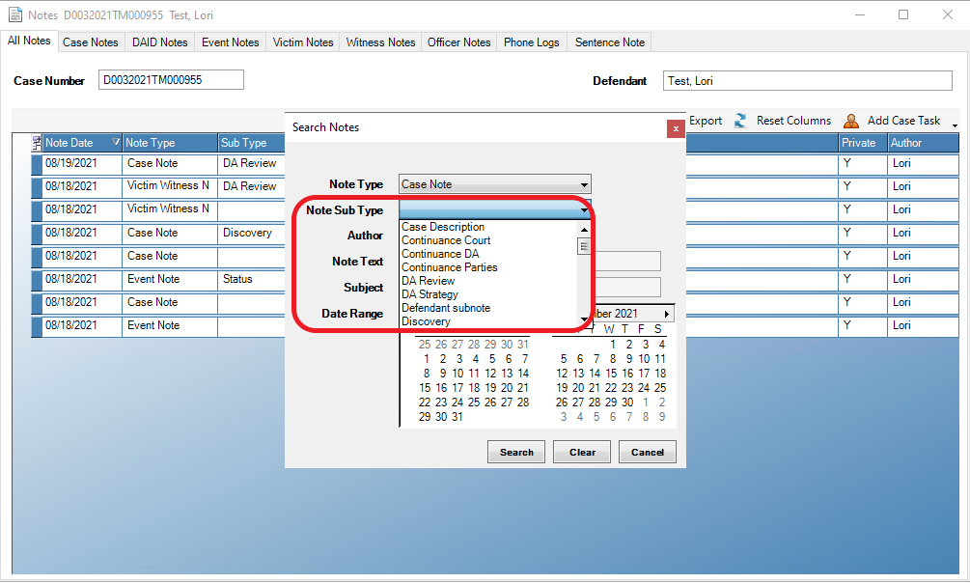

Fillable selections by Author, Note Text and Subject

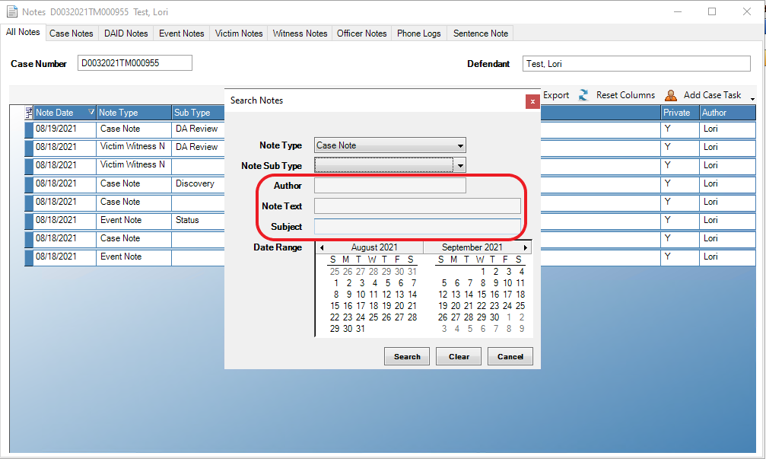

Users can search for 1 day of notes by highlighting a specific day. The search can be done for a date range by highlighting a start date on the calendar and using the CTRL key while pressing the end date.

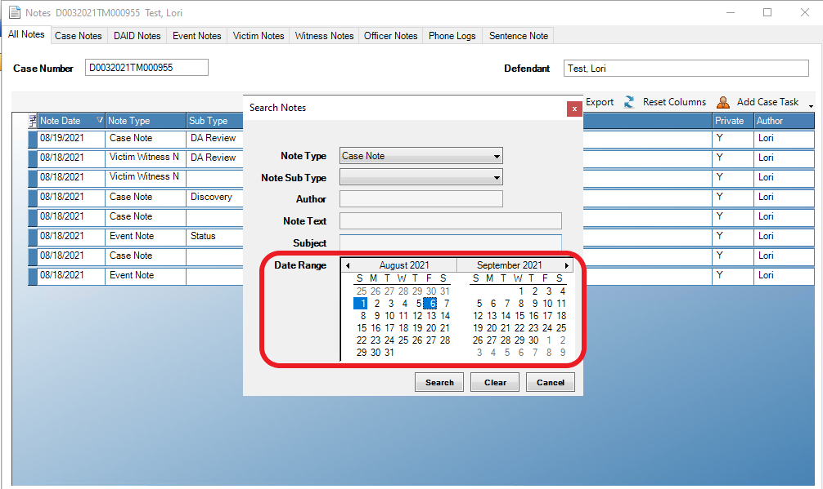

To clear a search and return to all notes available within a tab, select Reset Search

