Action Enhancement Guide

October 2024 Training Guide



Training Materials can be found on the CDAC website on the Action Page

CDAC Website: <https://coloradoda.org>

Action Questions: [Support@cdac.state.co.us](mailto:Support@cdac.state.co.us)



Table of Contents

1. User Customizable Tool Bar Options ………………………………………………. 3-4
   1. Setting Hot keys ………………………………………………...................... 5-6
   2. Re-setting Toolbar back to Defaults ……………………………………. 7

User Customized Tool Bars

**Purpose:** Allow users to customize tool bars on Dockets, Case Lists and Pending/Open Case forms for a more efficient way to access selections quickly. *Note each docket and case list are separate forms, apply customization to each screen.

**Recording Review:**

[**Customize Tool Bars Option-20241003_114256-Meeting Recording.mp4**](https://cdac1-my.sharepoint.com/:v:/g/personal/kristi_cdac1_onmicrosoft_com/EYTPlCAQKO1Dj_L-oh4GcNQBDtzfo0rCHC7hiZgd4t80BA?e=emnmSX&nav=eyJyZWZlcnJhbEluZm8iOnsicmVmZXJyYWxBcHAiOiJTdHJlYW1XZWJBcHAiLCJyZWZlcnJhbFZpZXciOiJTaGFyZURpYWxvZy1MaW5rIiwicmVmZXJyYWxBcHBQbGF0Zm9ybSI6IldlYiIsInJlZmVycmFsTW9kZSI6InZpZXcifX0%3D)

**Functionality:**

Right-Click in the Tool Bar sections. (examples in Red of the tool bars below)

Click on the Customize button that appears.

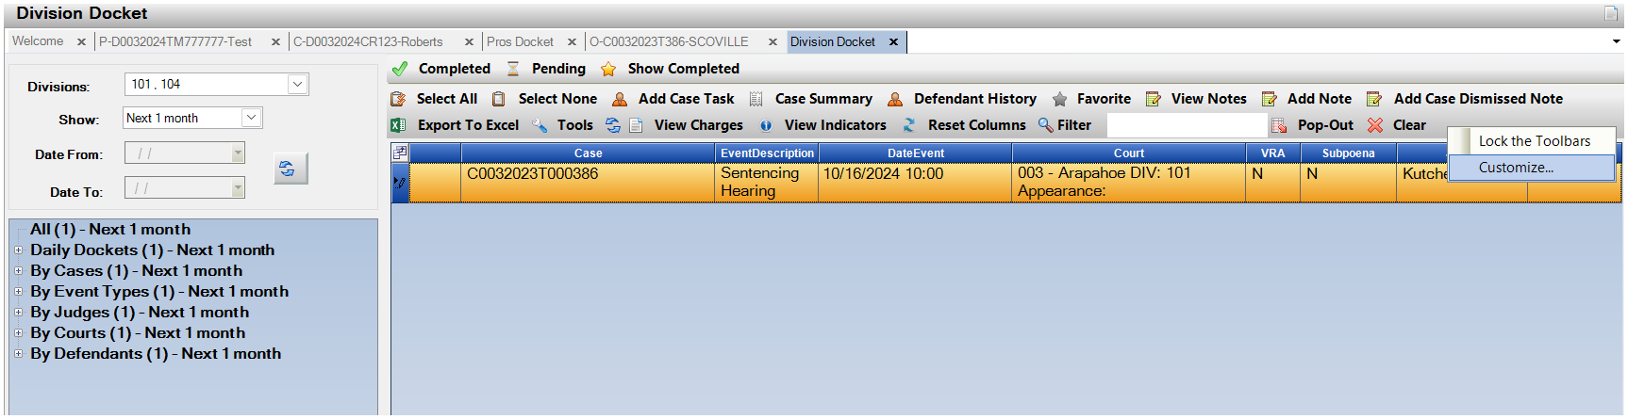 Docket Tool Bar:

Case Tool Bar:

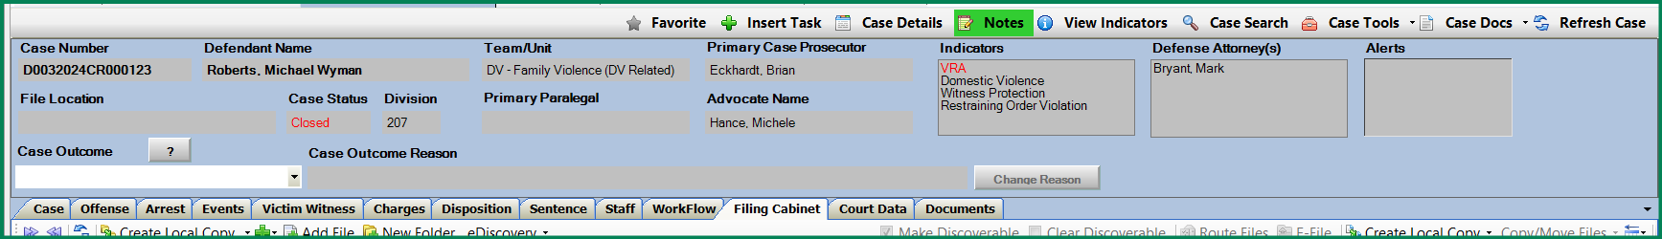

Pending Case Tool Bar: 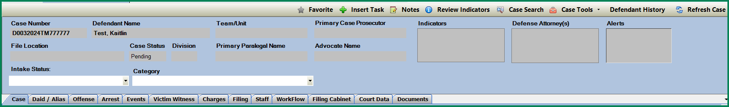

On the Customize Pop-Up🡪Click on the Commands Tab

Click on 🡪 Rearrange Commands

From the Rearrange Commands Pop-up

Use the Add/Delete options to add or remove buttons that you do not wish to see on the tool bar.

Use the Move Up / Move Down buttons to positions to the front or end of the tool bar displayed the buttons into specific positions.

Click on Close and the Tool bar will reflect your changes.

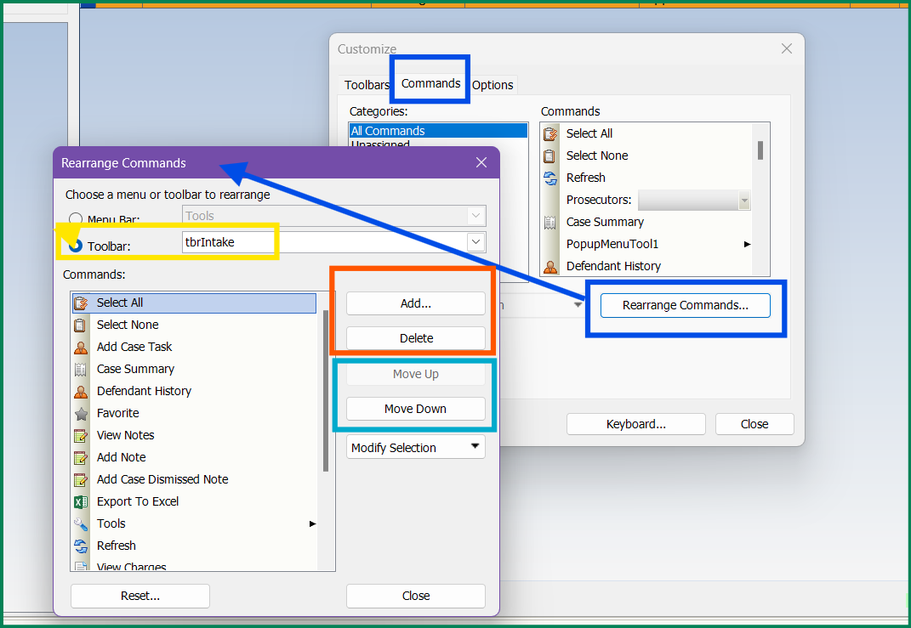

Examples:

Default Tool Bar in Division Docket

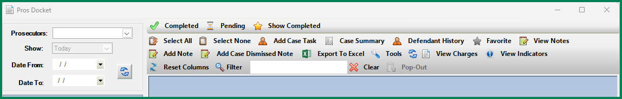

Updated Customized Tool Bar in Division Docket

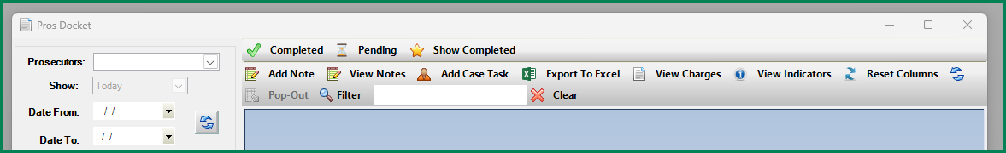

**Setting Hot Keys for Tool Bar Selections:**

Right Click on the Tool Bar 🡪 Click on Customize

On the Customize Pop-Up🡪Click on the Commands Tab

Click on Keyboard

On Customize Keyboard Pop-up you can select the command and then use the Specify a Shortcut to that command.

Click on Assign to Save and then Close.

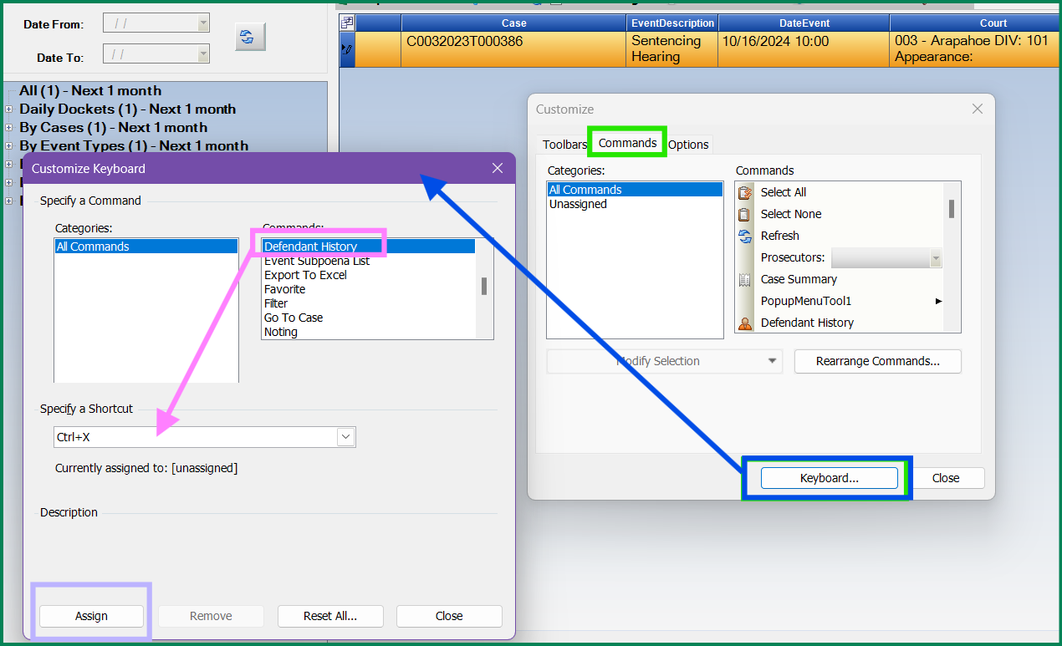

Click on Reset All to remove the customized Hot Keys

User Keyboard Commands that have been set can be viewed from the customize keyboard or right click on a row on the Docket/Case View and then customized set ones can be viewed like below.

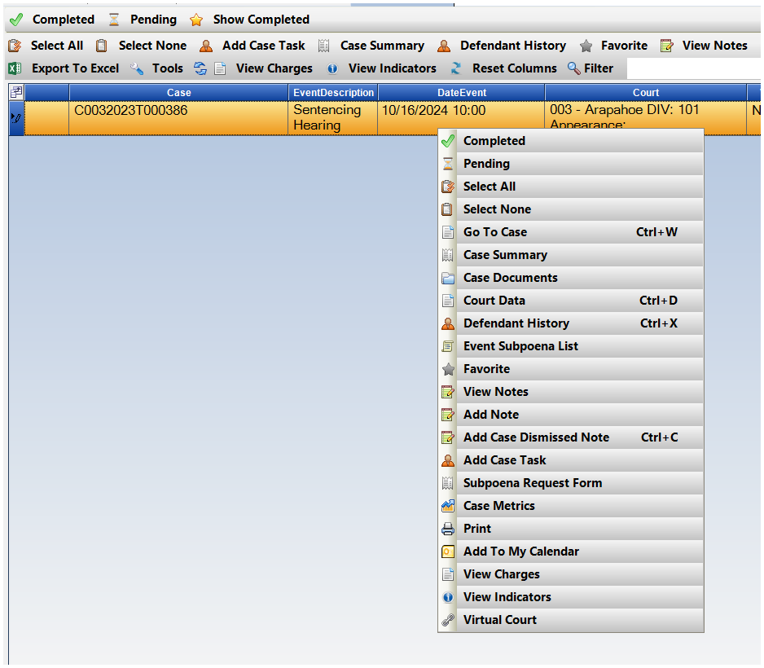

**Selections:**

To Re-Set your tool bars back to Default options:

On the Customize Pop-Up🡪Click on the Commands Tab

Click on 🡪 Rearrange Commands

From the Rearrange Commands Pop-up then Click on Reset to go back to the Default Tool Bar settings.

If any issues contact [Support@cdac.state.co.us](mailto:Support@cdac.state.co.us) which docket/case view you are having issues with and it can be reset from this side as well.

