Action Enhancement Guide

May 2024 Training Guide



Training Materials can be found on the CDAC website on the Action Page

CDAC Website: <https://coloradoda.org>

Action Questions: [Support@cdac.state.co.us](mailto:Support@cdac.state.co.us)



Table of Contents

1. File Cabinet: OCR updated component Kofax_3 ..……..……………………… 3
2. Pros Tools: Option to view charges …………….…………….…………………….. 4
3. Favorites Case List: Add WF Task option …………………….…………………….. 5
4. Special Pros & COV: updated user message ………………..…………………….. 6
5. Miscellaneous Updates/Corrected Functionality……….……………………….. 6

File Cabinet- OCR Updated component V3

**Purpose:** Update File Cabinet OCR process with latest component of Kofax_3.

**Functionality:** This latest upgrade will fix a known issue that will now retain a hyper link as clickable after the process runs.

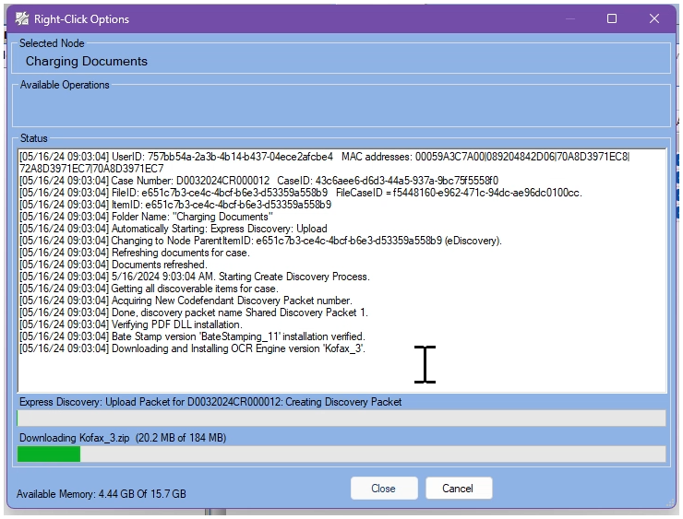This upgrade will automatically download for users that create discovery packets on the next packet they generate after the release.

They will see the following installation occurring just the first time.

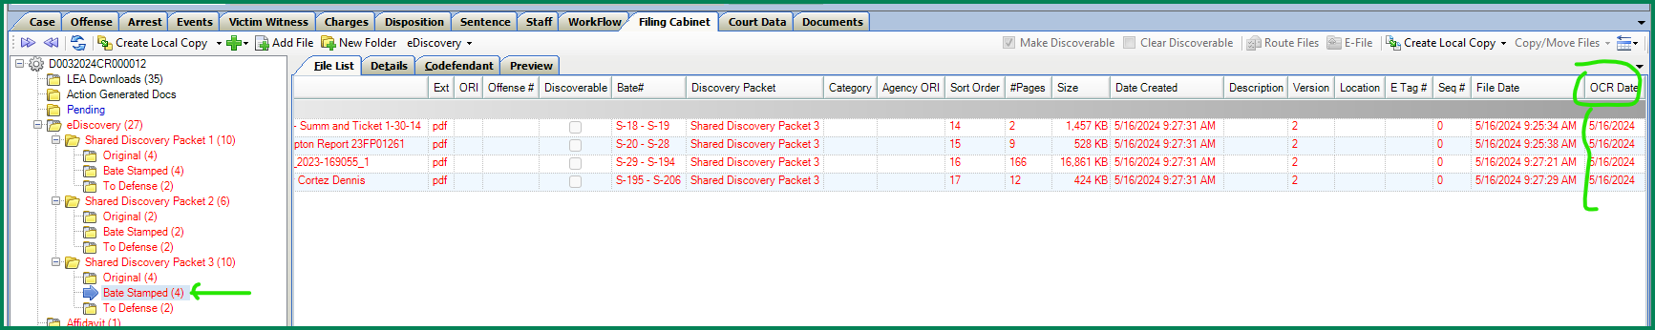

Prosecutor Tools: View Charges Option

**Purpose:** To have a quick method to display charges from dockets and case lists.

**Functionality**: On the Dockets and Case Lists- an option for users to select is: View Charges. This is accessible from the top menu or through a right click menu after highlighting a case row.

The pop-up will show the current active charge counts entered into Action including charge description, charge class and charge statute.

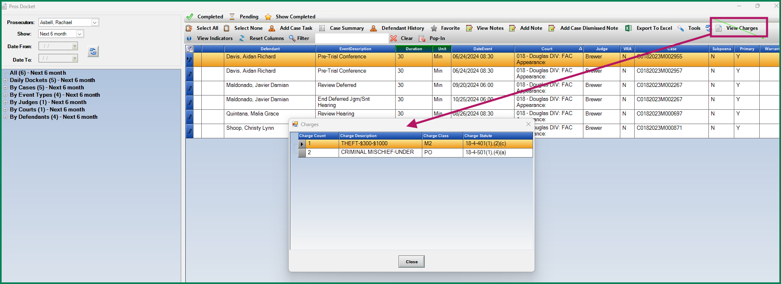

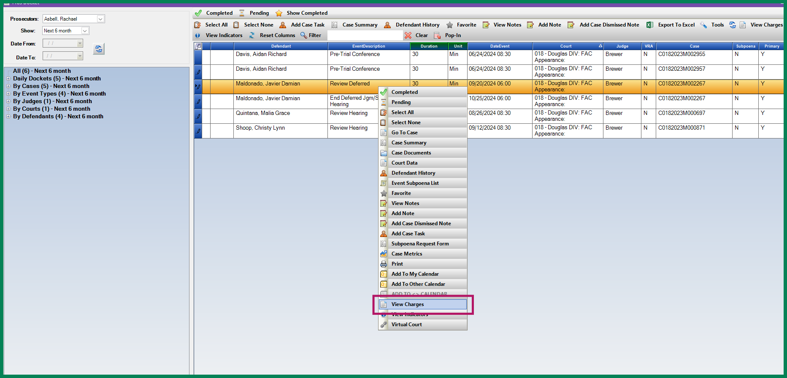

Favorites Case List: Create WF Task

**Purpose:** Create short-cut to create a work flow task from Users favorites case lists.

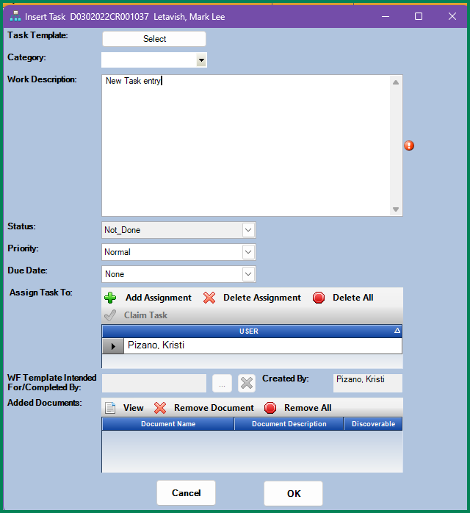**Functionality:** From the Users Favorites Case List, users now have the option to create a work flow task for cases on their list.This is accessible from the top menu or through a right click menu after highlighting a case row.

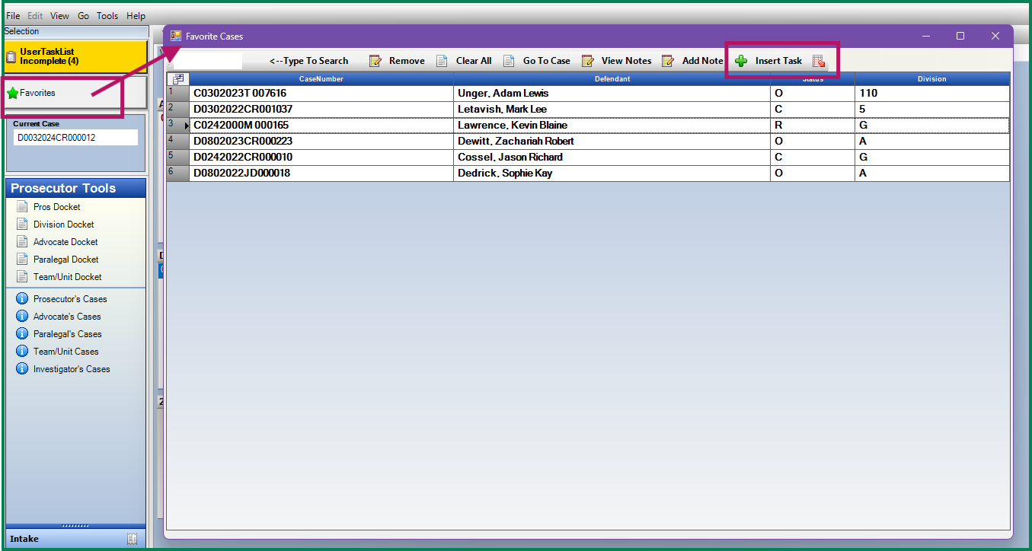

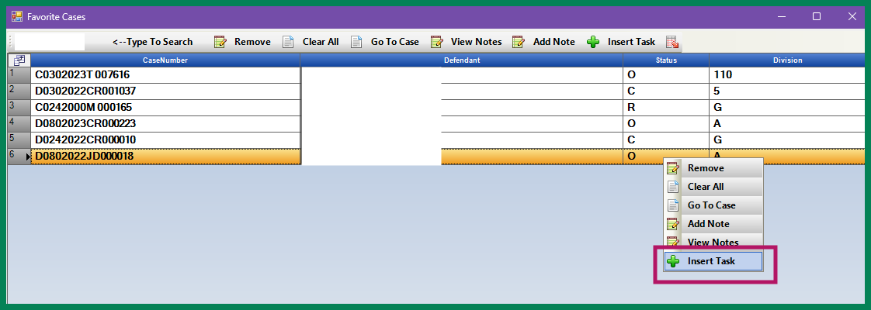

Special Prosecution & COV: Updated Status Message

**Purpose:** Display which district is currently handling the case as a Special Pros or Change of Venue if you district no longer has access to it.

**Functionality:** When doing a case search, if the case is being handled by another judicial district as a Special Prosecution or Change of Venue the message will display which district is now the controlling district as reference.

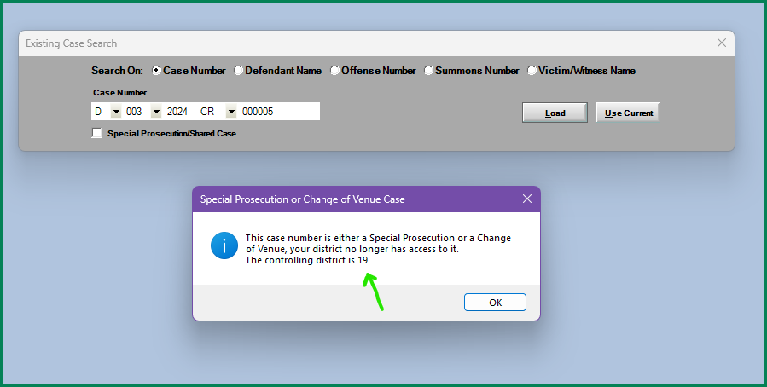

Miscellaneous

Bug Fix: Doc Gen Testing linked documents setting fixed.

Bug Fix: Pros Tools- if an event was added to a calendar multiple times the row for that event was displaying multiple times. This has now be fixed.