Action Enhancement Guide

January 2024 Training Guide



Training Materials can be found on our website on the Action Page

DA Office User Website: <https://coloradoda.org>

Action Questions Contact: [Support@cdac.state.co.us](mailto:Support@cdac.state.co.us)



Table of Contents

1. Auto-Sealing Cases ………………………………………… ………………………………………………. 2-7
2. Case Outcomes: Dismissed Cases ……………….………………………………………………. 8-21

Case Outcome Reasons List …………..……………………………………………12-15

1. Appending Bond Entries from Notes ……………………..…………………………………….. 22
2. Notes: Maximizing Notes ……………………………………………………………………………… 23
3. Notes: Ability to add or leave open a note ………………………………………………….. 24
4. Case Lists: VRA Column added ……………………………………………………………………. 25
5. Favorites Case List: Confirmation before clearing list ……………………………. 26
6. Defense Attorneys: Copy email address for use ……………………………………….. 27
7. Subpoena Status Screen: Grid column for comments ……………………………. 28
8. VW Batch Letter Notes: Add note when batch is printed …………………… 29
9. Miscellaneous smaller enhancements …………………………………………………………. 30

|  |  |
| --- | --- |
| Auto Case Sealings DA’s Offices and Auto Sealings Process Overview  * Quarterly process begins with Judicial detecting all the cases that qualify for the Auto Sealing Process. * Judicial will provide CDAC a list of cases that meet the criteria for Auto Sealing. The first list to be sent starting February 1, 2024. * CDAC will separate received list by district and distribute to each of the DA’s office.   *After the list has been received and is ready for distribution, it will be sent from the CDAC FTP server.  Please email [Kristi@cdac.state.co.us](mailto:Kristi@cdac.state.co.us) with the district contact that will be sent this information.     * DA’s offices then have 45 calendar days from Feb, 1st to object to any of the cases on the Auto Sealing list. (March 17th 2024) * The Auto Sealing Objection template, will be accessed via Action and e-filed to the court utilizing their provided template. This requires a selection of at least one of the five reasons for objection to be marked. See page 4 of guide for process. * The provided list to the DA’s offices will contain: District, Court Location, Case Number, Defendant Names and the highest convicted charge class – M1, M2 etc. * After the 45 calendar days have run, no more objections for the cases in the list can be submitted. Any case where an objection was not e-filed into will then start a Judicial process to be auto-sealed. * The courts have 14 days to seal the cases in their system by April 1, 2024 * Judicial will then provide CDAC a final list of all the cases that were Auto Sealed. * CDAC will then process this list against the cases in Action- setting the case status to Sealed. This process will mimic the current manual sealing case process which includes- Defendant name changes to Record Sealed, File Location set to Sealed Case, Case Note Generated and if District setting is turned on- a pre-fix folders in the file cabinet to Sealed.   **Auto Sealings Quarterly Processing**  Process begins with Judicial detecting all the cases that qualify for the Auto Sealing Process. Judicial will notify CDAC with an Initial list of all cases on February 1, 2024.  Types of cases for Auto-Sealings:  February 1, 2024  Initial List of eligible cases including Misdemeanors, petty offenses and drug convictions (18-18-) must be generated by SCAO, retroactive to 1/1/1998 (statewide ICON rollout). Historical cases that exist only in the forms of paper, microfiche, disc, state archives, and historical ledgers will not be included. A Defendant may still petition to seal such a case/ledger entry.  July 1, 2025    By this date, felony convictions that are not already included in quarter list must be included in the 7/1/2025 list, and in each quarterly list thereafter.    **Schedule for Quarterly Received Lists from Judicial**  2024  February 1, 2024 (late quarterly start so skipping April)  July 1, 2024  October 1, 2024  2025  January 1, 2025  April 1, 2025  July 1, 2025 (Start felony convictions that are already not included will be in lists).  October 1, 2025  **DA’s Process to E-File an Objection to an Auto Sealing case through Action**   1. Review Received Spreadsheet of cases sent by CDAC 2. Access in Action any case that the district wishes to file an objection on. Select “Object to Auto Sealing: under the Case Doc’s drop-down menu on any filed case. 3. This will create and launch the “Objection to Auto Sealing” filing on the E-Filing form. users will use Action accessing the case- and going to Case Doc’s Dropdown menu, selecting Object to Auto Sealing. 4. Users are required to select at least one of the five objection reasons before filing. Users will highlight document and click on “Edit” this opens the document and the five options are displayed. The user will check box the objection reason and then needs to click on the **SAVE icon** on the file and then close it. 5. E-File the document. This removes the case from auto sealing using the document type paired with template. 6. The Court will then mail notice to the defendant informing that the case will not be sealed, and defendant may request a hearing. If accepted the court will set a hearing on petition to seal (court event- HPSL) If the defendant does not request a hearing, the case remains unsealed. | |
|  | |
|  |  |

Case Outcome: Dismissed Case

**Purpose:**  New data fields of Case Outcome and Case Outcome Reason. The first case outcome that will be added for tracking is for a Dismissed Case. This is defined as all of the filed charges having a dismissed disposition type entered onto them under the Disposition tab of the case referencing the entire case has been dismissed. These are not required fields, but entry will aid in your districts data collection answering the questions- How many cases have we dismissed and what are the reasons for the case level dismissals.

Additional Case Outcomes like Deferred will follow in subsequent releases.

**Location:** Action🡪 Cases🡪 Case Header

**Fields:**

Case Outcome; Case Outcome Reason; Change Reason

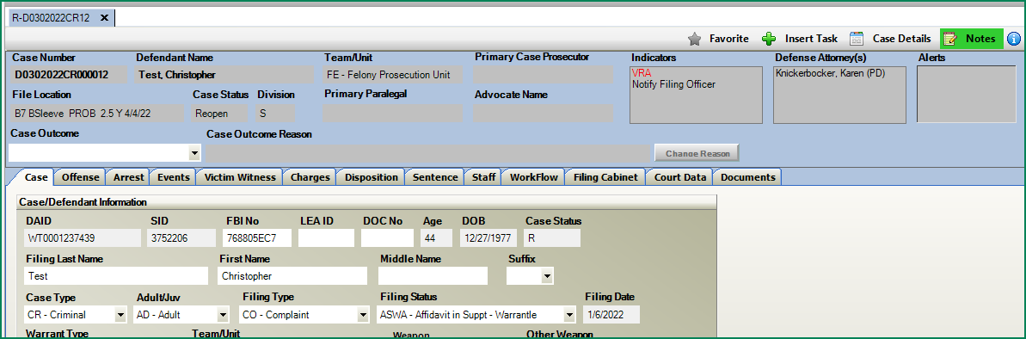

**Functionality:**

* Validation check within Action ensures that all of the charges entered have a dismissed disposition type or the Case Outcome of Dismissed cannot be set.
* If Validation check passes a new pop-up will appear prompting the user to set the Case Outcome to Dismissed.

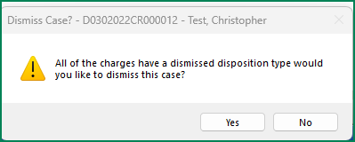

Example: All Charges on this case have one of the Dismissed Dispo Types entered.

*Validation* runs automatically and pop-up appears asking the user if they would like to set the case outcome to dismissed.

Dismissed Dispo Code Types sent from Judicial:

|  |  |
| --- | --- |
| DMCT | Dismissed By Court |
| DMDA | Dismissed By Dist Attorney |
| DMNF | Dismissed By Dist Attorney - N |
| DMPL | Dismissed by Plea |
| DSPR | Dismissed by prosecutor |
| DFSA | Dismissed Finding Set Aside |

. The user can select Yes or No.

**Yes**= Dismiss Case Wizard options appear in secondary pop-up. Users can set the Case Outcome, Reason and are also presented with a wizard option to also create a Motion & Order to Dismiss and then to also Close the Action case.

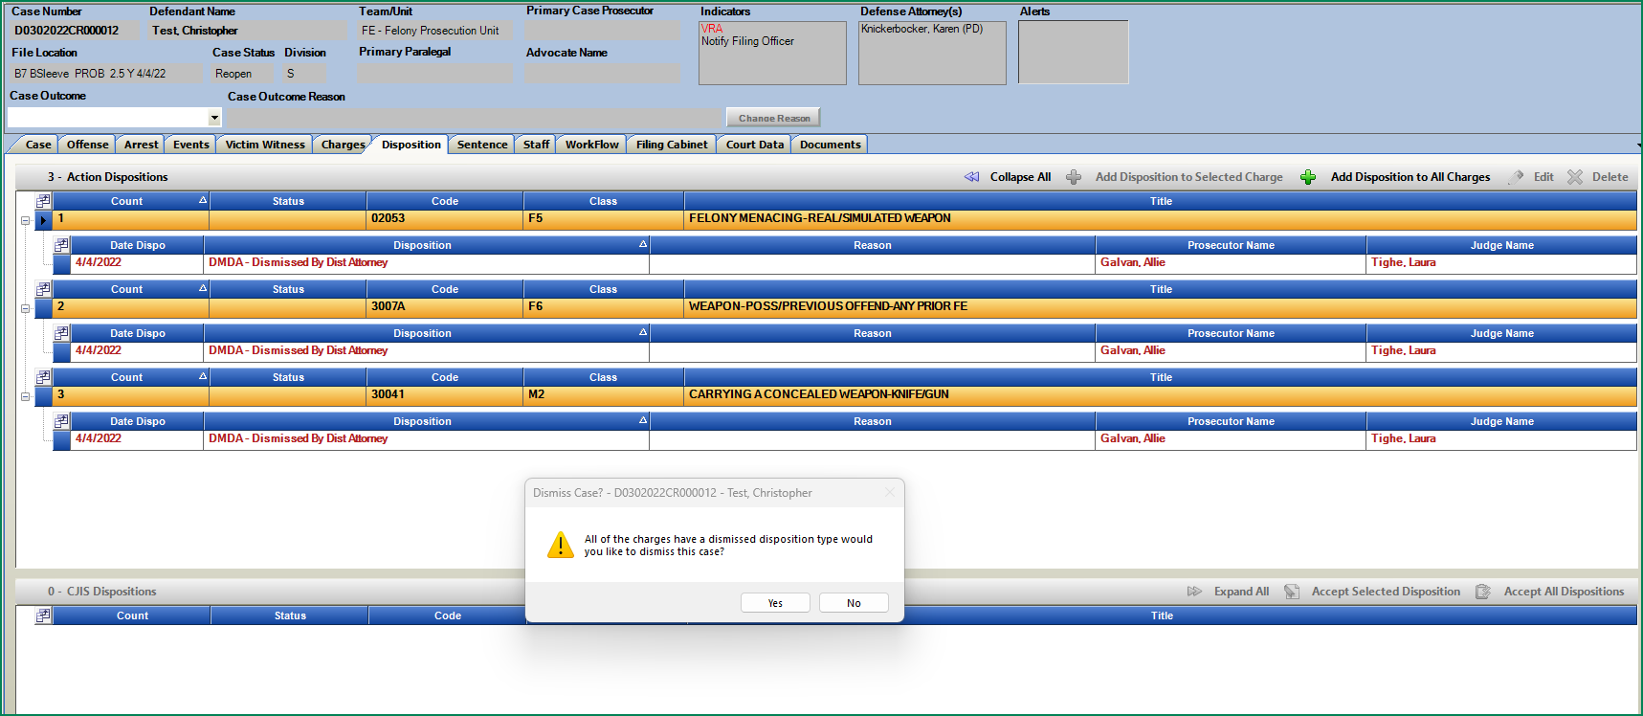**No**= Closes the pop-up. Case outcome can be added anytime via the dropdown selection case outcome/dismissed when user is ready.

If Yes: Second Pop-up for Wizard opens with these additional options.

User can checkbox which options they would like to perform at this time.

Click on Proceed

* Set Case Outcome and Select Dismissed Reason
* Create Motion & Order to Dismiss Case
* Close Case (grayed out if close case validation detects that validation is not currently met- example pending future event or event without event Action).

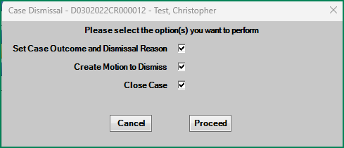

*Validation:* If all of the charges do not have a latest dated dismissed type of disposition entered on them, then a case outcome of Dismissed cannot be set.

**Case Outcome Dismissed Reason Screen:**

Prompted from pop-up or if selected from Case Outcome field dropdown.

Users can select a reason for the case dismissal. This grid is searchable using the Search Content field to help filter results for selection. The grid provides reasons, categories, definitions, used for and not to be used for columns with information for more consistent data entry.

Only one reason can be selected for this case level dismissal.

*How do you know which Dismiss Reason to select?*

Users can reference notes entered by the Prosecutor on the case. Referenced in the next section- New Noting type for Dismissed cases, which if entered will appear on this screen so that users have a good idea of what to select.

The Prosecutor can enter these notes or create a wf task for the user if helpful to identify what to select.

The added note type is accessible under Notes on the Docket and Case List views

**Case Outcome Dismissed Reason Screen**

* DA Note: See following pages to how that can be populated from Notes
* Search Content: Search for any word within the reason grid. (Grid content referenced on next page)
* 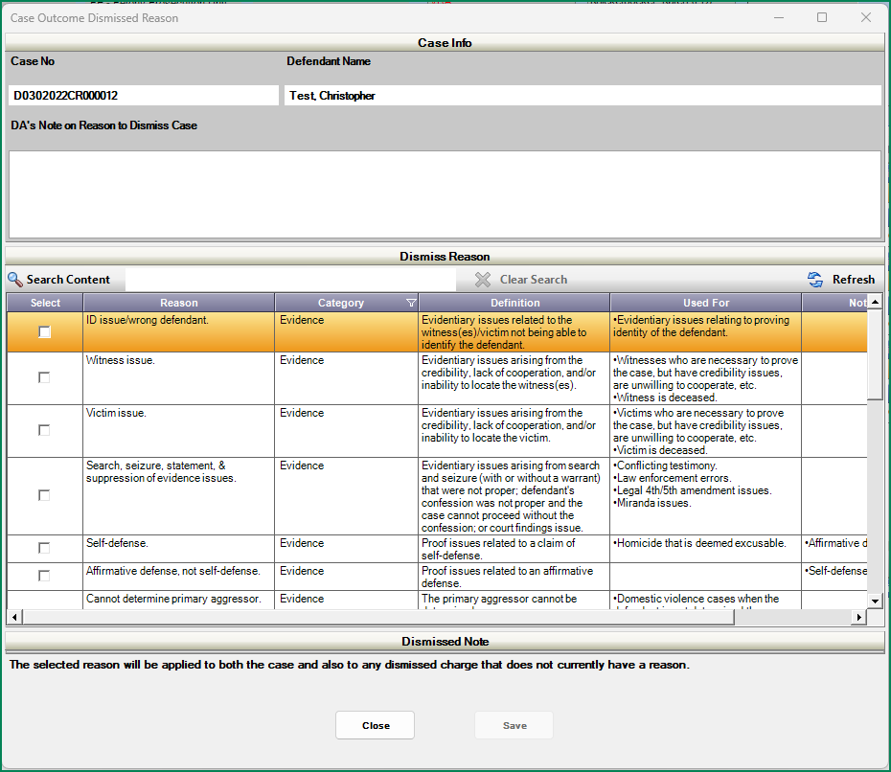Select the appropriate reason for the case level dismissal and click on Save.
* Dismissed Note * if the dispositions on each charge did not already have a reason associated with them, the reason selected here will populate onto them. If a Reason had already been selected at the charge level those remain as selected.

|  |  |  |  |  |  |  |  |
| --- | --- | --- | --- | --- | --- | --- | --- |
| Action Reason Code | Action Reason Code | Reasons | Reason Type | Category | Definition | Use for: | NOT to be used for: |
| _A01 | D/M: ID issue/wrong defendant | ID issue/wrong defendant | Dismissed Reasons | Evidence | Evidentiary issues related to the witness(es)/victim not being able to identify the defendant. | ●        Evidentiary issues relating to proving identity of the defendant. |  |
| _A02 | D/M: Witness issue | Witness issue | Dismissed Reasons | Evidence | Evidentiary issues arising from the credibility, lack of cooperation, and/or inability to locate the witness(es). | ●        Witnesses who are necessary to prove the case, but have credibility issues, are unwilling to cooperate, etc. |  |
|  |  | ●        Witness is deceased. |
| _A03 | D/M: Victim Issues | Victim issue | Dismissed Reasons | Evidence | Evidentiary issues arising from the credibility, lack of cooperation, and/or inability to locate the victim. | ●        Victims who are necessary to prove the case, but have credibility issues, are unwilling to cooperate, etc. |  |
|  |  | ●        Victim is deceased. |
| _A04 | D/M: Seach/Seizure Suppressed Evidence | Search, seizure, statement, & suppression of evidence issues. |  |  | Evidentiary issues arising from search and seizure (with or without a warrant) that were not proper; defendant's confession was not proper and the case cannot proceed without the confession; or court findings issue. | ●        Conflicting testimony |  |
|  |  | ●        Law enforcement errors |
| Dismissed Reasons | Evidence | ●        Legal 4th/5th amendment issues |
|  |  | ●        Miranda issues. |
|  |  |  |
| _A05 | D/M: Self-defense | Self-defense | Dismissed Reasons | Evidence | Proof issues related to a claim of self-defense. | ●   Homicide that is deemed excusable. | ●        Affirmative defense |
| _A06 | D/M: Affirmative Defense | Affirmative defense, not self-defense | Dismissed Reasons | Evidence | Proof issues related to an affirmative defense. |  | ●        Self-defense |
| _A07 | D/M: Cannot determine primary aggressor | Cannot determine primary aggressor | Dismissed Reasons | Evidence | The primary aggressor cannot be determined. | ●        Domestic violence cases when the defendant is not determined the primary aggressor (when not self-defense per se). |  |
| _A08 | D/M: Lack/Incomplete element of offense | Lack/incomplete element of offense | Dismissed Reasons | Evidence | Proof issues related to corpus, element of intent, and/or element of possession. |  |  |
| _A09 | D/M: Discovery Issues | Discovery issues |  |  | Discovery was not received. | ●        Evidence was suppressed for discovery violation. |  |
| Dismissed Reasons | Evidence | ●        Discovery is necessary but has not and cannot be provided. |
| _A10 | D/M: Lab results inconclusive/negative | Lab results inconclusive/ negative | Dismissed Reasons | Evidence | Substance tests were negative for controlled substances, inconclusive forensic evidence, and/or lab results were not received. |  |  |
| _A11 | D/M: Evidence Supports Misdo charge | Evidence only supports misdemeanor charge | Dismissed Reasons | Evidence | The evidence only supports a misdemeanor charge. | ●        Felony charge that is dismissed because an element of the charge isn’t met by the evidence. |  |
| _A12 | D/M: Evidence Supports Felony charge | Evidence supports felony charge | Dismissed Reasons | Evidence | The evidence supports a felony charge with proper approval. | ●        Misdemeanor charge that is dismissed due to up-filing (converted to a felony). |  |
| _A13 | D/M: Further investigation needed | Further investigation needed | Dismissed Reasons | Evidence | An arrest warrant when an officer needs to complete further investigation. |  |  |
| _A14 | D/M: Charge/case consolidated | Charge/case consolidated | Dismissed Reasons | Change in Case | Charge is dismissed and consolidated with another existing case/charge. |  |  |
| _A15 | D/M: Diversion/Restorative Jus/Def Pros | Diversion, restorative justice, or deferred prosecution | Dismissed Reasons | Change in Case | Charge is dismissed due to successful completion of post-file diversion, restorative justice, or deferred prosecution programming. |  |  |
| _A16 | D/M: Provided Proof of Drivers Lic/Reg | Provided proof of driver's license/registration | Dismissed Reasons | Prosecutorial Discretion | The defendant has provided proof of a valid driver's license or vehicle registration. |  |  |
| _A17 | D/M: Referred to other agency | Referred to other agency |  |  | The case is referred to a different law enforcement agency (state or federal), another DA’s Office, or U.S. Attorney’s Office. | ●        Referred to the military to prosecute; |  |
| Dismissed Reasons | Prosecutorial Discretion | ●        Youth bureau; |
|  |  | ●        A different state or, federal jurisdiction; |
|  |  | ●        Another judicial district. |
| _A18 | D/M: Pursuant to plea negotiations | Pursuant to plea negotiations - pled to other charge or case |  |  | Dismissal due to plea negotiations. | ●        Dismissed as part of a global agreement. | ●        Sending the case to another office or agency for prosecution. |
| Dismissed Reasons | Prosecutorial Discretion | ●        In coordination with plea agreements across jurisdictions. |
| _A19 | D/M: Victim Requests no prosecution | Victim requests no prosecution | Dismissed Reasons | Prosecutorial Discretion | The victim requests no prosecution. |  | ●        Evidentiary issues arising from the credibility, lack of cooperation, and/or inability to locate the victim. |
| _A20 | D/M: Def Cooperated with LEA | Defendant cooperated with law enforcement | Dismissed Reasons | Prosecutorial Discretion | Dismissal due to cooperation with law enforcement. |  |  |
| _A21 | D/M: Interest of Justice or Fairness | Interest of justice or fairness. | Dismissed Reasons | Prosecutorial Discretion | The charge is provable but for equitable reasons the prosecutor is choosing not to proceed. | ●        As a last resort with detailed notes, if no other reason is applicable. | ●  Do not use it if another reason applies. |
| _A22 | D/M: Legal or Process Issue | Legal or process issue |  |  | Charge dismissal due to legal and/or process issues. | ●        Statute of limitations has expired |  |
|  |  | ●        Defective summons; |  |
|  |  | ●        Speedy trial has expired; |  |
| Dismissed Reasons | Legal/Process | ●        Lack of jurisdiction/venue; |  |
|  |  | ●        Double jeopardy; |  |
|  |  | ●        Or when there is a judicial determination of no probable cause. |  |
| _A23 | D/M: Competency Issue | Competency issue | Dismissed Reasons | Defendant Specific | The defendant has competency issues. |  |  |
| _A24 | D/M: Sanity Issue | Sanity issue | Dismissed Reasons | Defendant Specific | The defendant has sanity issues. |  |  |
| _A25 | D/M: Defendant Deceased | Defendant deceased | Dismissed Reasons | Defendant Specific | The defendant is deceased. |  |  |
| _A26 | D/M: Direct Filed as an adult | Direct filed as an adult | Dismissed Reasons | Juvenile Specific | The juvenile case is dismissed due to the defendant being charged as an adult. | ●        The juvenile case is dismissed, pursuant to the requirements of statute, and re-filed in adult court. |  |
| _A27 | D/M: Other Juv Specific reason | Other juvenile specific reason | Dismissed Reasons | Juvenile Specific | The juvenile is improperly filed in adult court or when the officer is to issue a civil citation. | ●        The charge is provable but the prosecutor is choosing not to proceed since the defendant is juvenile. |  |
|  |  | ●        The officer is directed to issue a civil citation in a juvenile case. |  |

**Dismissed Case Note**

From Docket Views or Case List select Notes and new option: Add Case Dismiss Note

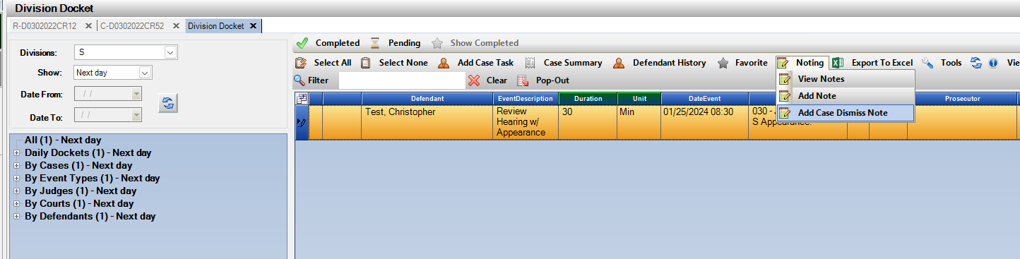

Right click option: Add Case Dismiss Note

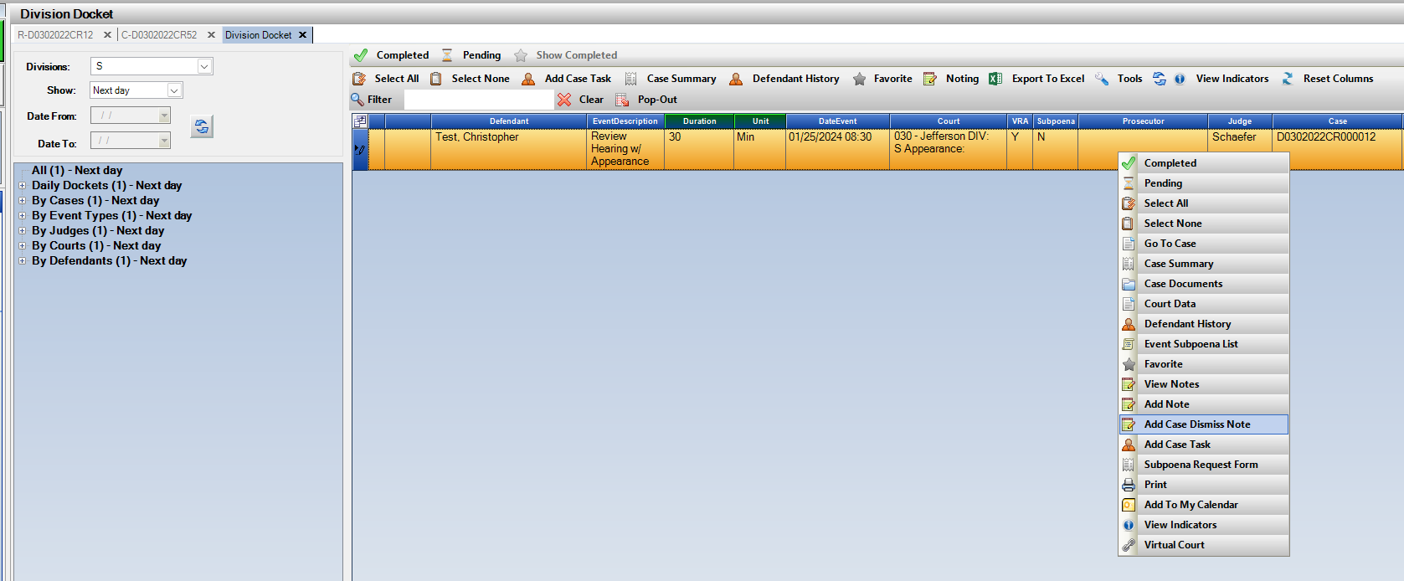

Note Sub Type: Dismissal

Subject: Case Dismissed Note

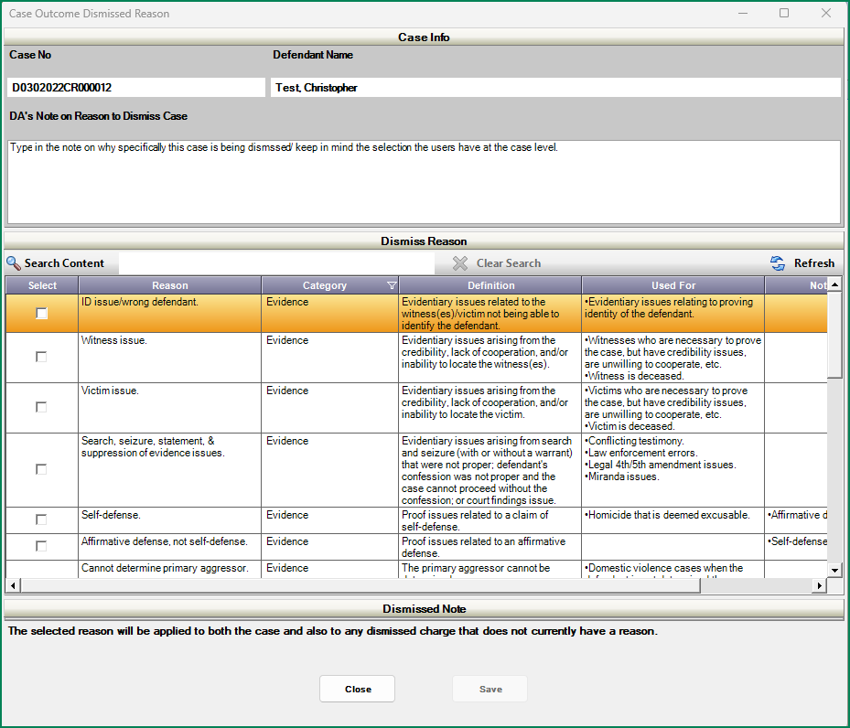This entered Note then appears on the Case Outcome Dismissed Reason screen. 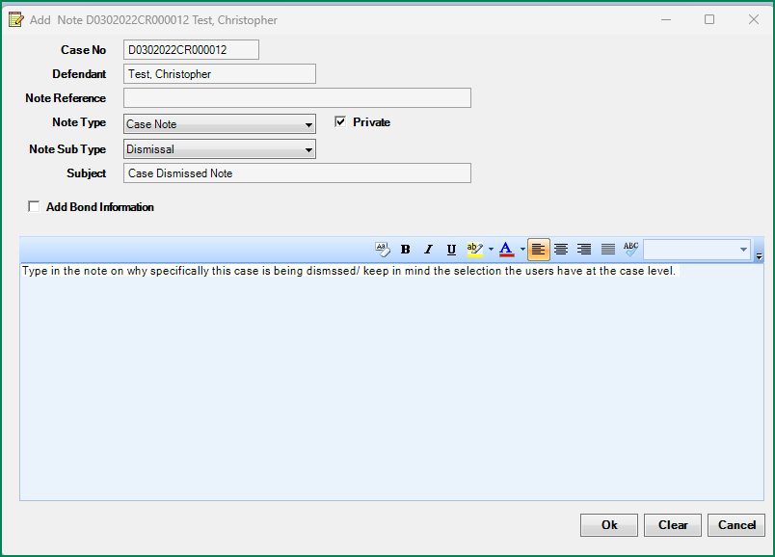

**Motion and Order to Dismiss**

If selected with the wizard, this Motion to Dismiss will open next. It displays the Case Dismissal Reason that was selected. User can click on the “Copy from Dismissal reason” to add that text for the motion or the user can type in any info. into the Motion to Dismiss Text section. When saved, the motion and order will generate on the e-filing form from within Action to submit to Judicial.

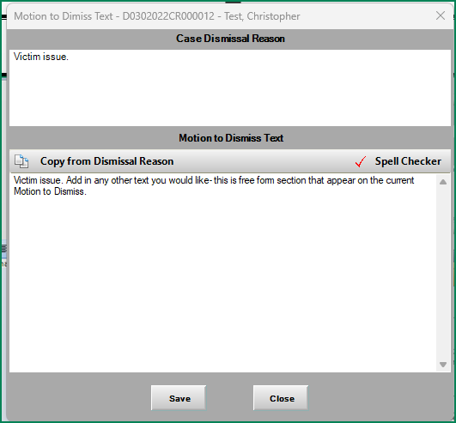

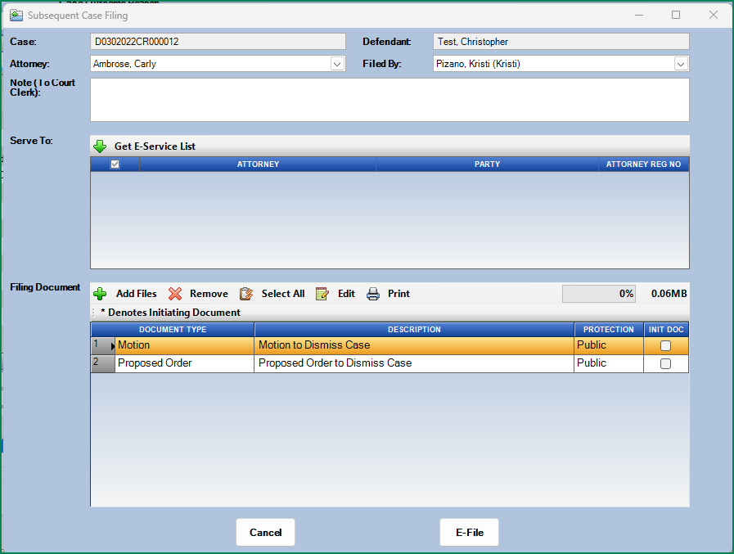*Note the Motion and Order can still also be accessed from Case Documents🡪 Motions 🡪 Motion to Dismiss Case at any time.

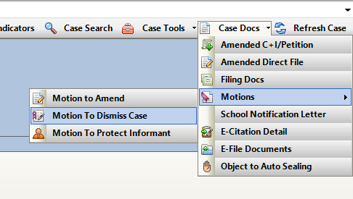

**Case Outcome and Case outcome reason is now set based on your selection.**

If there was not a reason entered for the charge level dismissed dispositions on the disposition tab, the selected case outcome reason will be added at the charge level.

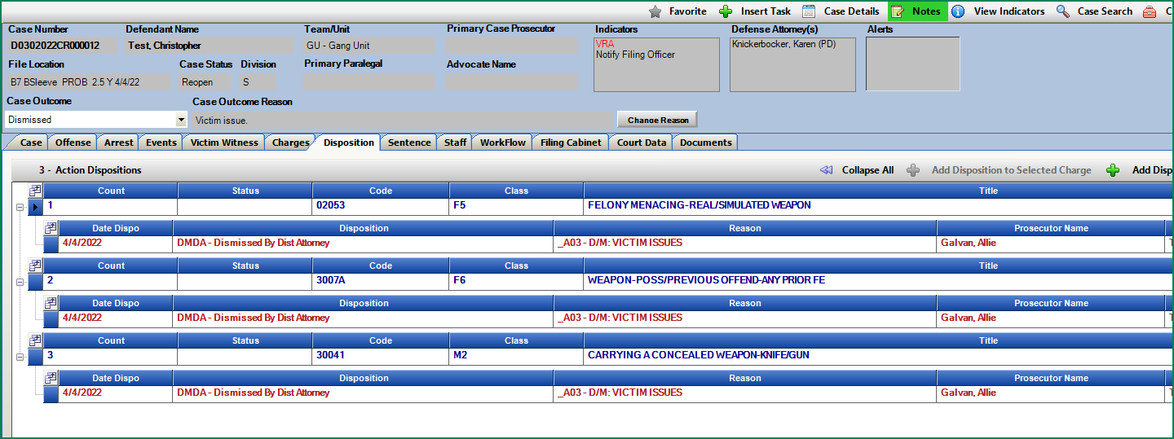Charge level reasons if selected prior to selecting the case outcome reason will remain at the charge level.

**Change the Case level Outcome Reason:**

Click on Change Reason button- for case level outcome. Any change will only change at the case level and not re-update the charge dispos.

Please note case outcome is set to dismissed, but case status is still Open- continue to close out case as normal.

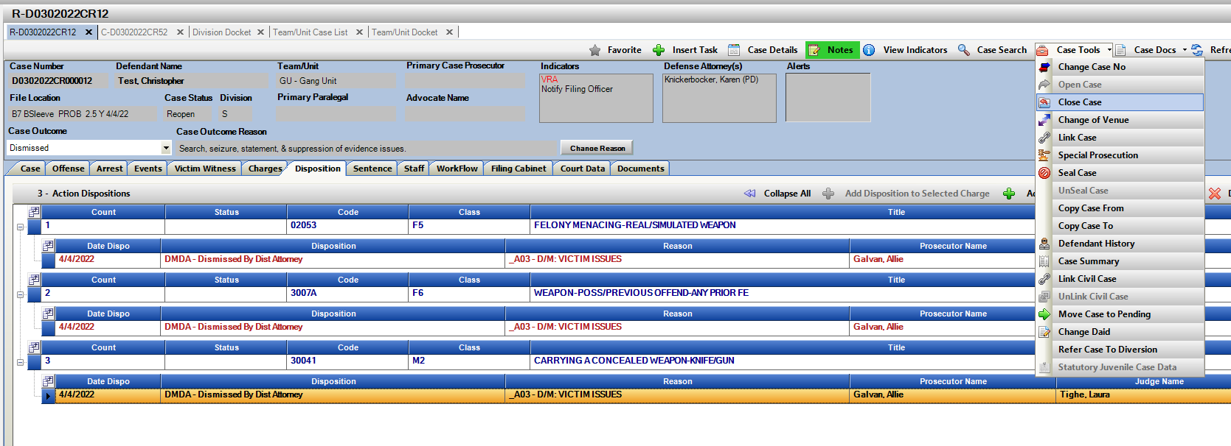*Setting case outcome and reasons is accessible on all case statuses.

**Close Case:**

If Close Case was also selected in the wizard the close case validation will then run popping up the current close case screen.

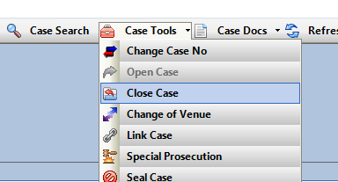This can also be selected manually under Case Tools 🡪 Close Case.

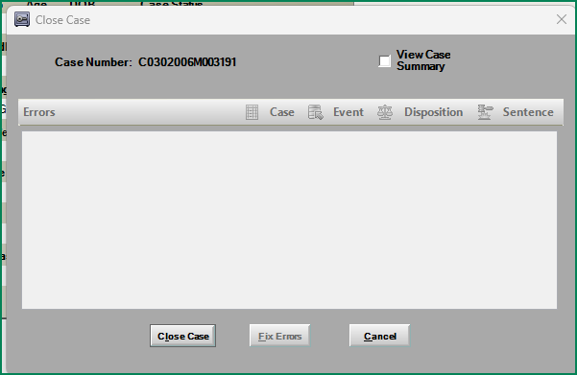

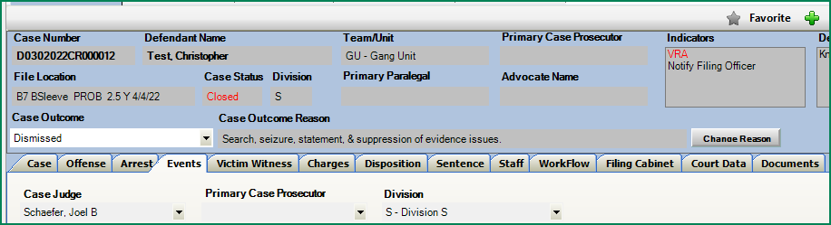Example- Case Status is Closed and Case Outcome and Case Outcome Reasons have been set.

Appending Bond Entries from Notes: Requested & Granted information will save to note text.

**Purpose:** When appending notes and adding or modifying bond information the noting text displayed in the note will now also update.

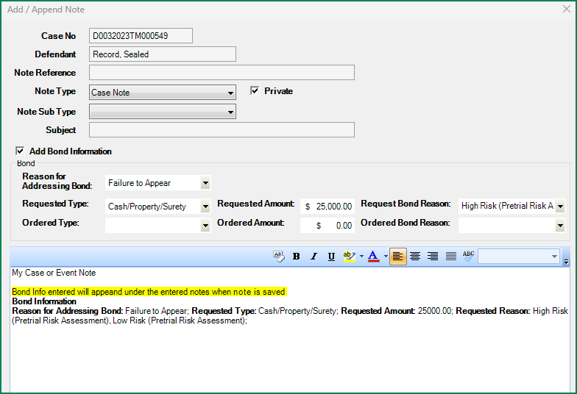

Notes: Maximizing Notes form will expand the notes text section.

**Purpose:** When expanding the note section, the note text field will now expand with the window size allowing for more content visibility while creating a note.

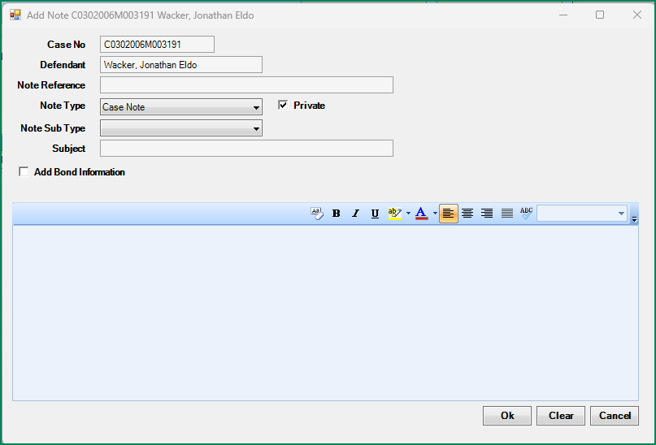

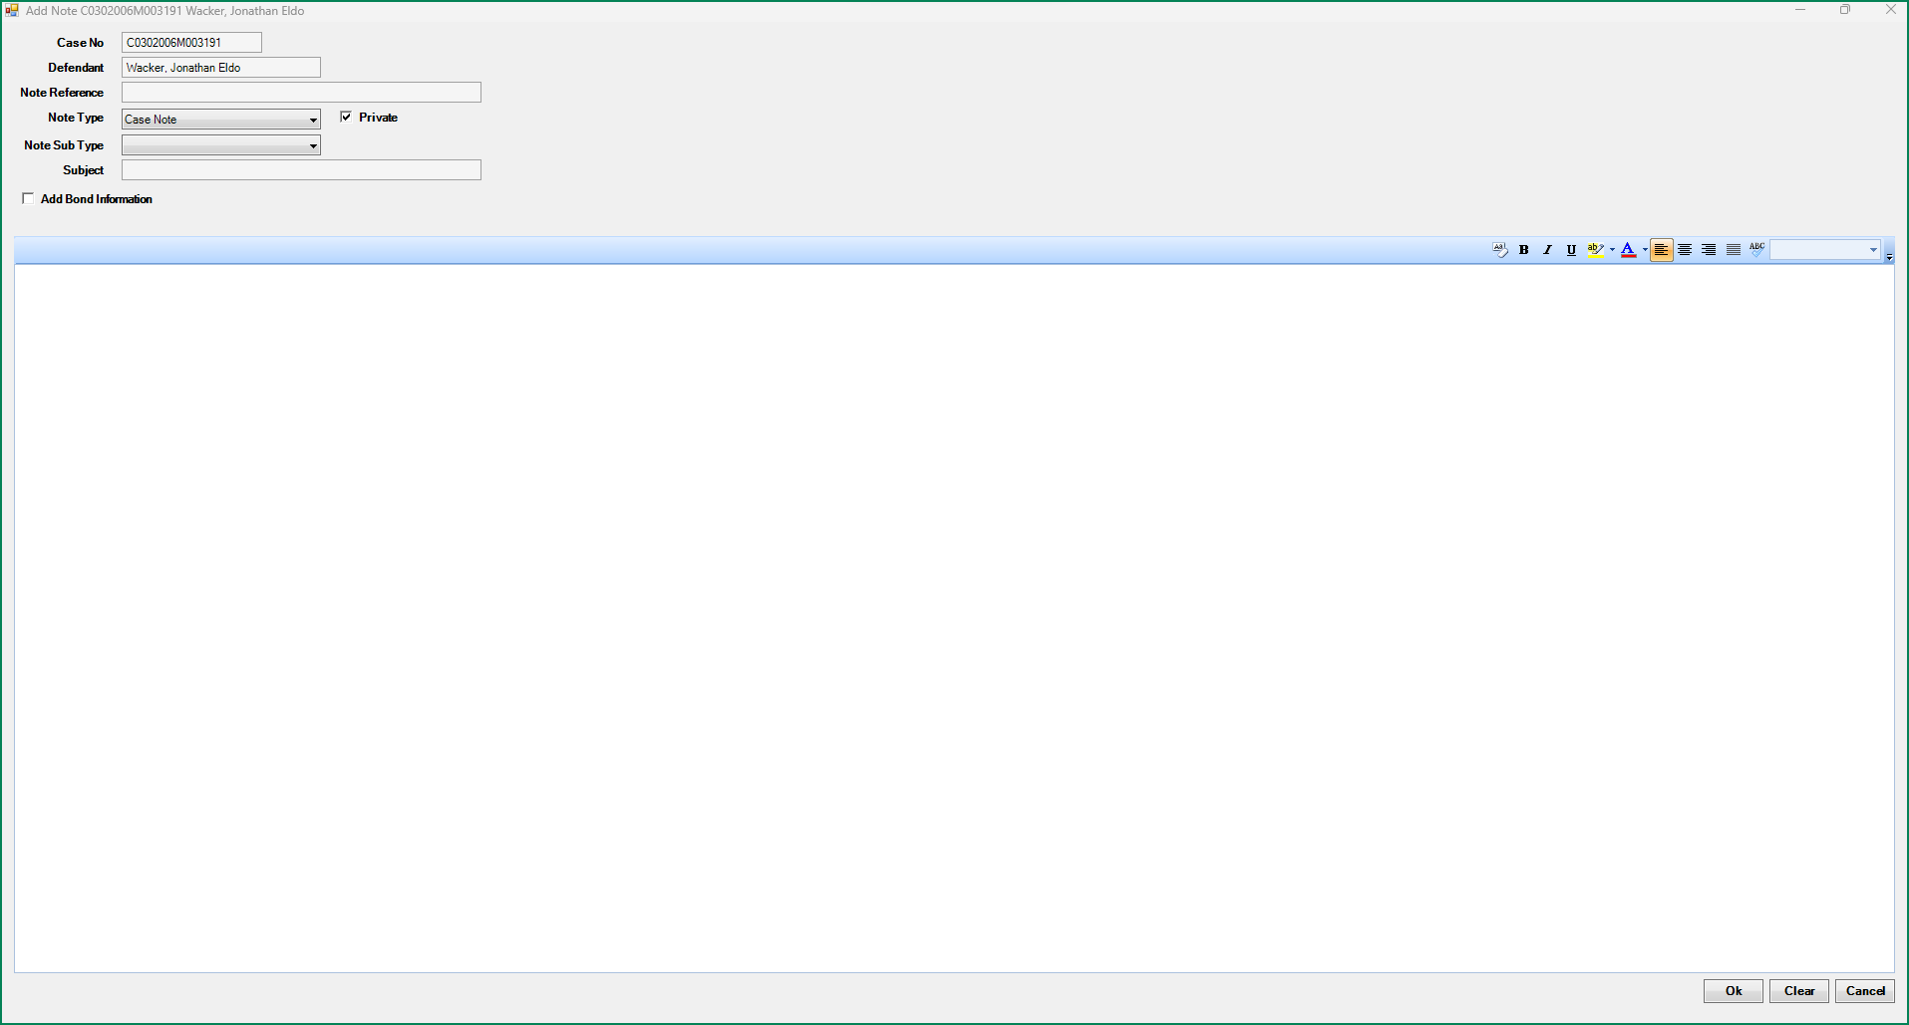

Notes: Ability to view or add notes while continuing to work on an Action case.

**Purpose:** To allow for continued work on cases while adding or viewing notes within a case without having to close out of the notes. Functionality that has been on the dockets and case listing for notes is now extended to the case level. Users can start a note minimize or move to another screen while continue to work within Action. The minimized notes will go to the Action icon in the tray.

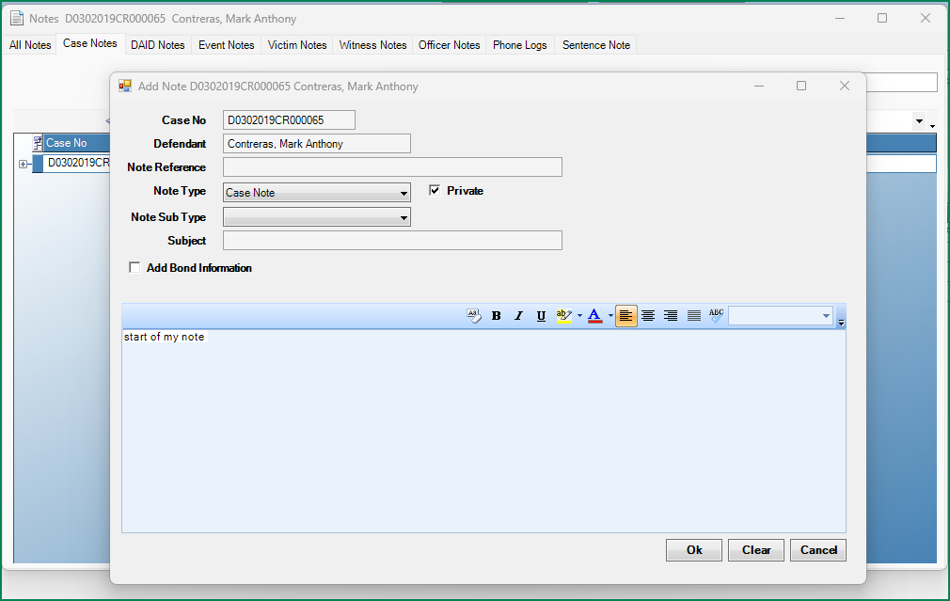

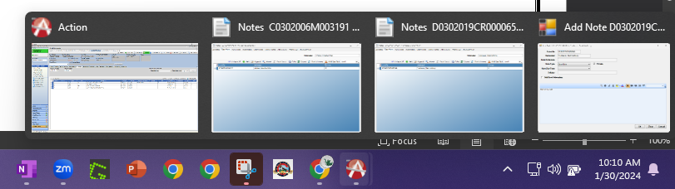

Case Lists: VRA column added to Case list views.

**Purpose:** Case lists options under Prosecutor Tools have the VRA column now added as a default. This was previously only on the docket views but has been expanded to the case listings as well. The VRA in this column is referenced as one or more witness on the case is flagged as VRA required on their record.

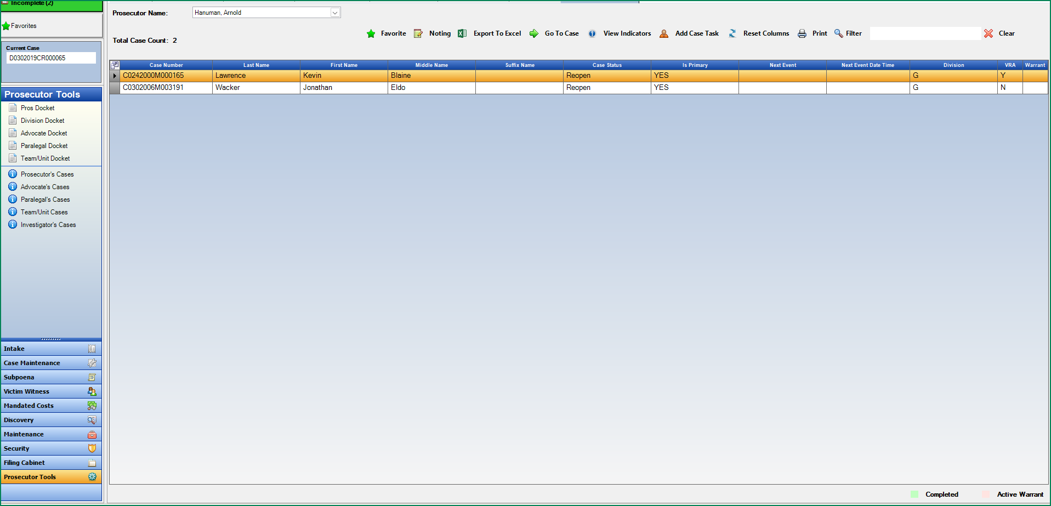Favorites: Added Pop-up to confirm clearing of list.

**Purpose:** Favorites list🡪 Remove or Clear All will now confirm with the user prior to clearing list of selected or all favorited cases.

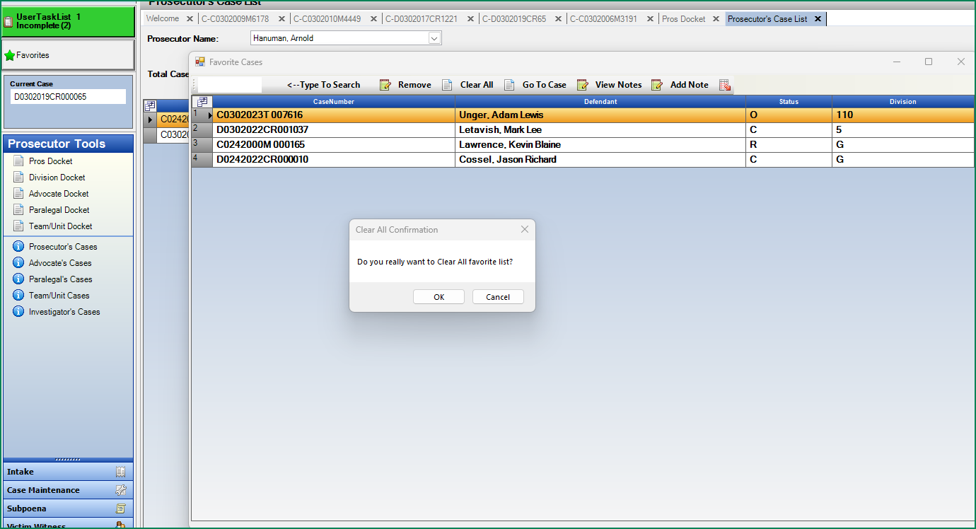

Defense Attorney: Copy email address

**Purpose:** Quick access to copy a defense attorney’s email address. When the i -Icon is selected the defense details appear and the email is highlighted. Ctrl + C to copy and then paste as needed.

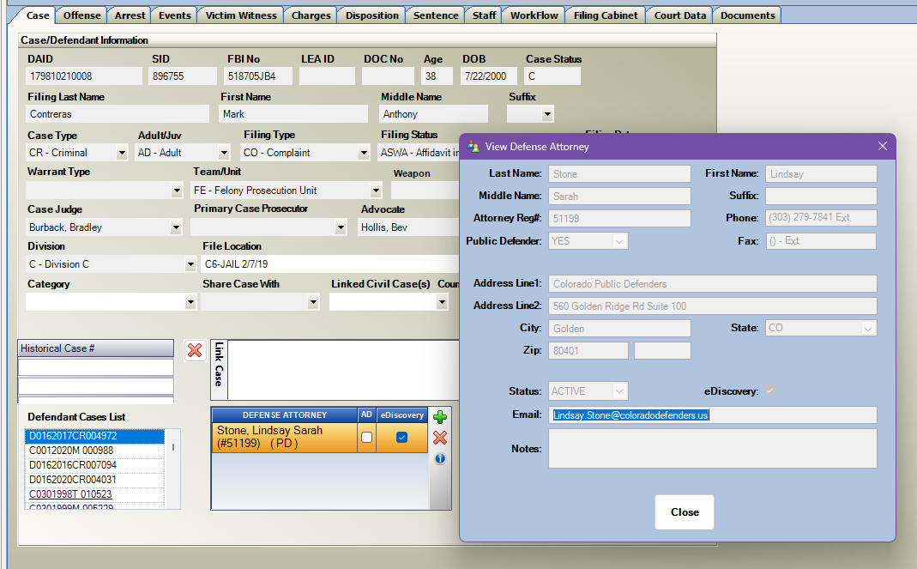

Subpoena Status Screen: Grid column for comments

**Purpose:** Column for Comment has been added to the grid display. If a user enters a comment on a Subpoena record then the grid will indicate Y and if user places mouse over it will display from the grid the comment in a tool tip.

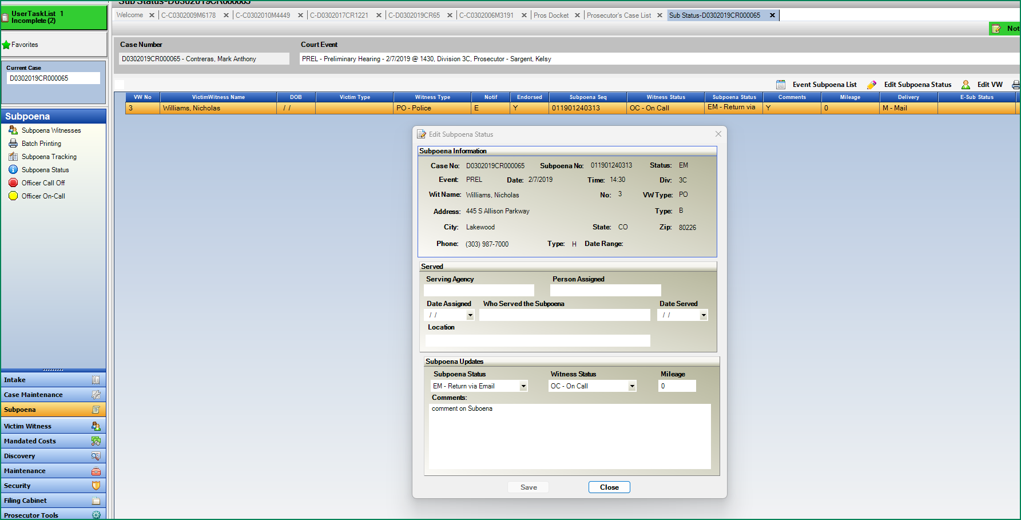



Victim Witness Batch Letter Note: VW note will now be generated when a batch is printed, instead of when batch was generated.

**Purpose:** For Districts currently on VW Batch Letters, there is functionality to generate a VW note to the witness. This functionality is changing to only create the note after the batch is printed vs. when the batch was produced.

This enhancement will also go back and remove any VW note that had been created but the batch never printed. This will help ensure that notes are more accurately added only if the batch is printed.

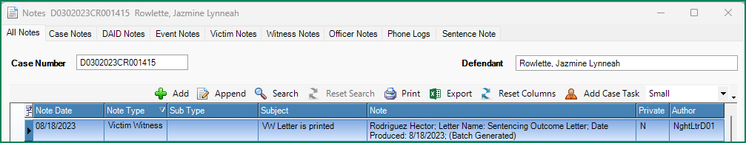

Miscellaneous

Court Data Tab: Resize for scaling and 4k resolution monitors.

Non-Multiple Case view: Added Min/Max Close to screens in Pros Tools.

Workflow templates: Modified some WF templates so that forms are not cut off in different resolutions.

Traffic Intake Form: Arrest ORI field updated to allow users to type in an ORI instead of using search only.

Intake: Filings cases from Intake to Case Maintenance added logic to help with an occasional occurrence that charges were not appearing after case moved from Pending to Open.

Dispositions: Corrected functionality in accepting all dispositions from Judicial and ability to add the same reason code to all charges at that time.