Action Enhancement Guide

April 2024 Training Guide



Training Materials can be found on the CDAC website on the Action Page

CDAC Website: <https://coloradoda.org>

Action Questions: [Support@cdac.state.co.us](mailto:Support@cdac.state.co.us)



Table of Contents

1. Case Outcome: Deferred and Split Deferred Options …………………………… 3-9
   1. Deferred Reasons …………………………………………………………………… 6
2. Auto Sealings: Alert box will show Auto Sealed ………………………………….. 10
3. Multiple Open Case: Case Tabs will include Defendant Last Name …….. 11
4. Copy Case To and Copy Case From:
   1. Notes: Copy Case Notes Option………………………………………………… 12-13
   2. Workflow: Copy Workflow Tasks Option ………………..……………….. 14-15
5. DA Case Tools: Separate Add/View/Dismiss Note buttons …………………… 16
6. Offense Tab: Copy Information from Offense grid…….…………………………… 17
7. Victim Witness Tab: Add Witness Email to grid and copy from grid………. 18-19
8. Miscellaneous Updates/Corrected Functionality……….………………………….. 20

Case Outcome- Deferred Options

**Purpose:** To track Case outcome and reasons for Deferred Dispositions.

**Functionality:** Once a case has an entered Deferred or Deferred Spilt Dispositions users can enter a related Case Outcome from the Disposition screen along with a Deferred Outcome Reason. There is NOT validation for these on the disposition screen to prompt a user, these will be manually selected by the users appropriately if the district wishes to track this information.

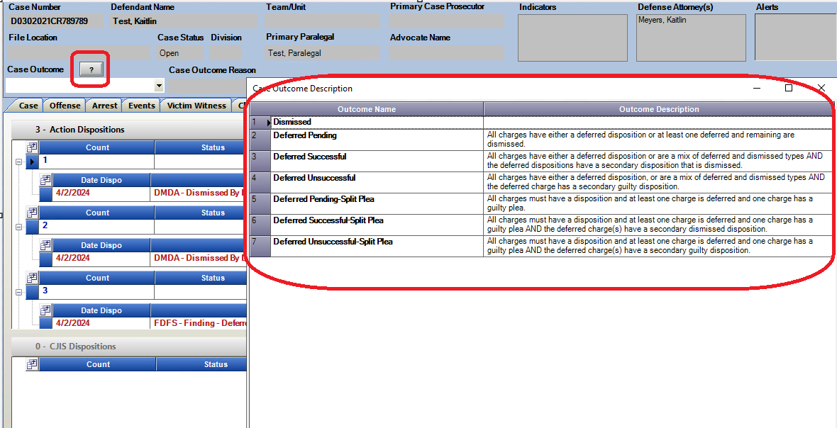Case outcome descriptions: Click on the Question mark box icon next to Case Outcome.

**Deferred Pending:**  All charges have either a deferred disposition or at least one deferred and remaining are dismissed.

**Deferred Successful:**  All charges have either a deferred disposition or are a mix of deferred and dismissed types AND the deferred dispositions have a secondary disposition that is dismissed.

**Deferred Un-successful:**  All charges have either a deferred disposition, or are a mix of deferred and dismissed types AND the deferred charge has a secondary guilty disposition.

**Deferred Split- Pending**: All charges must have a disposition and at least one charge is deferred and one charge has a guilty plea.

**Deferred Split- Successful**: All charges must have a disposition and at least one charge is deferred and one charge has a guilty plea AND the deferred charge(s) have a secondary dismissed disposition.

**Deferred Split- Unsuccessful:** All charges must have a disposition and at least one charge is deferred and one charge has a guilty plea AND the deferred charge(s) have a secondary guilty disposition.

Choose the correct Outcome per the description and a pop-up dialogue will show the selection and give the option to Set Case Outcome and Deferral Reason and if the other entries on the case meet the criteria to close a case then a user can select this option here as well to close it after completing the case outcome.

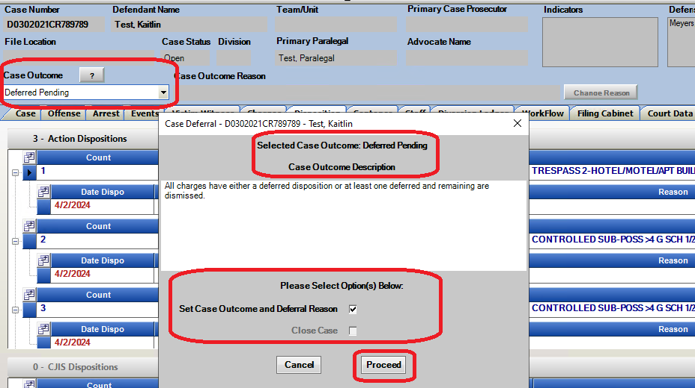

The Deferred Reasons are then displayed for selection. If a Deferred note is entered it will be shown as a case note. Grid content can be searched for in the Search Content field.

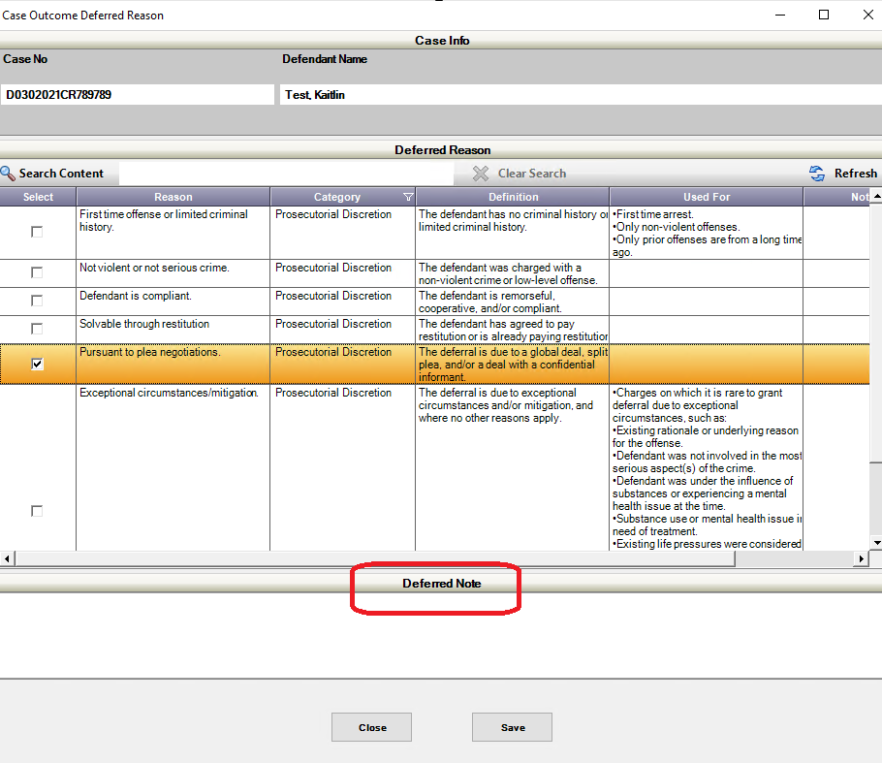

Deferred Note:

If Deferred note field is utilized a Case Note is generated as reference.

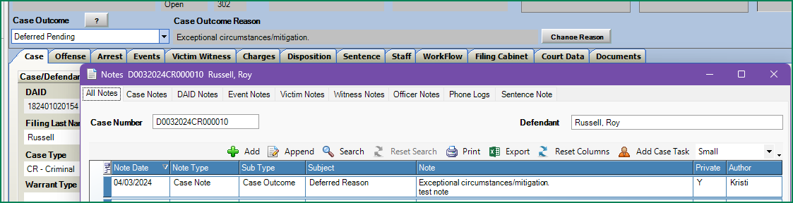

Edit Case Outcome Reason:

If this reason needs to be updated or additional information added, select Change Reason. The same Pop-up dialogue will be available to make changes.

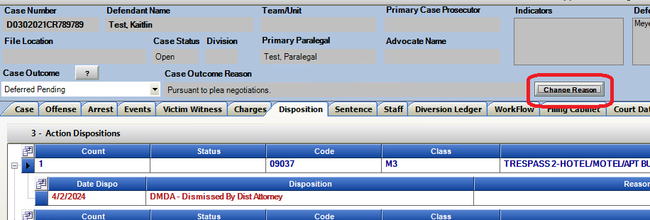

|  |  |  |  |  |
| --- | --- | --- | --- | --- |
| **Reason Types** | **Category** | **Reason** | **Definition** | **Use for:** |
|  |  | First time offense or limited criminal history | The defendant has no criminal history or limited criminal history. | ●        First time arrest. |
| Deferral Reason | Prosecutorial Discretion | ●        Only non-violent offenses. |
|  |  | ●        Only prior offenses are from a long time ago. |
| Deferral Reason | Prosecutorial Discretion | Not violent or not serious crime | The defendant was charged with a non-violent crime or low-level offense. |  |
| Deferral Reason | Prosecutorial Discretion | Defendant is compliant | The defendant is remorseful, cooperative, and/or compliant. |  |
| Deferral Reason | Prosecutorial Discretion | Solvable through restitution | The defendant has agreed to pay restitution or is already paying restitution. |  |
| Deferral Reason | Prosecutorial Discretion | Pursuant to plea negotiations | The deferral is due to a global deal, split plea, and/or a deal with a confidential informant. |  |
| Deferral Reason | Prosecutorial Discretion | Exceptional circumstances/ | The deferral is due to exceptional circumstances and/or mitigation, and where no other reasons apply. | ●        Charges on which it is rare to grant deferral due to exceptional circumstances, such as: |
|  |  | mitigation |  | ●        Existing rationale or underlying reason for the offense; |
|  |  |  |  | ●        Defendant was not involved in the most serious aspect(s) of the crime; |
|  |  |  |  | ●        Defendant was under the influence of substances or experiencing a mental health issue at the time; |
|  |  |  |  | ●        Substance use or mental health issue in need of treatment; |
|  |  |  |  | ●        Existing life pressures were considered (business, school, family, or peer pressure); |
|  |  |  |  | ●        Offense was an accident |
|  |  |  |  | ●        Age of defendant (minor or young); |
|  |  |  |  | ●        Facing deportation; |
|  |  |  |  | ●        Deemed to have a promising future or unlikely to commit a crime in the future. |

**Examples of Deferred Outcomes:**

**Deferred Pending:**  All charges have either a deferred disposition or at least one deferred and remaining are dismissed.

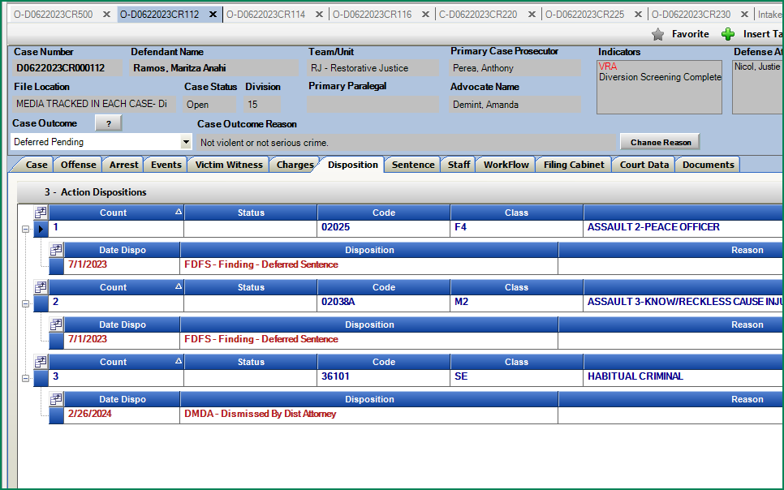

**Deferred Successful:**  All charges have either a deferred disposition or are a mix of deferred and dismissed types AND the deferred dispositions have a secondary disposition that is dismissed.

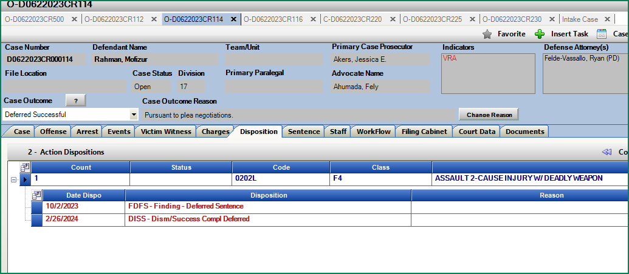

**Deferred Un-successful:**  All charges have either a deferred disposition, or are a mix of deferred and dismissed types AND the deferred charge has a secondary guilty disposition.

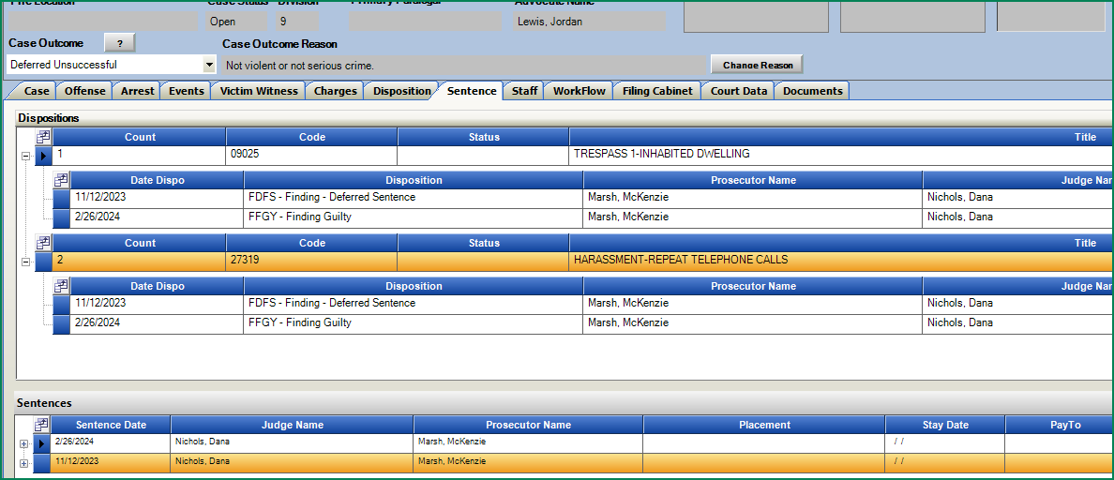

**Deferred Split- Pending**: All charges must have a disposition and at least one charge is deferred and one charge has a guilty plea.

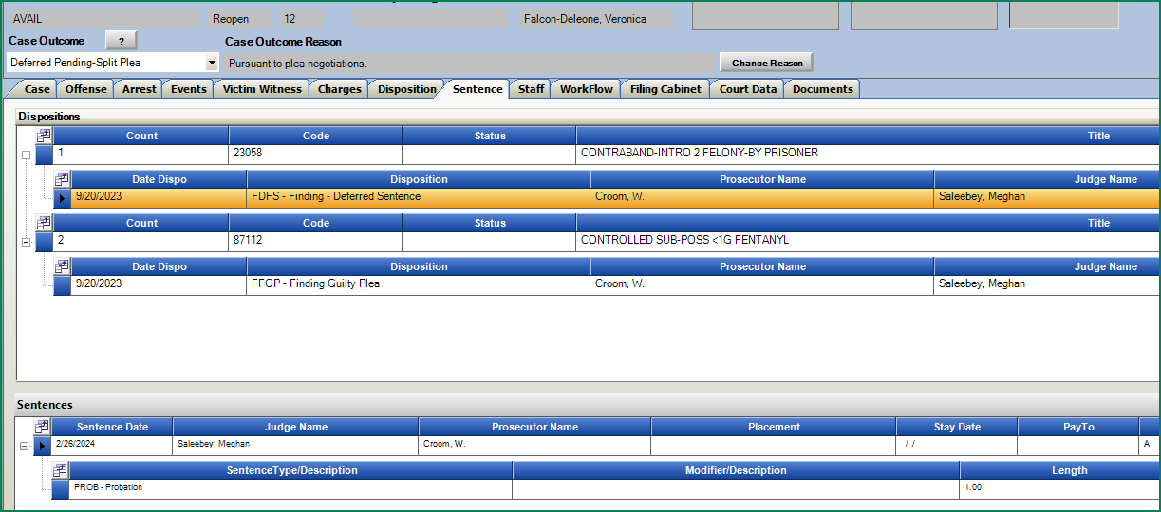

**Deferred Split- Successful**: All charges must have a disposition and at least one charge is deferred and one charge has a guilty plea AND the deferred charge(s) have a secondary dismissed disposition.

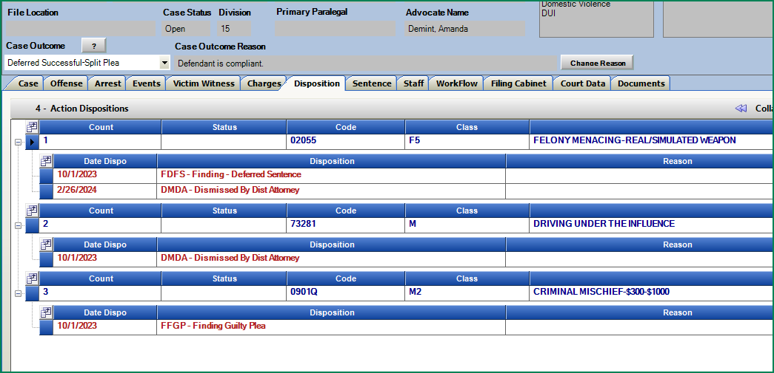

**Deferred Split- Unsuccessful:** All charges must have a disposition and at least one charge is deferred and one charge has a guilty plea AND the deferred charge(s) have a secondary guilty disposition

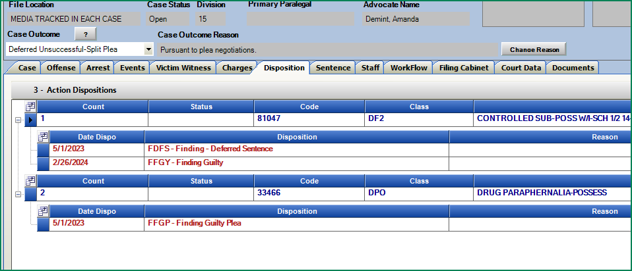

Auto Sealing: Case Alert

**Purpose:** Case level notification that if a case has been part of the Auto-Sealing process and not objected to and was officially sealed by Judicial. This will help distinguish within Actio

**Functionality**: When a case has been Auto Sealed by Judicial they will send CDAC a final list of all the cases sealed by the auto process. CDAC will utilize the list to update at the case level that a case has been Sealed, in addition the Alert on the case header will also indicate this case was Auto Sealed. This will not be set when users seal cases manually through Action

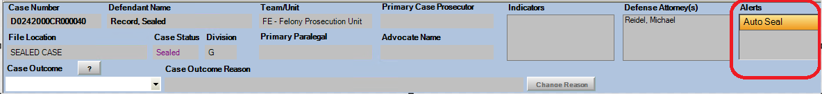

Multiple Open Cases: Tabs for cases will include Defendant Last Name.

**Purpose**: In Multi-Tab mode users can reference the defendant’s last name along with the case number and case status.

**Functionality**: With multiple cases open, the Case tabs will display the Status referenced with a O-Open, P-Pending, C-Closed, S-Sealed, N- No File at the beginning and the case number and defendant last name for easy identification.

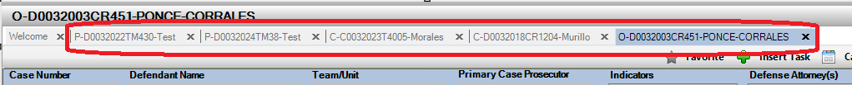

Copy Case To & Copy Case From: Copy Case Notes

**Purpose:** While utilizing the existing Copy To and Copy From functions, case notes can now also be copied.

**Functionality**: Copy To and Copy From feature under Case Tools. Added Checkbox to include option for copying Case Notes. This will allow users to copy notes designated as “Case Notes” as part of the copy process. Other noting types are not included at this time. Those can be manually copied if needed from one case to another.

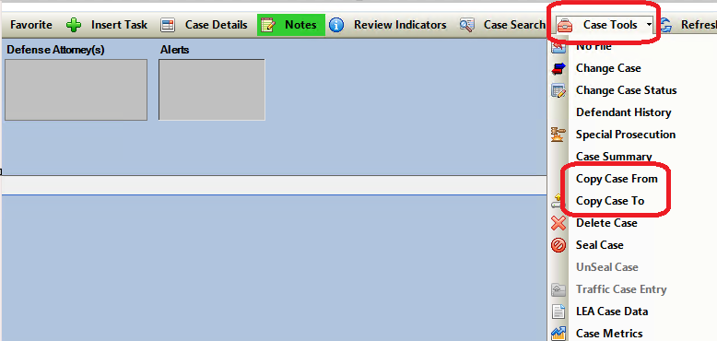

Enter the case you want to copy to or copy from and a pop up will show your options to select.

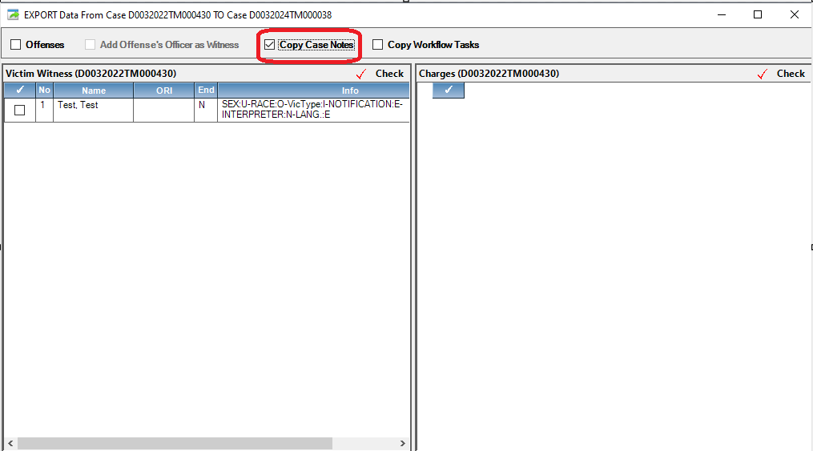

The Case Notes will remain on the original case but will create a copy of these Case Notes on the case that is chosen. There will be a reference on the Note as to the which case this Note was copied from. Note* The copied notes show the date the notes were copied not when they were created.

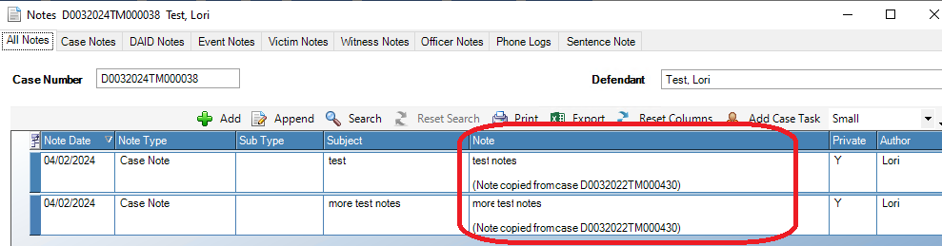

Copy Case To & Copy Case From: Copy WorkFlow Tasks

**Purpose**: While utilizing the existing Copy To and Copy From functions, Workflow Tasks can now also be copied.

**Functionality**: Copy To and Copy From feature under Case Tools. Added Checkbox to include option for copying Workflow tasks.

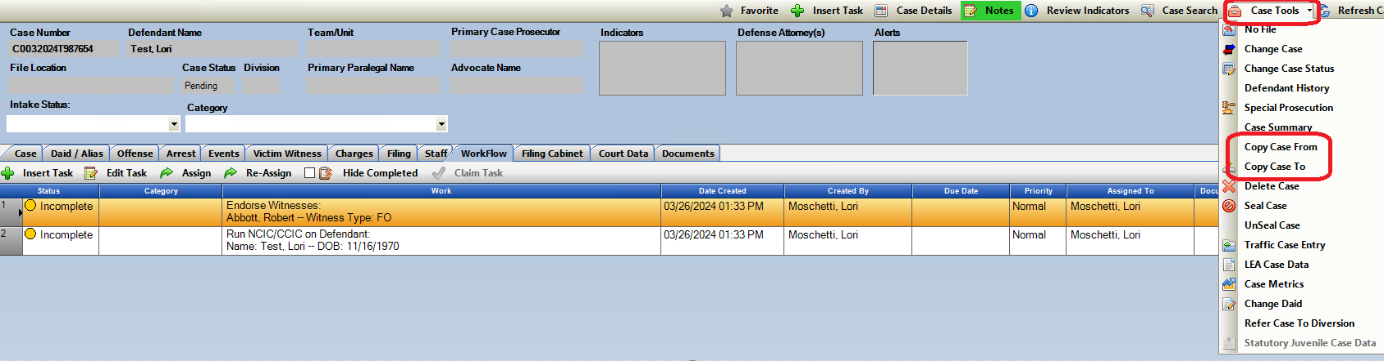

Enter the case you want to copy to or copy from and a pop up will show your options to select.

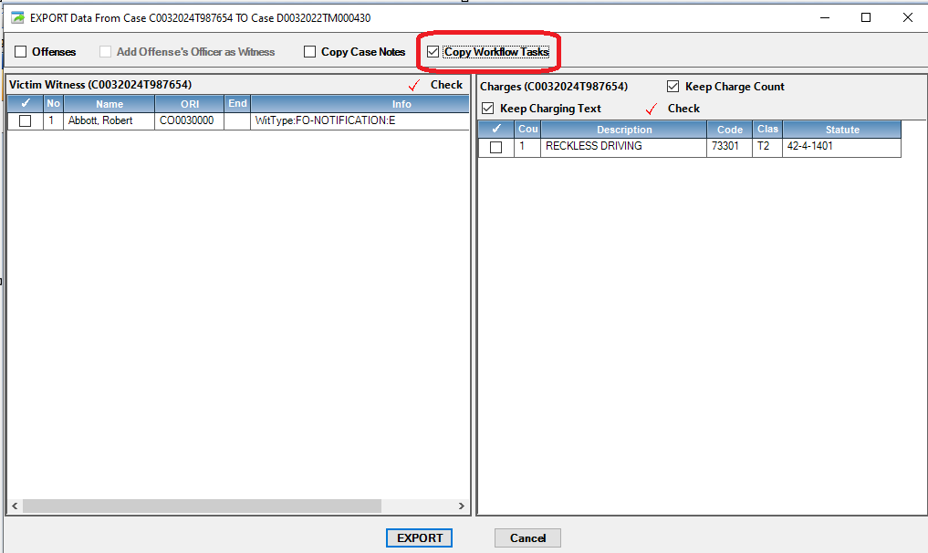

The Workflow tasks will remain on the original case but will create a copy of these tasks on the case that is chosen. There will be a reference on the task as to the which case this task was copied.

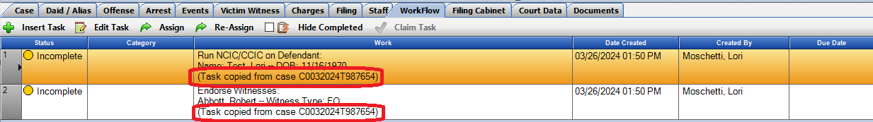

Prosecutor Tools: Separate Note Buttons on all Dockets and Case Lists

**Purpose:** This had previously been a dropdown with options, but has been separated back out into separate buttons for quicker access.

**Functionality:** Quickaccess toView Notes, Add Note and Add Case Dismissed Note within a Docket or Case List. These options also exist on a Right mouse click on a selected row of the grid.



Highlight designated case, choose type of note and this will initiate a pop up.

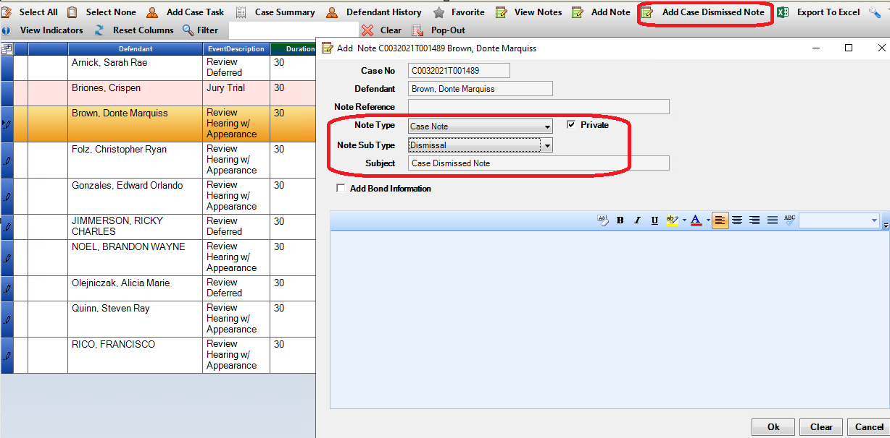

Offense Tab: Ability to copy information from the grid.

**Purpose:** Quickly copy specific offense information per field from the grid without needing to go into edit the record. This includes Offense/Summons Number, ORI, Agency Name and Officer Name.

**Functionality**: Highlight a field under the main Offense drop down and select Ctrl C. This will copy this information for easy transfer. To Paste selection, use Ctrl P or right click and select Paste.

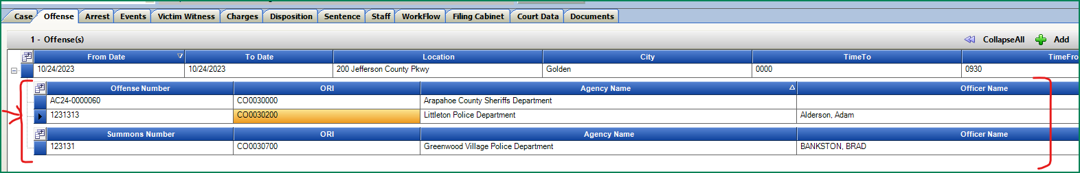

Victim Witness Tab: Ability to add Witness Email to the grid and copy email address from the grid.

**Purpose:** Ability to view a witness email from the main view grid and quickly copy it.

**Functionality:** Userscan select Witness Email from the Field Chooser on the Victim, Witness Tab. This is a per user preference and will be saved until a user selects “reset columns” or unselects from the Field Chooser.

*Note: If there is more than 1 email listed for a witness, the latest entered Active entry will be displayed. Inactive emails will not be shown.

**Adding column to Grid:**

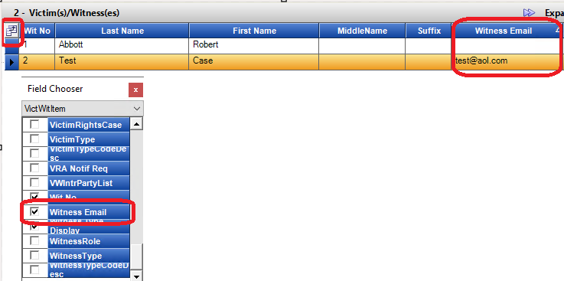

**Copy Witness Email from Grid:**

Users are able to highlight the witness email from this grid and select Ctrl C to copy this email.

*Note: If a user clicks on this witness email field from the grid and it’s not highlighted as below initially but the entire row is highlighting, have them click on “Re-Set Columns” button on the page and then re-select Witness Email option.

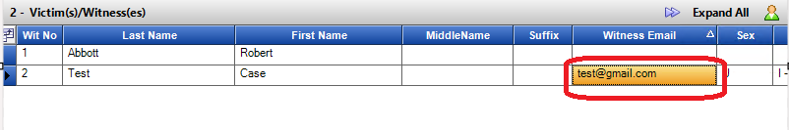

Miscellaneous Updates

Prosecutor Tools- Dockets: Corrected functionality: In Single mode after minimizing the docket window and a User then re-selects the same docket, this will re-launch that form.

Prosecutor Tools: Corrected functionality: Sort column fixed to retain the selected user sort after an event is marked as completed.

Notes: Corrected functionality: When viewing notes and then Add Note is selected the case notes grid will now stay expanded instead of closing click on Add note from this window, the grid stays expanded.

Victim/Witness Tab: Expanded character limit on VW email length is expanded to accommodate longer email addresses.

Un-Sealed Case Status: If a case is set to a sealed case status and then it is unsealed, the case status will be Closed – if a user needs to re-open the case, they can use the Open case option under case tools- working backwards to set the status then to Re-Open.

DAID: Corrected functionality for pending Intake Traffic cases on Standard Entry form when changing or updating DAID.

.