Action Enhancement Guide

September 2023 Training Guide



Training Materials can be found on our website on the Action Page

DA Office User Website: <https://coloradoda.org>

Action Questions Contact: [Support@cdac.state.co.us](mailto:Support@cdac.state.co.us)



Table of Contents

1. User Task List- Add Case Status as Column ………………………………………………. 3
2. Edit Drug Charges Type/Quantity and Unit ………………………………………………. 4
3. Initial Warrant Amount Requested ……………………………………………………………… 5-6
4. Bond Entries from Notes Requested and Granted …………………………………….. 7-11
5. Docket and Case List Filter ……………………………………………………………………………… 12
6. Update to Victim Services – Victimization and Categories ……………………… 13-15

User Task List

**Purpose:** Update to User Task list – option to display case status

**Location:** Action 🡪 User Task List 🡪 Field selector

**Fields:**

Case Status

**Functionality:** Users can add in a column for case status to the User Task List. This will allow each user to add to their user preference through the field selector. Select Case Status and then the column will appear. Users can sort by this column on the grid.

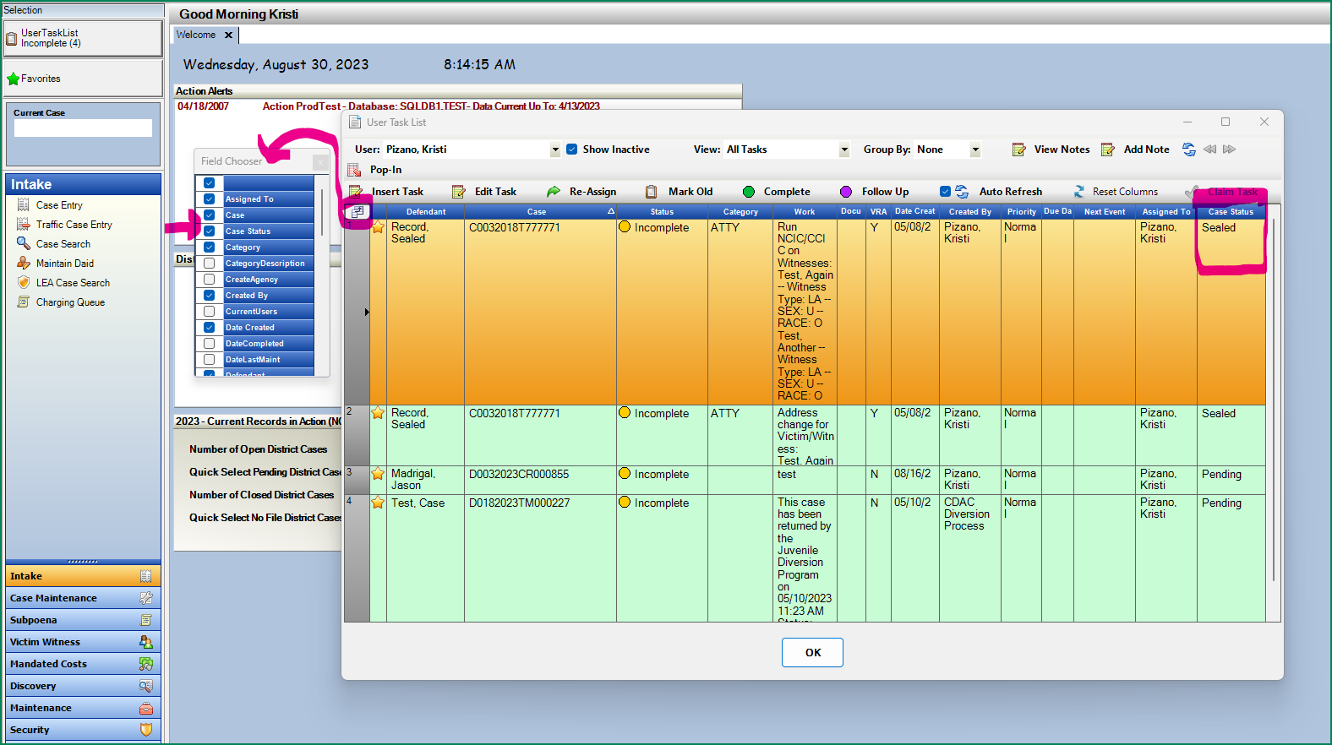Edit Drug Charges- Type/Quantity/Unit

**Purpose:**  Allow users to update drug type/quantity/unit on filed charges instead of being locked down after filing.

**Location:** Action🡪 Cases🡪 Charges Tab

**Fields:**

Drug Charge fields- Drug Type/Quantity/Unit

**Functionality:** Filed drug charges can now be edited to allow users to enter or edit the drug type/quantity or unit amount. Highlight the charge from the Chares Tab within a case and click on Edit. The 3 drug fields are now editable. *Note these edits will not update the charge text. This is not to replace the functionality of Amending a charge but to edit the charge with information that is now available. This will assist in reporting functions of drug information as well for your districts.

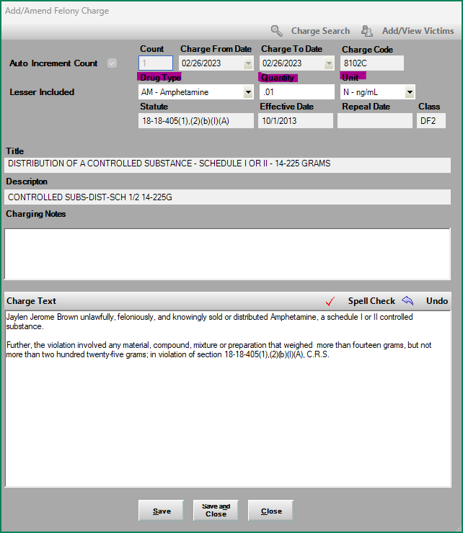

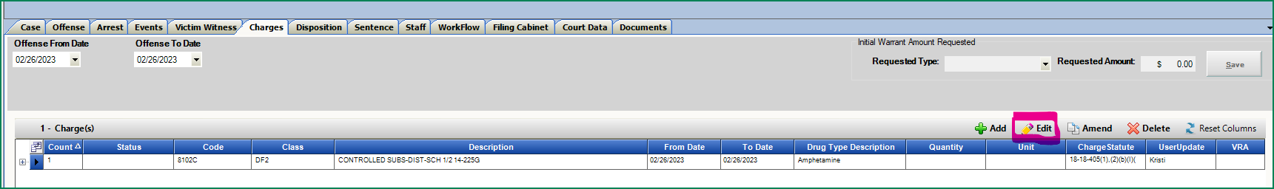

Intake: Initial Warrant Amount Requested

**Purpose:** Fields to be used specifically for an initial warrant/bond request while case is in Intake. Saves this entered value as the initial bond and also displays on the charging documents when generated.

**Location:** Action🡪 Cases🡪 Charges Tab on Pending Intake Cases

**Fields:**

**Functionality:** Users can create entries for an Initial Requested Bond Type and Amount. Granted Bond fields is being moved to the Case and Event Notes- see following section. This refines the previous entries as being expands the previous single-entry space for Bond Amount.

**Requested & Granted Selection Types:**

Bond Denied

Cash

Cash/Property/Surety

NO Bond

Personal Recognizance

Property

Surety

**Requested & Granted Amounts:** Currency Entry

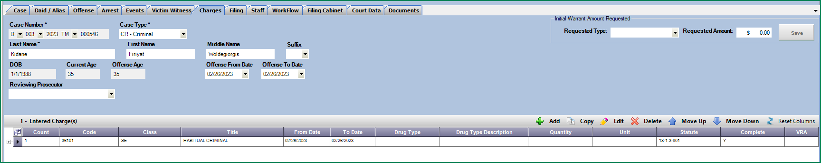Requested Amount will appear on C&I Filing Documents as previous Bond field did- same functionality.

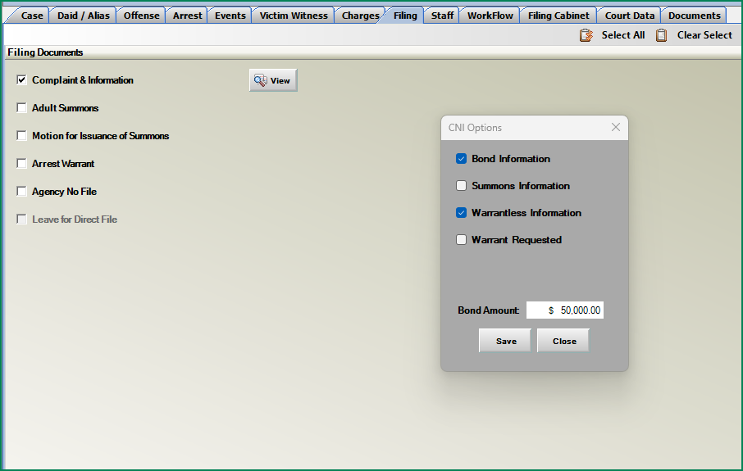

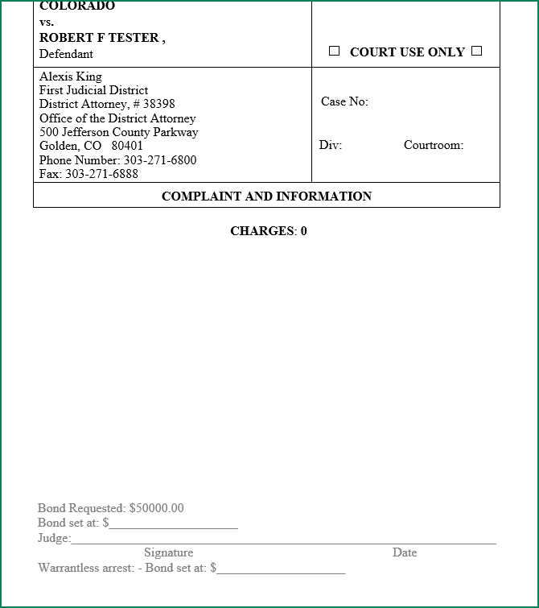

Bond Entries from Notes: Requested & Granted

**Purpose:** Created quick access functionality to enter Bond information from Event and Case Notes within Action.

**Location:**

Action🡪 Prosecutor Tools 🡪 Dockets 🡪 Add Note or Add Multi-Note

Action🡪 Prosecutor Tools 🡪 Case Lists🡪 Add Note or Add Multi-Note

Action🡪 Any other entry point for a Case or Event Note

**Single Note Functionality:**

Users can create entries for Requested and Granted Bond Information at the note level. Access by clicking on Add Notes from the Dockets, Case List, Action Case etc. The Note type has to be either be a Case Note or an Event Note to see the Bond fields.

Click on the Add Bond checkbox to enable the fields.

* Bond information entered will append to the end of the users not automatically when saving the note.

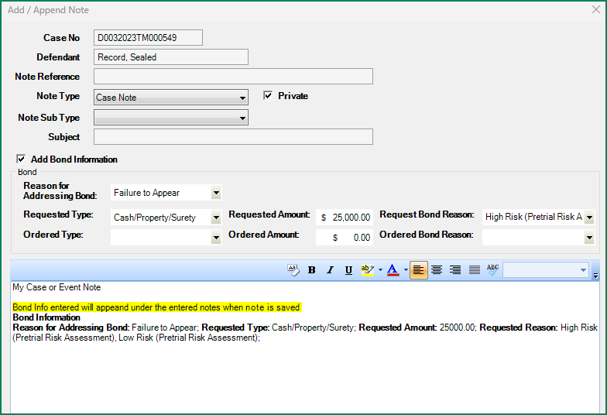

**Fields:**

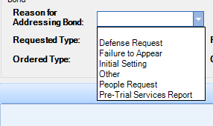

**Reasons for Address Bond:**

Defense Request

Failure to Appear

Initial Setting

Other

People Request

Pre-Trail Services Report

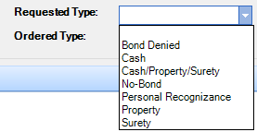**Requested & Granted Types:**

Bond Denied

Cash

Cash/Property/Surety

NO Bond

Personal Recognizance

Property

Surety

**Requested & Granted Amounts:** Currency Entry

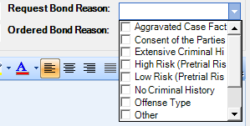 **Requested & Ordered Bond Reasons:**

**MULTI-SELECT Options**

Aggravated Case Facts

Consent of the Parties

Extensive Criminal History

High Risk-Pre-Trial Risk Assessment

Low Risk-Pre-Trial Risk Assessment

No Criminal History

Offense Type

Other

Public Safety

Treatment Intervention

Victim Input

**Multi-Note Functionality:**

Users can create entries for Requested and Granted Bond Information at the note level for multiple cases at a time. From the Dockets and Case Lists highlight and select multiple rows then click on Add Notes. The Note type has to be either be a Case Note or an Event Note to see the Bond fields.

* Click on the Add Bond button on the end of each case row to access the Bond Entry.
* Add Bond will change to Edit Bond when something has been added for visual indication to the user while on this view.
* Bond information entered will append to the end of the users not automatically when saving the note.

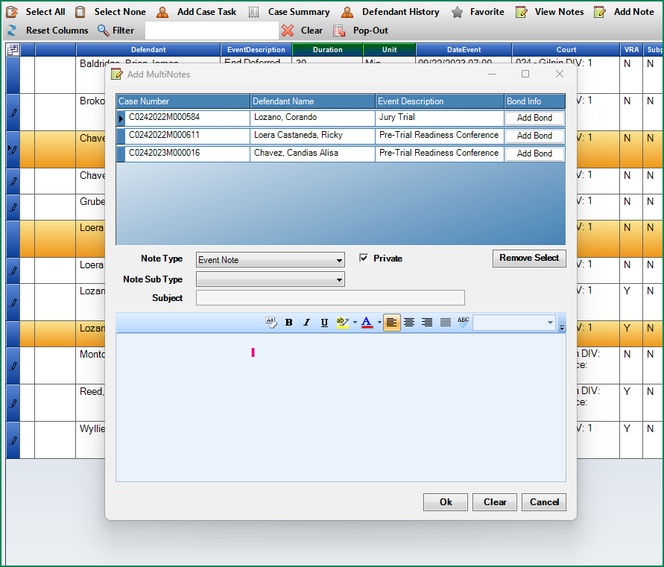Example of 3 cases highlighted and then Add Note selected. Note new column Bond Info. Click on the Add Bond for each case selected to add case specific bond information in this mode.

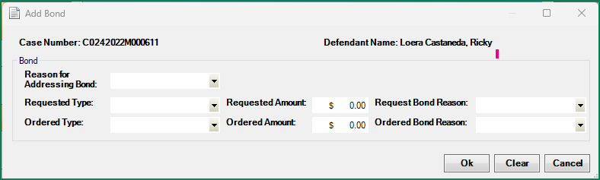

Multi-Note for 3 selected cases added bond for 2 of the 3 cases which updated Add to Edit Bond in the Bond Info. Column

Click on Edit Bond to modify any information before saving the note.

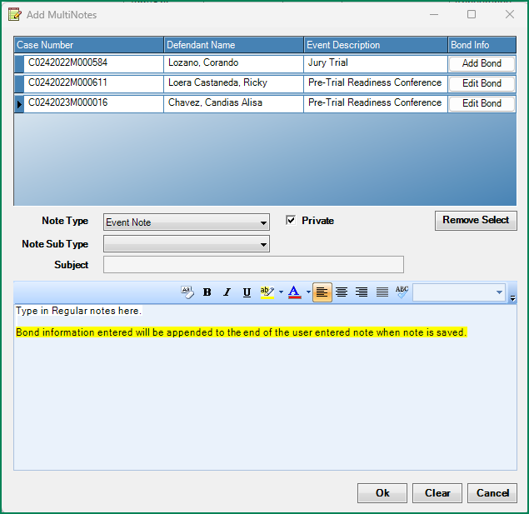

Example of Multi-Note after entering Bond on 2 cases and saving note- See appended Bond Info for each case in the Noting Text.

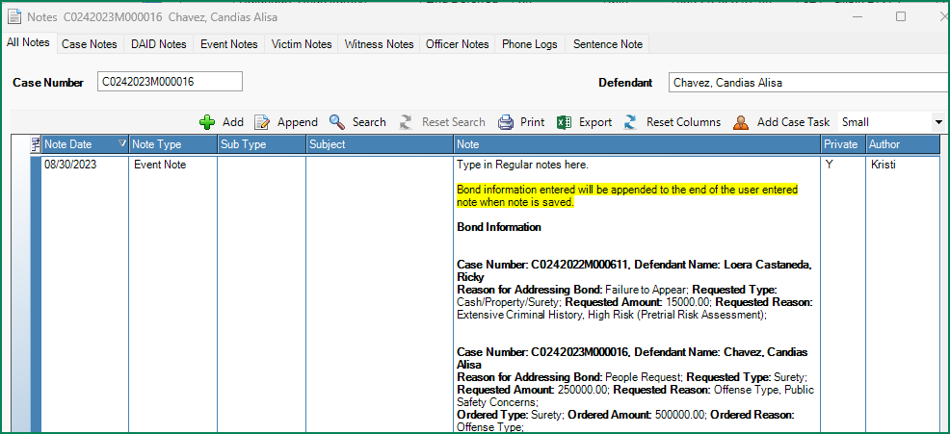

**Appending Notes once saved.**

Note that if a user goes back to Append a saved Note, the Bond information fields can be updated, however these changes will not update the noting text that was appended to the note. Please manually update the noting text with any changes to Bond information as necessary.

Example: Appended Note- Requested Amount reentered as $7,500,000- but the noting text dose not auto update. User can update in the noting text manually.

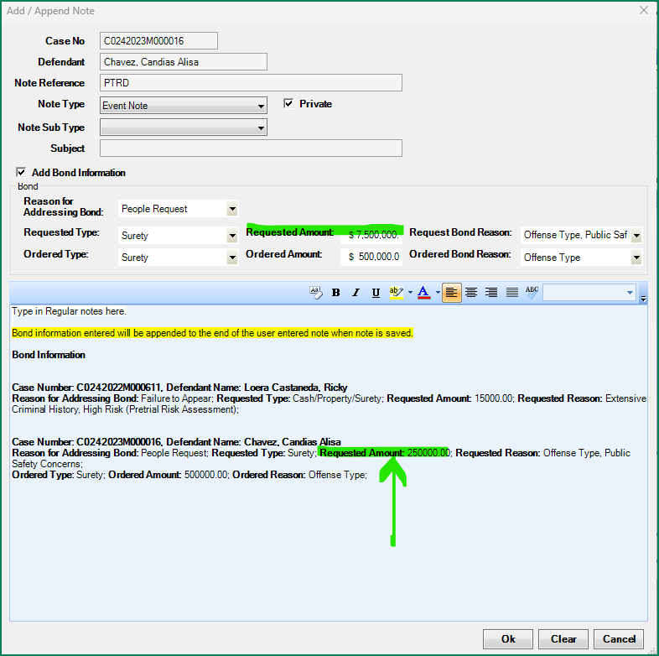

Prosecutor Tools: Dockets and Case List Filter

**Purpose:** Quick way to filter results on a docket or case list.

**Location:** Action🡪 Prosecutor Tools 🡪 Dockets or Case List Selections

**Fields:**

Filter & Clear Filter

**Functionality:**

* Type in filer the end of case number, defendant name, judge name, division- etc. the filter provides a quick way to find a case- click on the Red X next to the filter to clear or highlight and delete/type over for new filter results.



Search case number example:

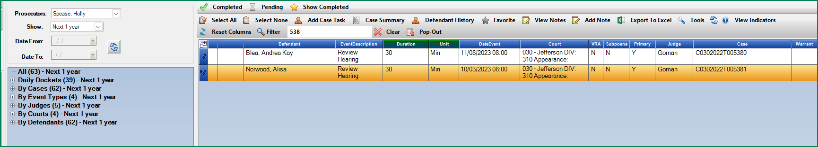

Search name example:

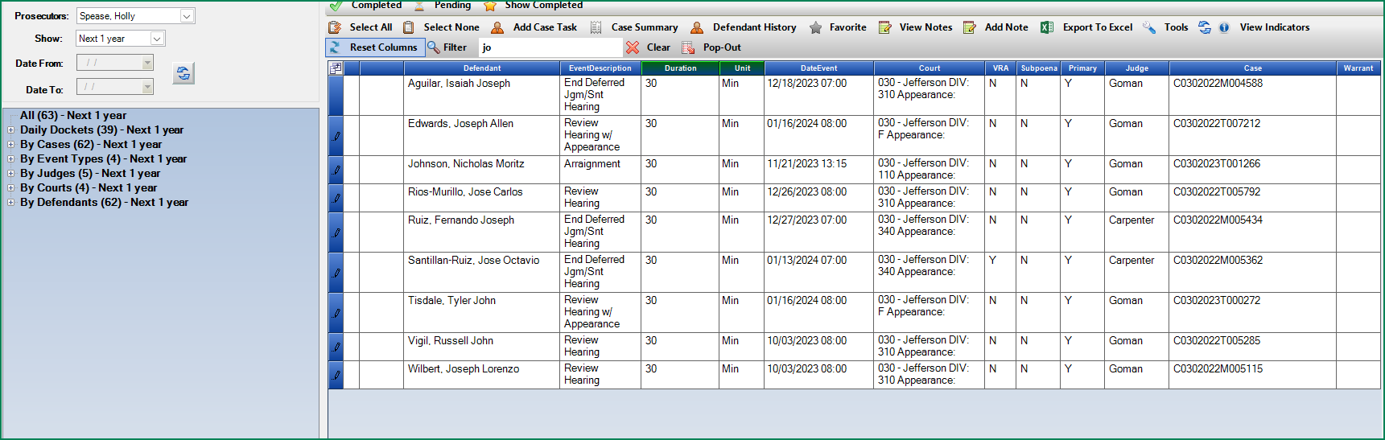

Victim Witness: Victim Services- VOCA Victimizations and Categorizations

**Purpose:** Enhancement to the Victim Services collection section for Victim Specialists to enter specific Victimization types and Categorizations for each Victim and Witness as needed for VOCA reporting.

**Location:** Action🡪 Victim Witness 🡪 Victim Services 🡪 Victimization and Categories Tab.

**Fields:**

Victimization Types

Individual Classifications

**Functionality:**

* Victimization Types and Individual Classifications are multi-selectable.
* Each item also has a tool tip displayed if hovered over.
* Click on the (i) icon next to each to see a pop-up of the description instead of the tool tip.
* Each column provides an “Other” selection. Click on either Other on the interested column to enable the entry text boxes.
* Click on Save after making entries, form remains open after saved.
* Click on Save and Close after making entries, form closes after saved.

VOCA Reports on Action Viewer 🡪Reports 🡪 Victim Witness Folder are being worked on and we will notify users once accessible.

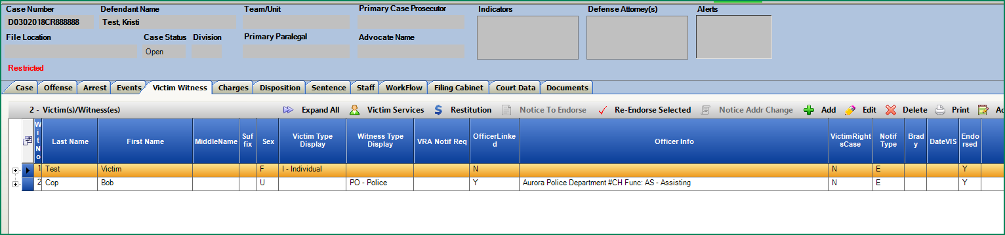

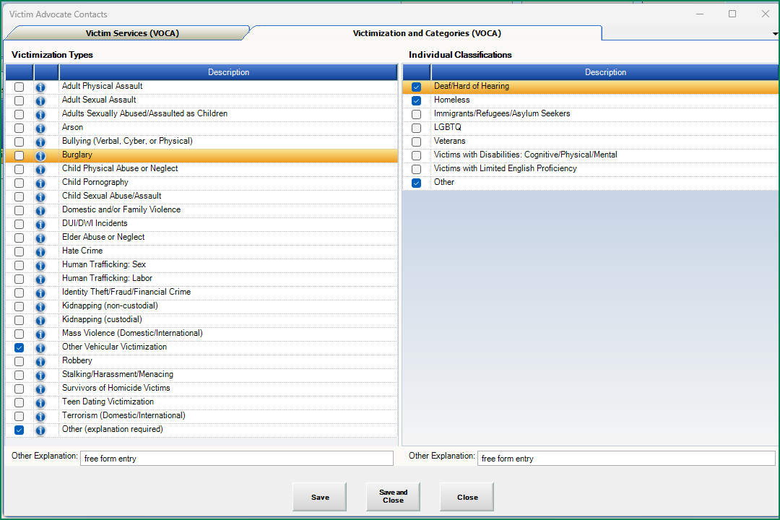

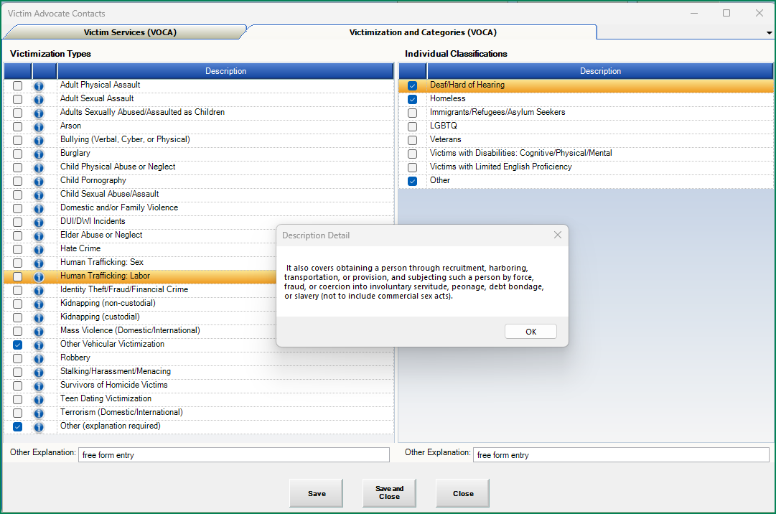

**VOCA Reports:**

Updated VOCA reports can be found on Action Viewer 🡪 Reports 🡪 Victim Witness Folder 🡪   
VOCA Statistics Itemized_V2 & VOCA Statistics_V2.

These Version 2 reports will pull the victim services entries from the new fields above as well as the Categories.

