Action Enhancement Guide

October 2023 Training Guide



Training Materials can be found on our website on the Action Page

DA Office User Website: <https://coloradoda.org>

Action Questions Contact: [Support@cdac.state.co.us](mailto:Support@cdac.state.co.us)



Table of Contents

1. No-File Process- Updated Selections and Process ………………………………….. 3-19
   1. No File 3-5
   2. Edit No-File 6-9
   3. Produce/View No-File Letter 10-15
   4. Reference List of Updated Reasons for No-File 16-19
2. Miscellaneous Action Updates …………………………………… ………………………………………… 20

No File Process

**Purpose: Update to No-File Processing in Action. This enhancement to the process requires a reason selection. This will assist districts in local data collection as to why cases are being no-filed.**

**Location:**

No-Files can only be set for a case while the case is in Intake in a Pending case status.

**Fields:**

Set Case as a No-File: Action 🡪 Intake pending cases 🡪 Case Tools 🡪 No File

Edit Case that is a No-File: Action 🡪 Intake pending cases 🡪 Case Tools 🡪 Edit No-File

Produce No File Letter: Action 🡪 Intake pending cases 🡪 Case Tools 🡪 Produce/ View No-File Letter

**Functionality:**

When a no-file is selected within Action on a pre-filed case a transfer of data is sent to CICJIS and then onto Judicial. The no-file reasons are not sent as part of this transfer- the reasons are only for internal data for the districts.

If a no-file is selected in error, the users must contact [Support@cdac.state.co.us](mailto:Support@cdac.state.co.us) to have the transfer lifted/reversed.

The no-file process has been re-designed to give users reasons specific to data elements for internal tracking. The options are accessible within Action and in this guide as reference.

Users will also be able to add or edit a no-file reason on past no-file cases, to either update past information or correct a reason that was selected in error. This will assist districts that wish to update some of their past no-file information for better data reflection.

**Setting a case to a No-File Status**

1. Case must be in Intake and Pending Case Status
2. User selects Case Tools Drop Down Menu of No-File
3. No-File window appears listing reasons for the no-file, one must be selected. Reference the list of options. Only one reason can be selected. (Reference List on pgs 16-19)
4. User can use the “Search Content” to search the new list of reasons- this filter matches on all grid content.
5. User can then enter a No-File Internal DA Note – this section is a free form text field to enter a no file note for internal reference only. This note will appear in the case as a Case Note. This field enables once a reason has been selected.
6. Click on No-File
   1. This send the transfer as normal to CICJIS and Judicial. This then updates the case status from Pending to No-File. This transfer is only sent this one time.

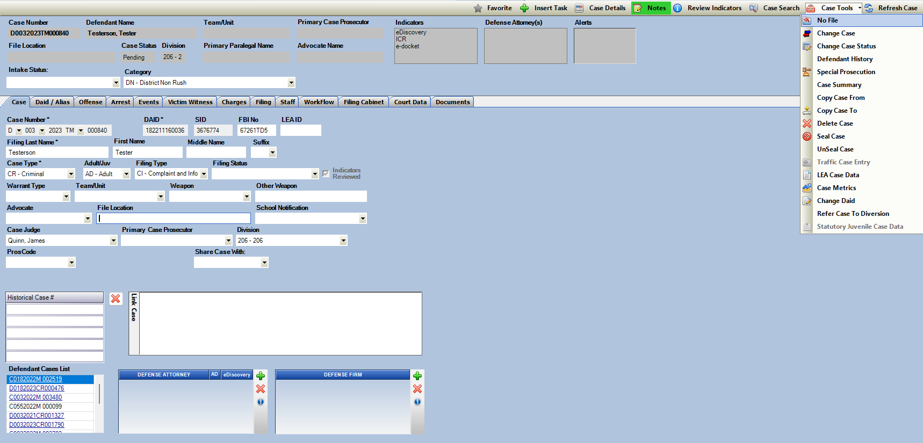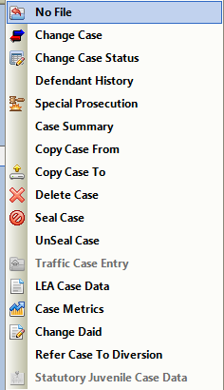

No-File Case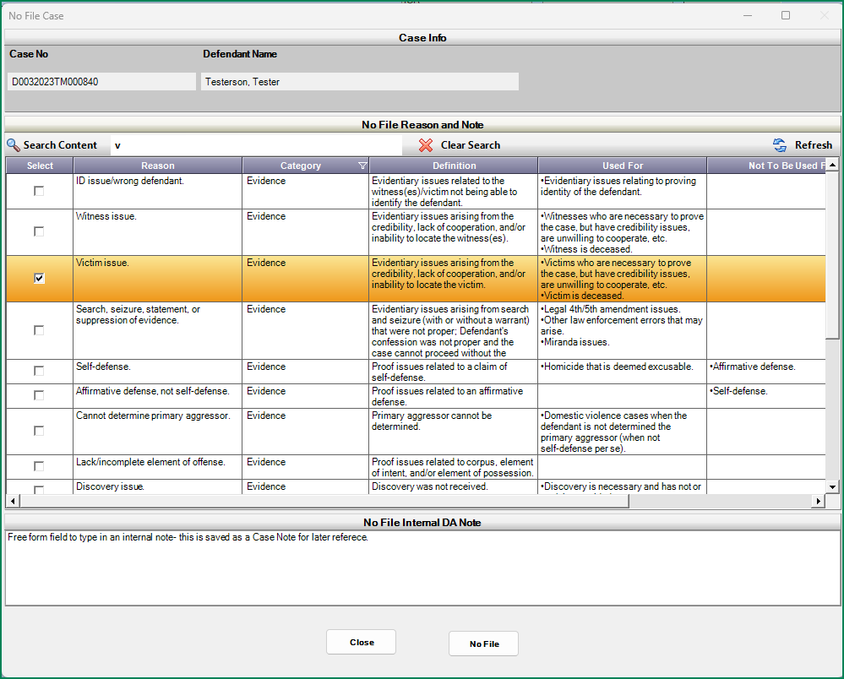 Screen:

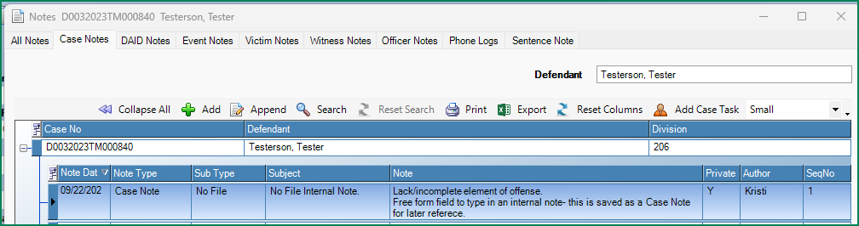

**Editing a Reason on a No-Filed Case - new cases moving forward**

1. Case must be currently set with a No-File Status
2. User selects Case Tools Dropdown menu option: Edit No-File
3. Edit No-File Window appears. Current selected Reason for no-file is highlighted, user may select a new reason and then add information for the internal DA Note.
4. 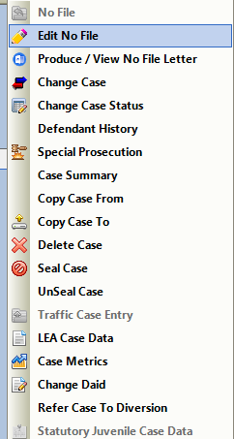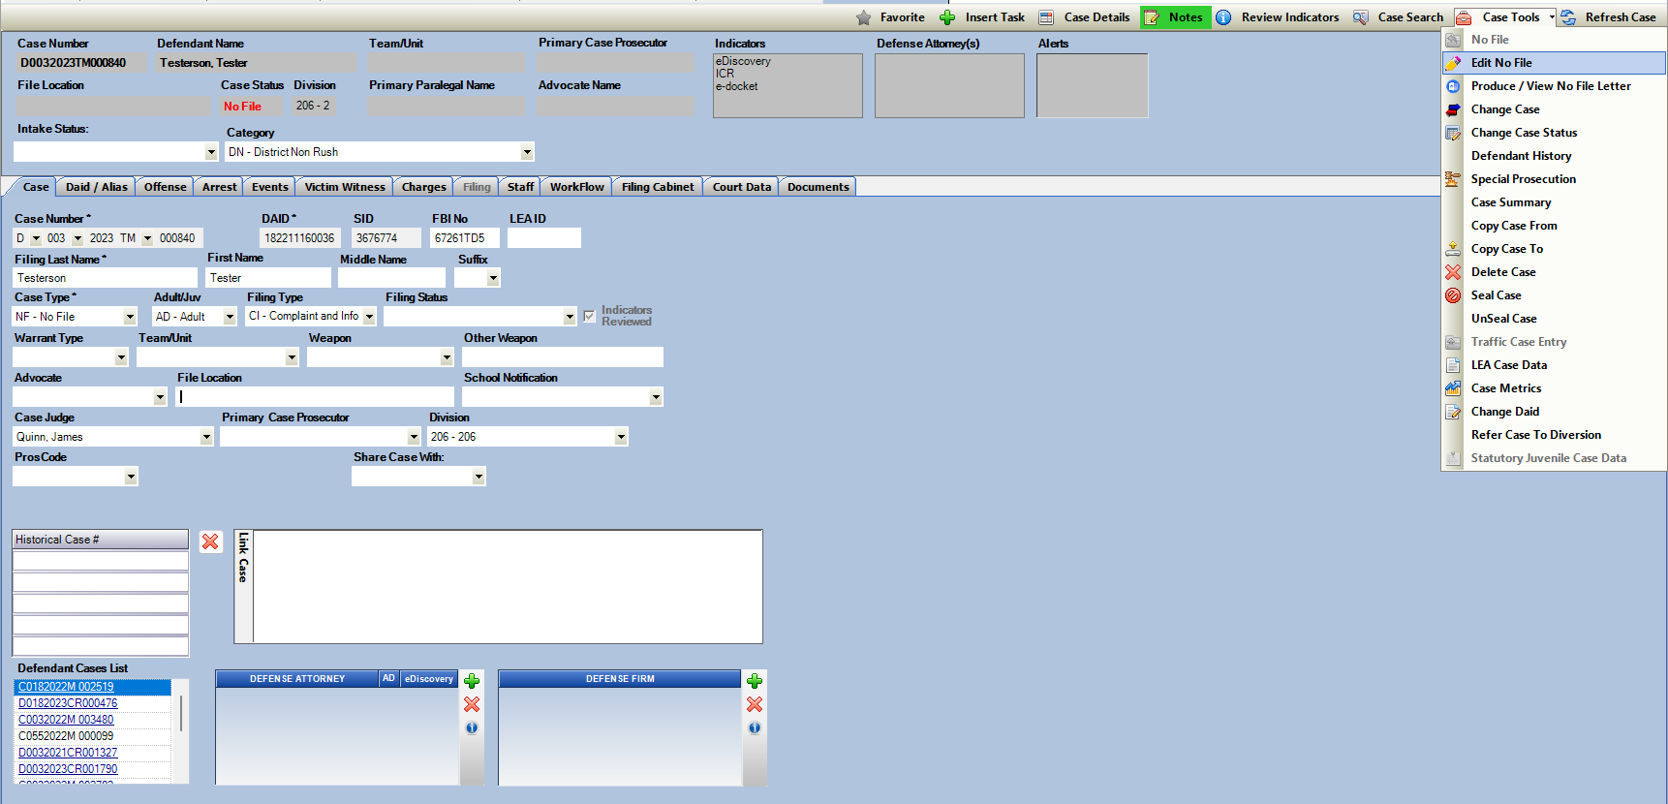Click Save to update the reason

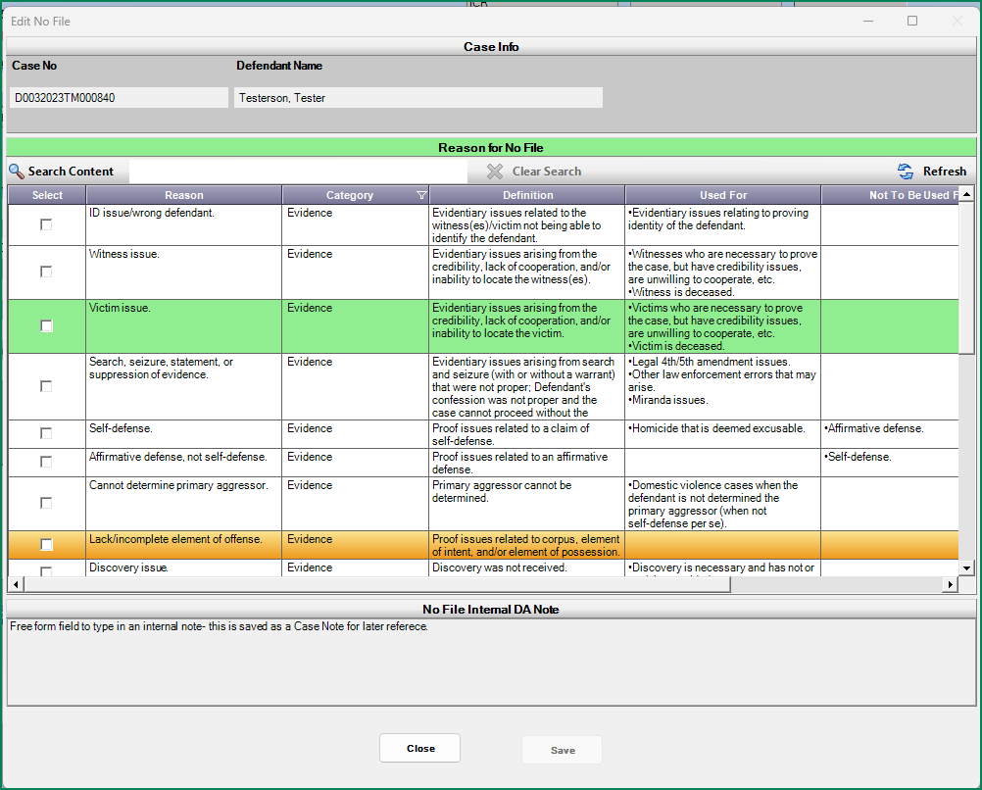Edit No-File Screen:

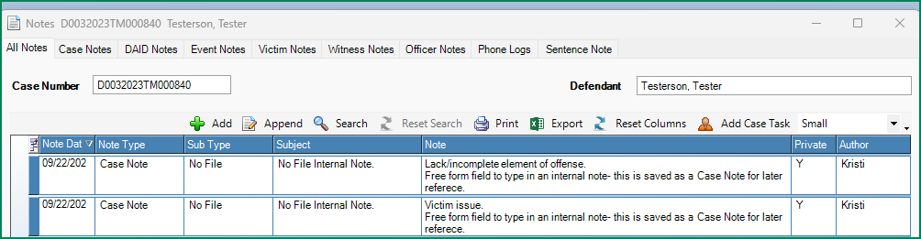A new internal note is created with the new reason reference and user entered note.

**Editing a Reason on a No-Filed Case - older cases that were previous no-file**

1. Case must be currently set with a No-File Status
2. User selects Case Tools Dropdown menu option: Edit No-File
3. Edit No-File Window appears
4. Historical No-File Reason is displayed to the users. They can keep this or if they wish can update the reason to one of the new selections. District may want to utilize this option if they are trying to update past no-filed cases for data collection. Contact [Support@cdac.state.co.us](mailto:Support@cdac.state.co.us) for a list of historical no-file cases in the district if helpful.
5. User may enter a new internal DA Note.
6. Click Save to update the reason

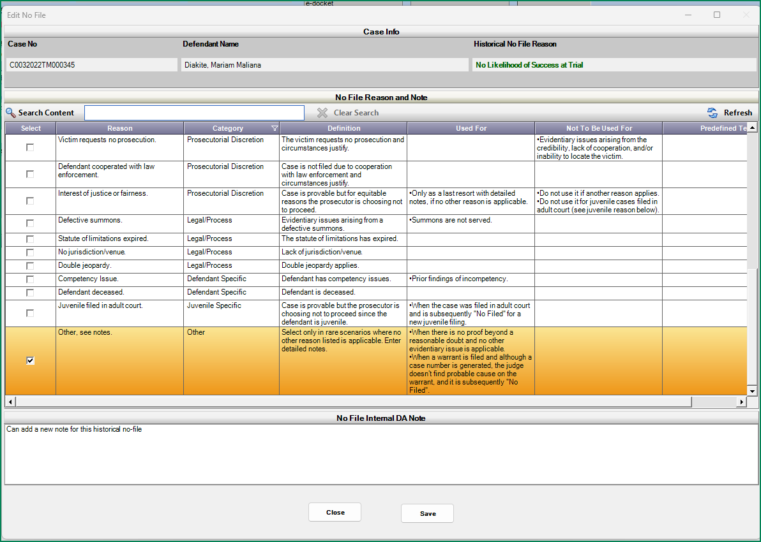Edit No-File Screen- Older cases updating reasons

**Produce/View No-File Letter**

1. Case must be current set with a No-File Status
2. *Note the option to produce letters is on a District setting if this is feature not used it can be turned off. Please contact [Support@cdac.state.co.us](mailto:Support@cdac.state.co.us) .
3. User selects Case Tools Dropdown menu option: Produce/ View No File Letter
4. Produce/View No-File Letter Pop-up appears.
5. Users can free form type in the No-File Letter Content section information about the no-file they would like to reference in a notification letter.
6. If a letter has not yet been produced, enter the desired text and click on Produce Letter.

Note-Spell Check and Referenced No-File reason.

1. 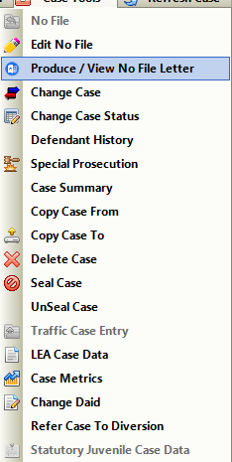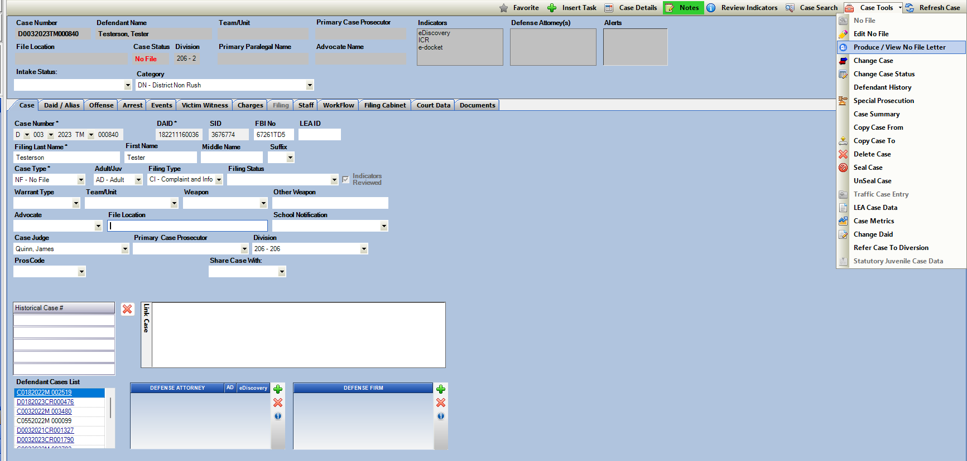Click on Produce Letter, the word document opens and a copy is auto saved to the File Cabinet under Action Gen. Documents.

Produce Letter Screen

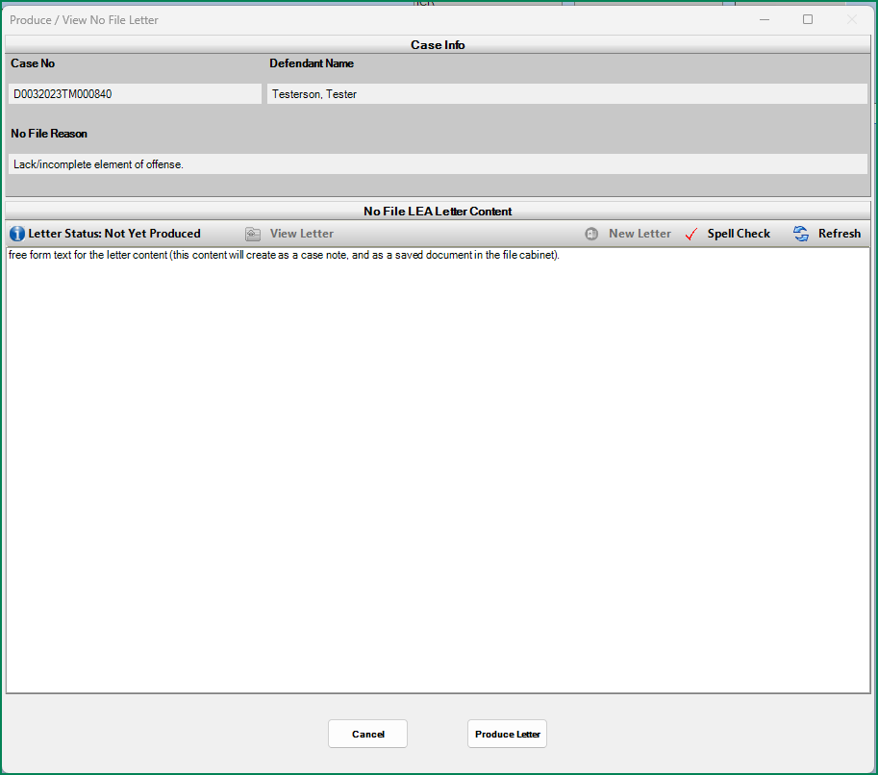Initial Letter Printed: Status of Not Yet Produced displays. User clicks Produce. Copy of the letter is saved to the File Cabinet.

Re-Print of Initial Letter: Status of when it was produced is displayed and user can click on View Letter to re-print with displayed content (or access directly from the file cabinet where it had been saved)

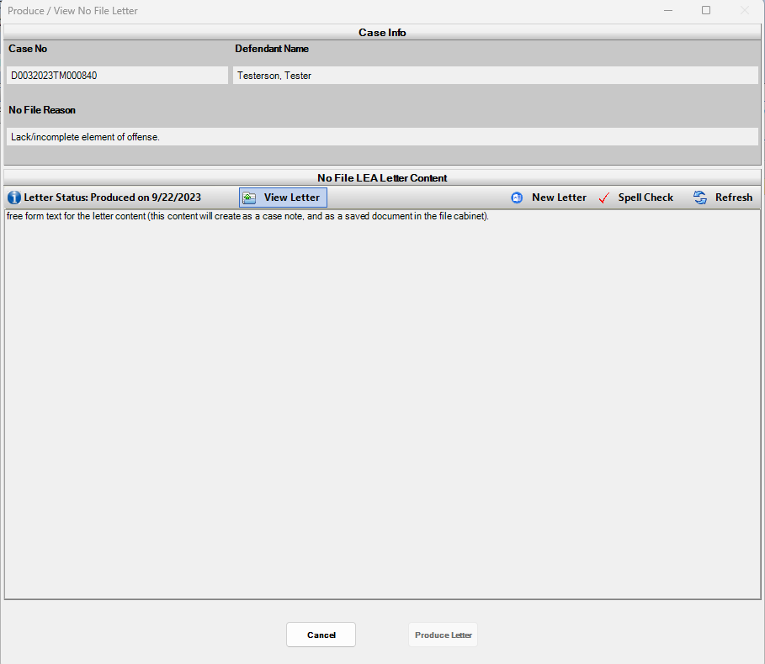

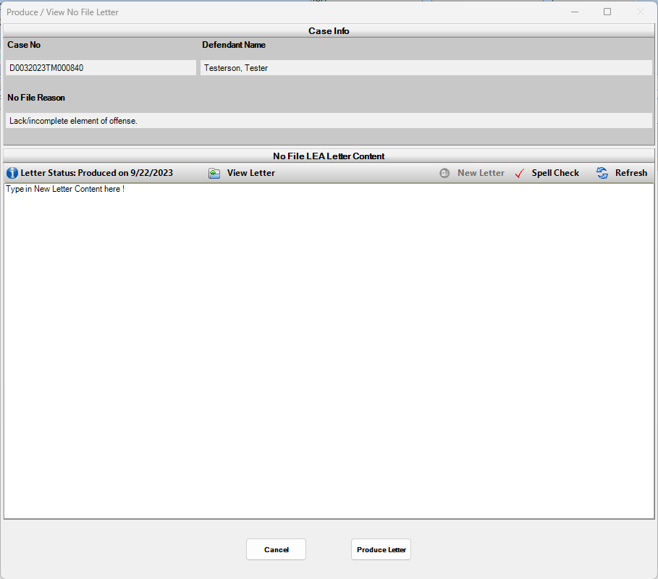Change in Letter Content: Status of when it was produced previously is displayed, user can click on New Letter to clear the letter content and enter new text. User clicks on Produce to create the letter with new content. Copy of the letter is saved to the File Cabinet.

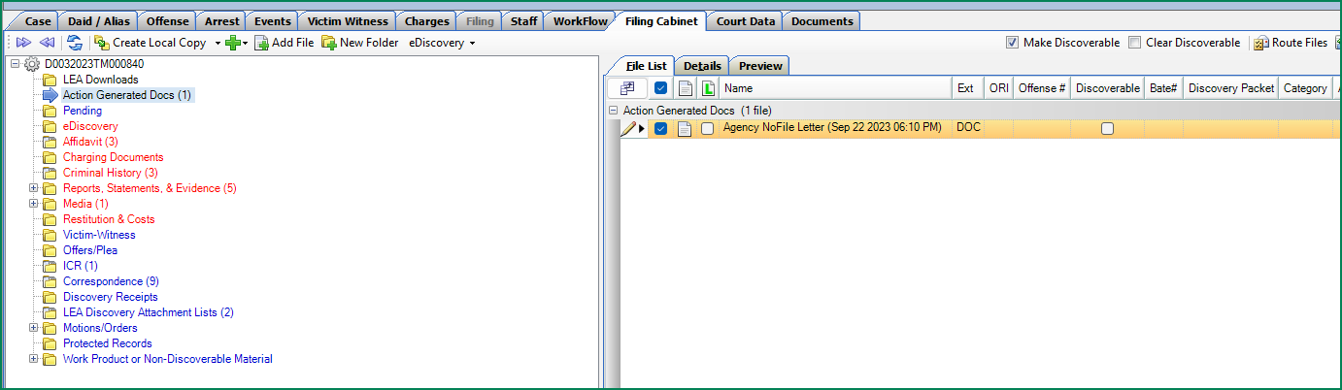Letter produces with user entered content and is saved to the File Cabinet- Action Generated Documents Folder.

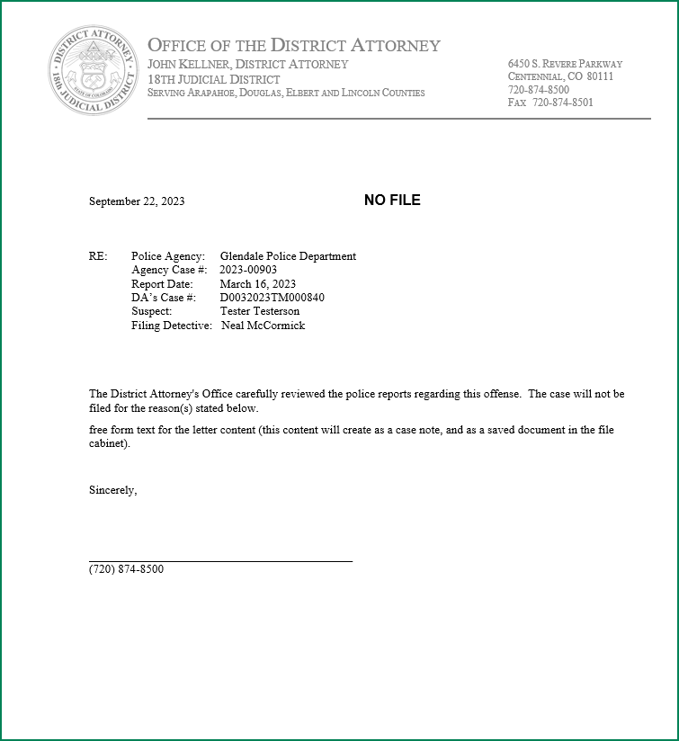

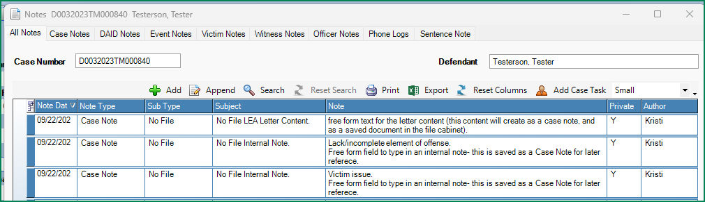Case Note with Subject: No File LEA Letter Content is also generated- this displays the content entered for the letter as a quick reference from the Notes within a case.

Reference List of No-File Reasons (Prosecutor Dashboard

|  |  |  |  |  |
| --- | --- | --- | --- | --- |
| Reason | Category | Definition | Use For: | NOT to be used for: |
| ID issue/wrong defendant | Evidence | Evidentiary issues related to the witness(es)/victim not being able to identify the defendant. | ●        Evidentiary issues relating to proving identity of the defendant. |  |
| Witness issue | Evidence | Evidentiary issues arising from the credibility, lack of cooperation, and/or inability to locate the witness(es). | ●        Witnesses who are necessary to prove the case, but have credibility issues, are unwilling to cooperate, etc. |  |
| ●        Witness is deceased. |
| Victim issue | Evidence | Evidentiary issues arising from the credibility, lack of cooperation, and/or inability to locate the victim. | ●        Victims who are necessary to prove the case, but have credibility issues, are unwilling to cooperate, etc. |  |
| ●        Victim is deceased. |
| Search, seizure, statement, or suppression of evidence. | Evidence | Evidentiary issues arising from search and seizure (with or without a warrant) that were not proper; defendant's confession was not proper and the case cannot proceed without the confession. | ●        Legal 4th/5th amendment issues. |  |
| ●        Other law enforcement errors that may arise. |
| ●        Miranda issues. |
| Self-defense | Evidence | Proof issues related to a claim of self-defense. | ●        Homicide that is deemed excusable. | ●        Affirmative defense |
| Affirmative defense, not self-defense | Evidence | Proof issues related to an affirmative defense. |  | ●        Self-defense |
| Cannot determine primary aggressor | Evidence | Primary aggressor cannot be determined. | ●        Domestic violence cases when the defendant is not determined the primary aggressor (when not self-defense per se). |  |
| Lack/incomplete element of offense | Evidence | Proof issues related to corpus, element of intent, and/or element of possession. |  |  |
| Discovery issue | Evidence | Discovery was not received. | ●        Discovery is necessary and has not or can’t be provided. |  |
| Lab results inconclusive/ negative | Evidence | Substance tests were negative for controlled substances, inconclusive forensic evidence, and/or lab results were not received. |  |  |
| Further investigation needed | Evidence | An arrest warrant when an officer needs to complete further investigation. |  |  |
| Plea in other case | Change in Case | Case is not filed due to a disposition in another case. | ●        Plea in another case that includes these charges (in any jurisdiction). |  |
| Case consolidated | Change in Case | Case is not filed due to consolidation with another existing case. |  |  |
| Pre-file diversion | Change in Case |  |  |  |
| Case is not filed due to successful completion of pre-file diversion programming. |
| Referred to other agency | Prosecutorial Discretion | Case is referred to a different law enforcement agency (state or federal), another DA’s Office, or the U.S. Attorney’s Office. | ●        Referred to: the military to prosecute; |  |
| ●        Youth bureau; |
| ●        A different state or federal jurisdiction; |
| ●        Another judicial district. |
| Victim requests no prosecution | Prosecutorial Discretion | The victim requests no prosecution and circumstances justify. |  | ●        Evidentiary issues arising from the credibility, lack of cooperation, and/or inability to locate the victim. |
| Defendant cooperated with law enforcement | Prosecutorial Discretion | Case is not filed due to cooperation with law enforcement and circumstances justify. |  |  |
| Interest of justice or fairness. | Prosecutorial Discretion | Case is provable but for equitable reasons the prosecutor is choosing not to proceed. | ●        Only as a last resort with detailed notes, if no other reason is applicable. | ●        Do not use it if another reason applies. |
| ●        Do not use it for juvenile cases filed in adult court (see juvenile reason below). |
| Defective summons | Legal/Process | Evidentiary issues arising from a defective summons. | ●        Summons are not served. |  |
| Statute of limitations expired | Legal/Process | The statute of limitations has expired. |  |  |
| No jurisdiction/venue | Legal/Process | Lack of jurisdiction/venue. |  |  |
| Double jeopardy | Legal/Process | Double jeopardy applies. |  |  |
| Competency Issue | Defendant Specific | Defendant has competency issues. | ●        Prior findings of incompetency. |  |
| Defendant deceased | Defendant Specific | Defendant is deceased. |  |  |
| Juvenile filed in adult court | Juvenile Specific | Case is provable but the prosecutor is choosing not to proceed since the defendant is juvenile. | ●        When the case was filed in adult court and is subsequently “No Filed” for a new juvenile filing. |  |
| Other, see notes | Other | Select only in rare scenarios where no other reason listed is applicable. Enter detailed notes. | ●        When there is no proof beyond a reasonable doubt and no other evidentiary issue is applicable. |  |
| ●        When a warrant is filed and although a case number is generated, the judge doesn’t find probable cause on the warrant, and it is subsequently ‘no filed’. |  |

Action: Miscellaneous Updates

Dockets and Case Lists: Refined search ability in the dropdown selection lists so that users can start typing in a last name instead of just the first letter to assist in narrowing down results quickly without needing to scroll through lists.

LEA Search Screen: Add additional sort by DOB column to correctly sort by this field if the column is clicked on for sorting.

Updated field name: Initial Warrant Requested changed to Initial Bond Requested on the Charges tab to more correctly identify the field.