Action Enhancement Guide

May 2023 Training Guide



Training Materials can be found on our website on the Action Page

DA Office User Website: <https://coloradoda.org>

Action Questions Contact: [Support@cdac.state.co.us](mailto:Support@cdac.state.co.us)



Table of Contents

1. Juvenile Data Screening Collection per SB 19-108……………………………………. 3-5
2. Referring a Case to Diversion ……..………………………………………………………………….. 6-10

**Juvenile Data Screening Collection**

**Juvenile Data Screening Collection Per SB 19-108**

**Purpose:** Capture State-Required Juvenile Screen information for all Juvenile Cases.

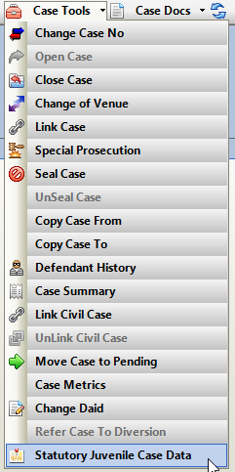**Location:** Action🡪Case Tools Drop down menu 🡪Statutory Juvenile Case Data

Note: When the information is entered on the Action side and if then the case is referred to Diversion at any point this data will transfer. Then if any additions or edits are made it will stay in synch between the two systems. In Diversion this information is displayed on the DCJ Data Tab within a case.

Case Indicators:

**School Related CRS 20-1-113:** This sets the Case level indicator on an Action Case. This provides other access point to mark the case while screening is being done.

**Diversion Screening Completed**: This sets the Case level indicator on an Action Case as well. This is user selected for purpose of marking off when a Juvenile case has been screening completed, with either a yes or no score. This can then be used to then run a report on Juvenile cases in a district and if the screening has been completed.

Client Information: This section does not populate in any Action defendant demographics info. but is user selection driven. This includes Ethnicity, Gender Identification, Sexual Orientation, SOGI Not Answered Options and Multi-Select Race.

*SOGI Not Answered is enabled for selection with “Not Answered” is selected in Sexual Orientation field.

Self-Identified Checkbox: check if this information was self-identified by the Defendant, otherwise leave blank.

State-Screeing Tool- ARNA: Section to track state screenings done on Client. Multiple entries can be made. Click on Add Screening.

Date of Screening: Defaults to todays date but can be edited.

Screening Completed: Yes or No

Yes = enables the ARNA Score 0-11; a Service Provider can also be selected.

No = enables the Reason Not Completed; a Service Provider can also be selected.

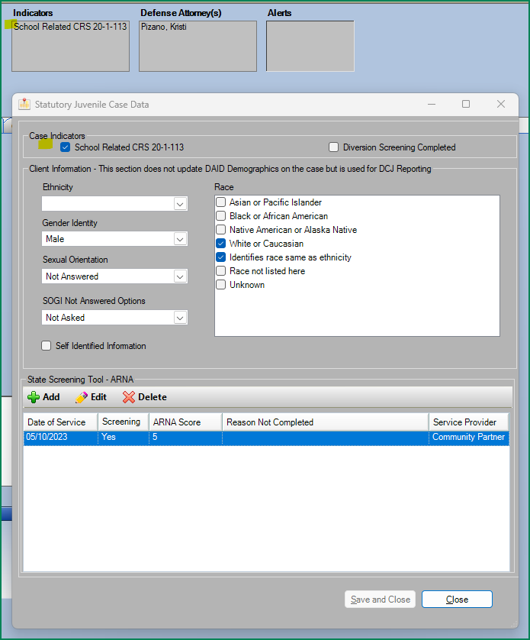

**Indicator Report**

Action Viewer Report 🡪 Reports 🡪 Statistics Folder🡪 Report Name: Case List by Indicator

Enter:

1. Court Location: Select one or All Court locations in your district.
2. Run Date: Select based on results you want to view.

* Date Created = Date Case was created within Action use this for Pre-Filing cases to capture data as well as case that have been Filed with the court.
* Date Filed = Date the case was Filed in Action to Judicial- This would Exclude pre-filing cases as they are not filed with the court.

1. Start Date & End Date = Enter the Date Range for the Data Run selected above. Remember this is based on when the case was either created within Action or when the case was Filed within Action to Judicial.
2. Indicator: Select specific Indicator from the drop-down list.
3. Click on: View Report

This will display for the RUN DATE selected above, any case that has the ARNA indicator selected on it.

This displays the Case Number, Defendant, DOB, Indicators on Case and Charges and Total Cases.

Example:

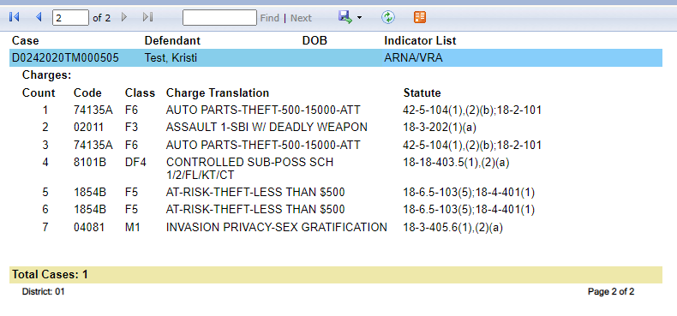

Referring an Action Case to Diversion

Location: Action Case🡪 Case Tools Dropdown🡪 Refer Case to Diversion

* Diversion System will populate with a copy of the Action case data when sent. This will not remove the case or any information from Action.
* Action Case Type and Filing Type automatically update to Diversion when referred for easy identification within the Action case that it’s in Diversion.
* An Internal Event is auto generated showing date the case referred to Diversion**.**

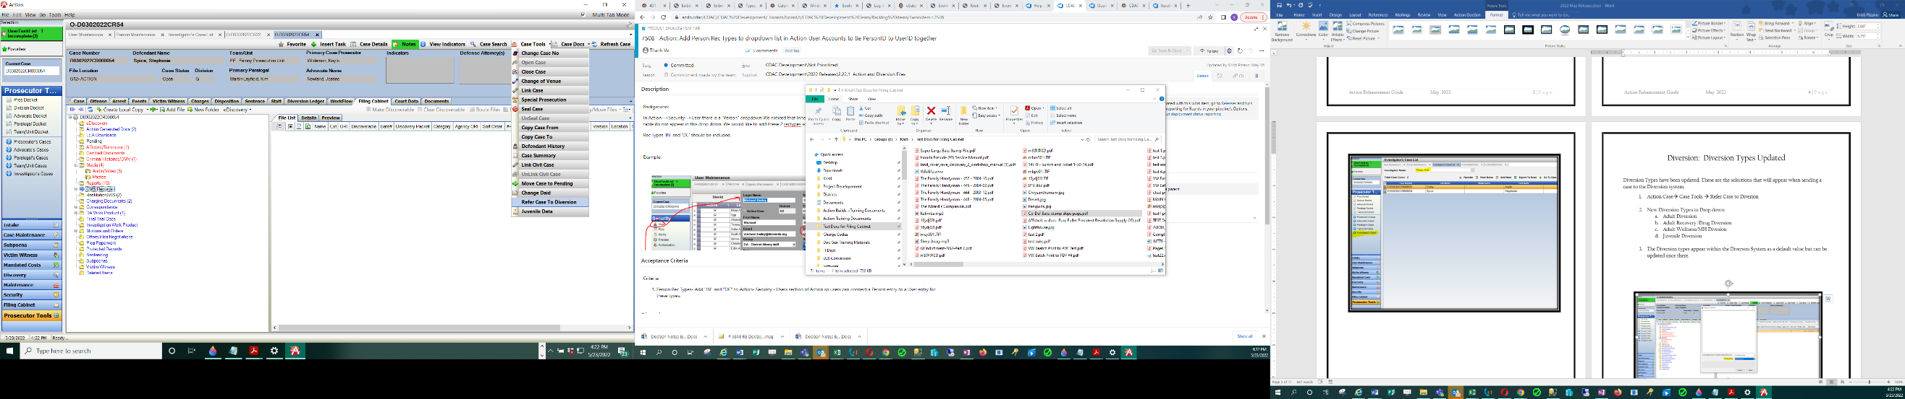

**Refer Case to Diversion- pop-up then appears.**

**Users can enter a note/comment: This will be displayed in the Diversion Module as a DA note.**

Select Option to Copy Files from Action to Diversion: * Note files will process based on users connection speed and other factors. Best practice is to review which files should be sent, as when the copy process starts will not allow the user to continue to work in Action until files are copied. An Alternative to sending at this point is to make a local copy of the files and then add in manually in the Diversion system to it’s file cabinet.

1. **Do Not Send Files** = No files sent & default option
2. **Send All Files** = All files in case- *note this would include Discovery packets, plus the original discoverable files as well as any work product. The discoverable files would be a duplicate of what is in the discovery packets.
3. **Send Only Discoverable Files** = Files that are marked as being discoverable does not send a discoverable packet- just the files in a case appearing in “Red” denoting a discoverable property.

Diversion Types: Select a Diversion Type- this can also be updated on the Diversion side.

Adult Diversion

Adult Recovery /Drug Diversion

Adult Wellness/MH Diversion

Juvenile Diversion

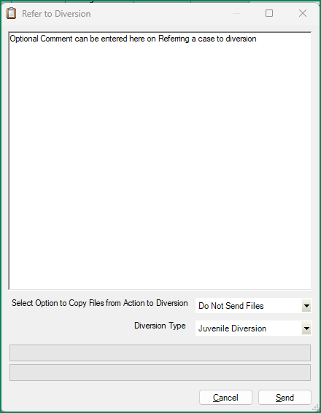

Click on Send

Action Case will close after selecting Send completing the transfer.

Reload the Action case.

1. Case Type and Filing Type both Auto Update to Diversion

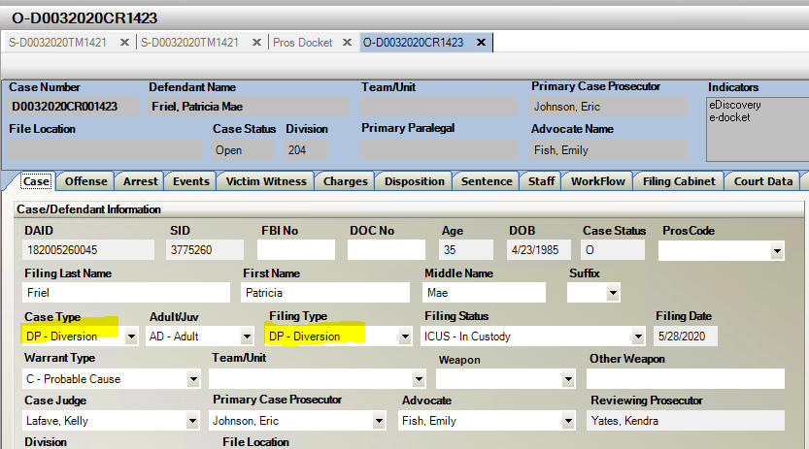

1. 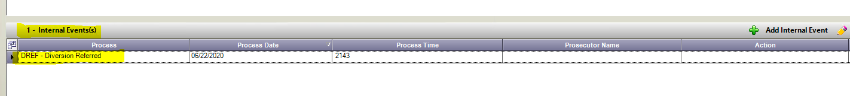An Internal Event is Auto Generated displaying on the Action side that the case has been referred to Diversion.

Examples of Send File Options:

1. 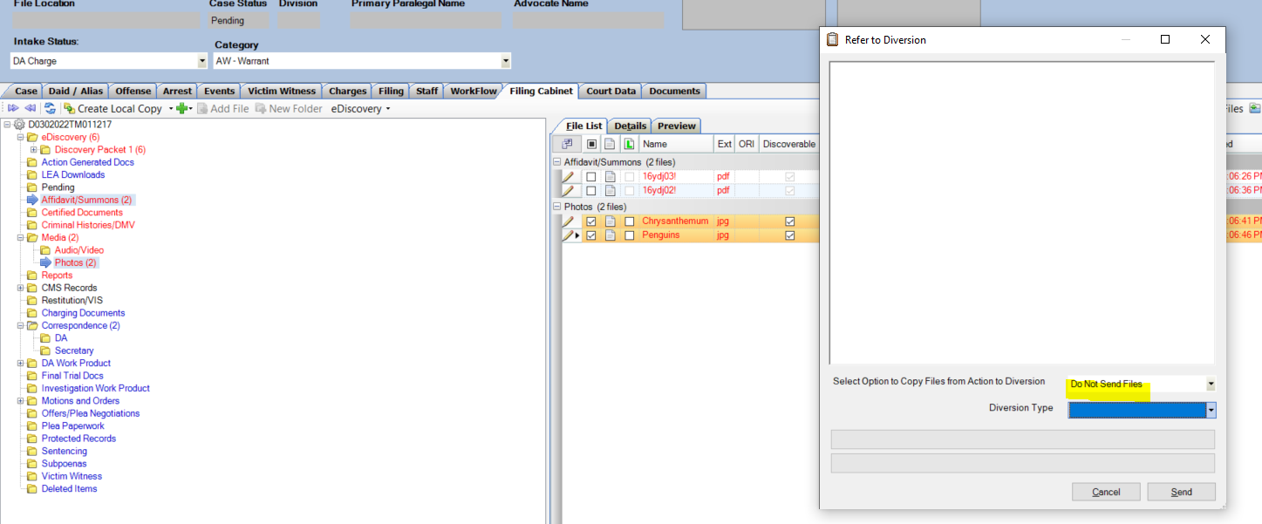**Do Not Send Files** = No files sent & default option
2. **Send All Files** = All files in case- *note this would include Discovery packets, plus the original discoverable files as well as any work product. The discoverable files would be a duplicate of what is in the discovery packets.

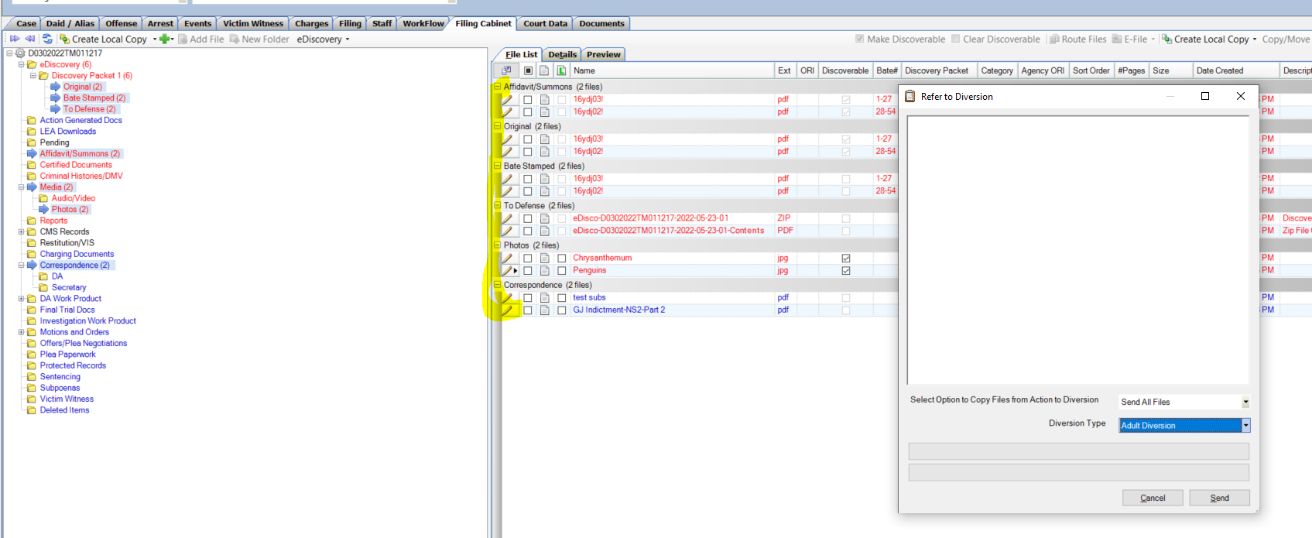

1. 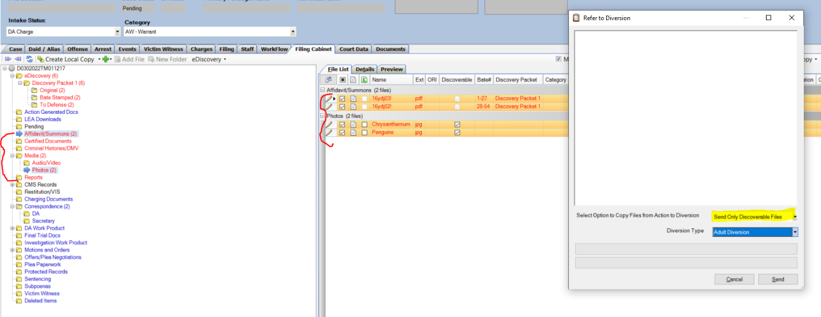**Send Only Discoverable Files** = Files that are marked as being discoverable does not send a discoverable packet- just the files in a case appearing in “Red” denoting a discoverable property.