Action Enhancement Guide

January 2023 Training Guide



Training Materials can be found on our website on the Action Page

DA Office User Website: <https://coloradoda.org>

Action Questions Contact: [Support@cdac.state.co.us](mailto:Support@cdac.state.co.us)



Table of Contents

1. Bond Fields- Requested and Granted………………………………………………………………. 3-4
2. Active Warrant Status …………………………………………………………………………………….. 5-7

Bond – Requested/Granted

**Purpose:** Created to give users the ability to track and then report on Bond information that is being requested vs. what has been granted in a case. This information is User Entered.

**Location:** Action Cases🡪 Charges Tab

**Fields:**

**Requested & Granted Selection Types:**

Bond Denied

Cash

Cash/Property/Surety

NO Bond

Personal Recognizance

Property

Surety

**Requested & Granted Amounts: Currency Entry**

**Requested & Granted Date: Date Entry**

**Functionality:** Users can create entries for Requested and Granted Bond Information at the case level. This expands the previous single entry space for Bond Amount.

* User Entry
* Provides information for reporting if entered
* Intake and Case Maintenance – Charges Tab
* Save Button- enables after new data is entered or existing data is modified.
* No-Bond Selection is a Type
* 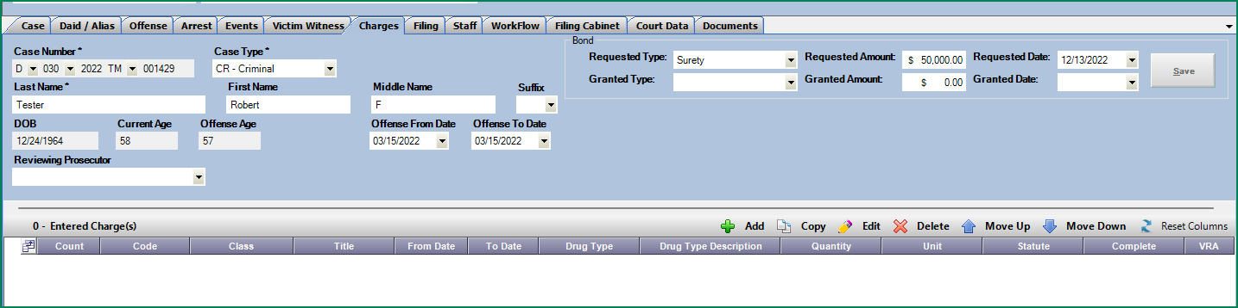Requested Amount will appear on C&I Filing Documents as previous Bond field did- same functionality.

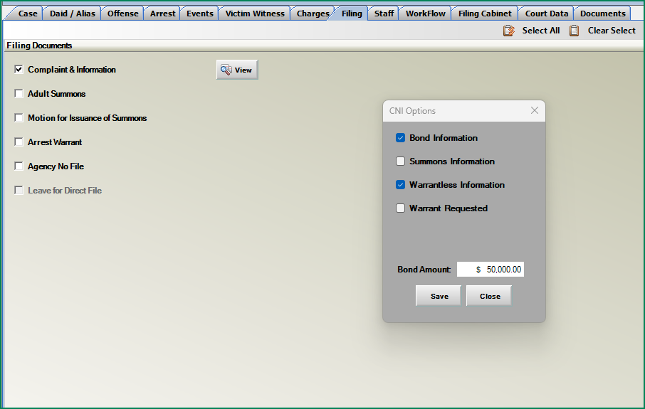

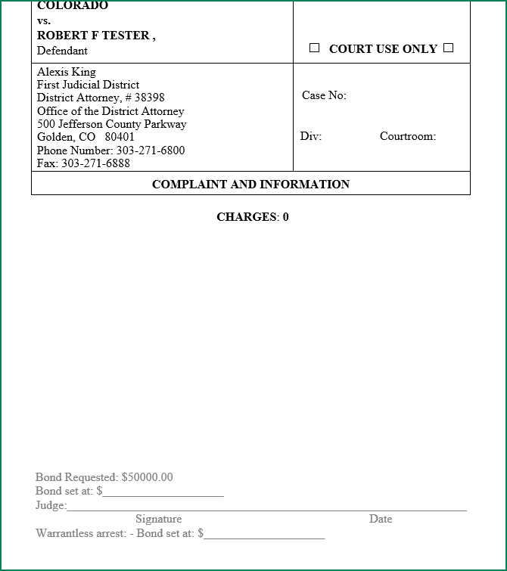

Warrant- Active Status

**Purpose:** Display Active Warrant Status of a Defendant on Specific Cases from Judicial Data.

**Location:** Action Cases🡪 Case Header 🡪 Alerts Box

Prosecutor Tools 🡪 Dockets and Case List Options🡪 Column “Warrants”

**Functionality:**

Warrant status is sent to Action from Judicial. This is a live feed of the current status entered by the court. This is Defendant/Case Specific.

“Active Warrant” in red will appear in the Alerts box of the case header as notification.

This information is also displayed under Pros. Tools options- Dockets and Case Lists. New column “Warrant” will be defaulted. The “Active Warrant” status will display with a “Y” in the column and the row on the grid will be in light red.

Case Header Display

Active Warrant Example

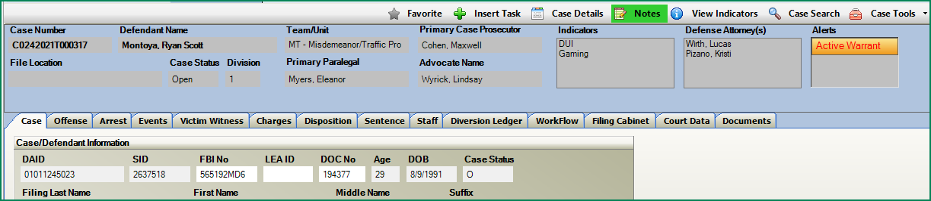

No Warrant Example

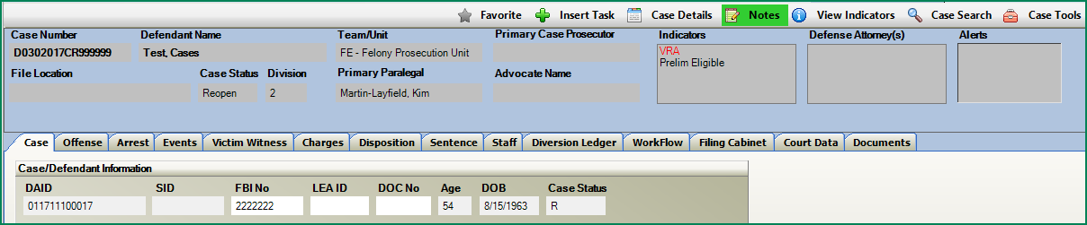

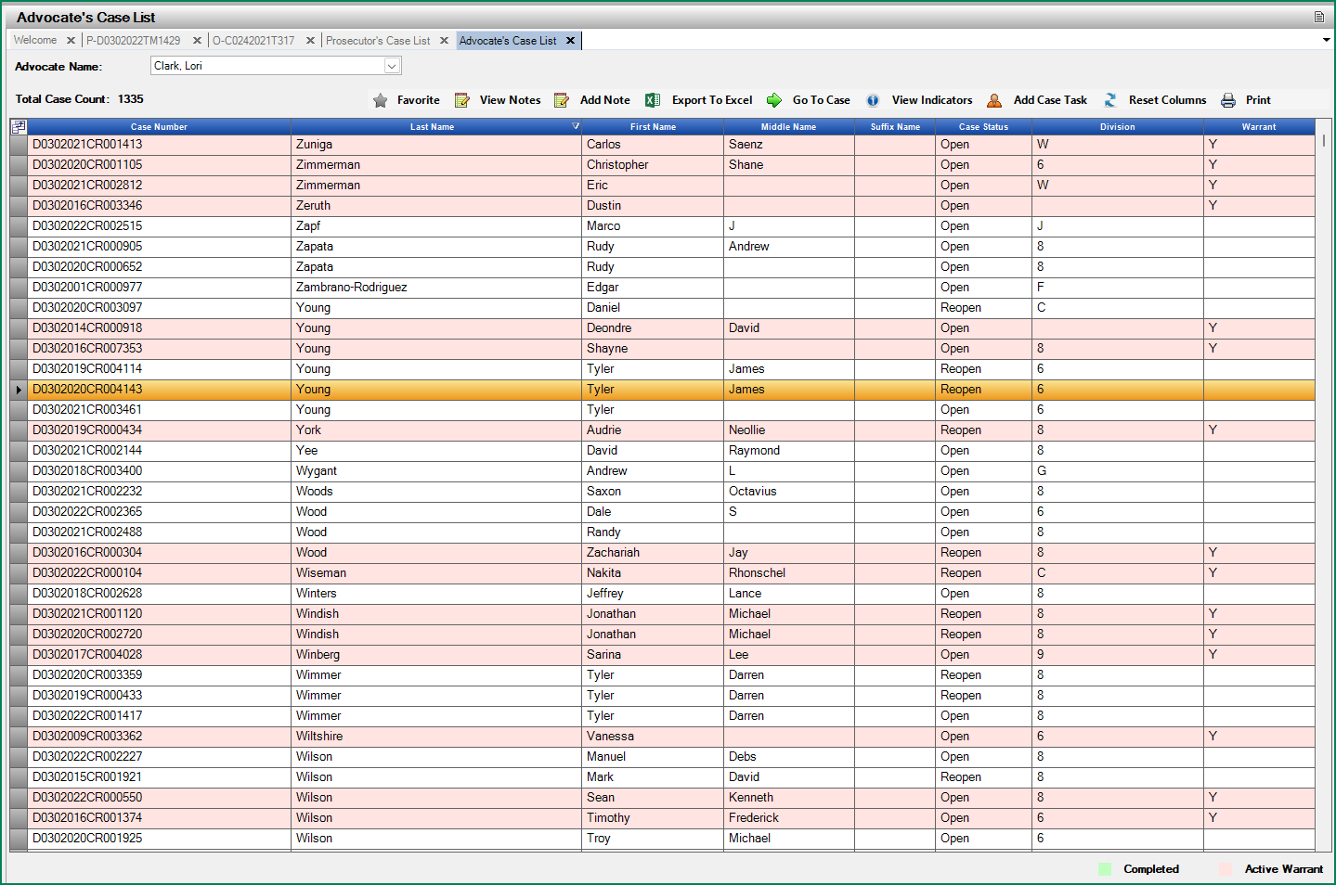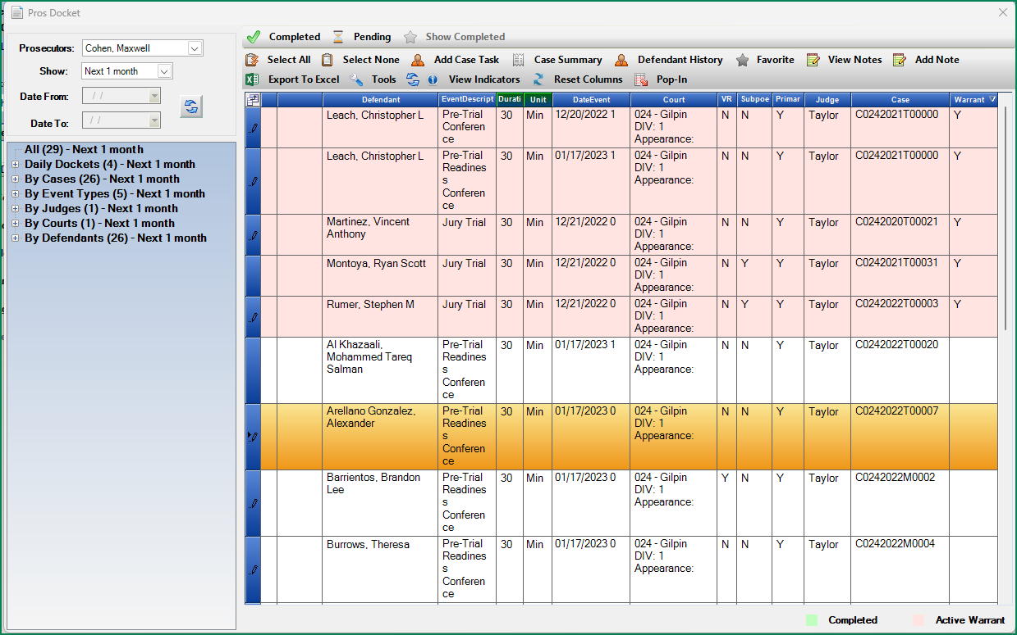Pros Tools- Dockets and Case List Display

Cross Reference Example of Active Warrant Status in Action and Display in Court Data Access

